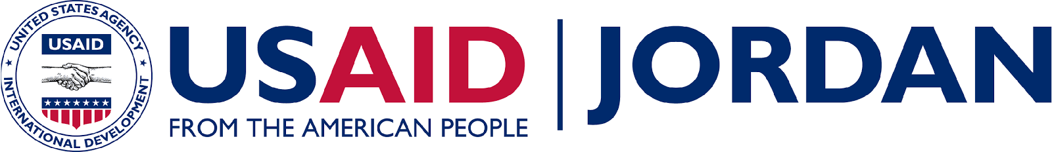
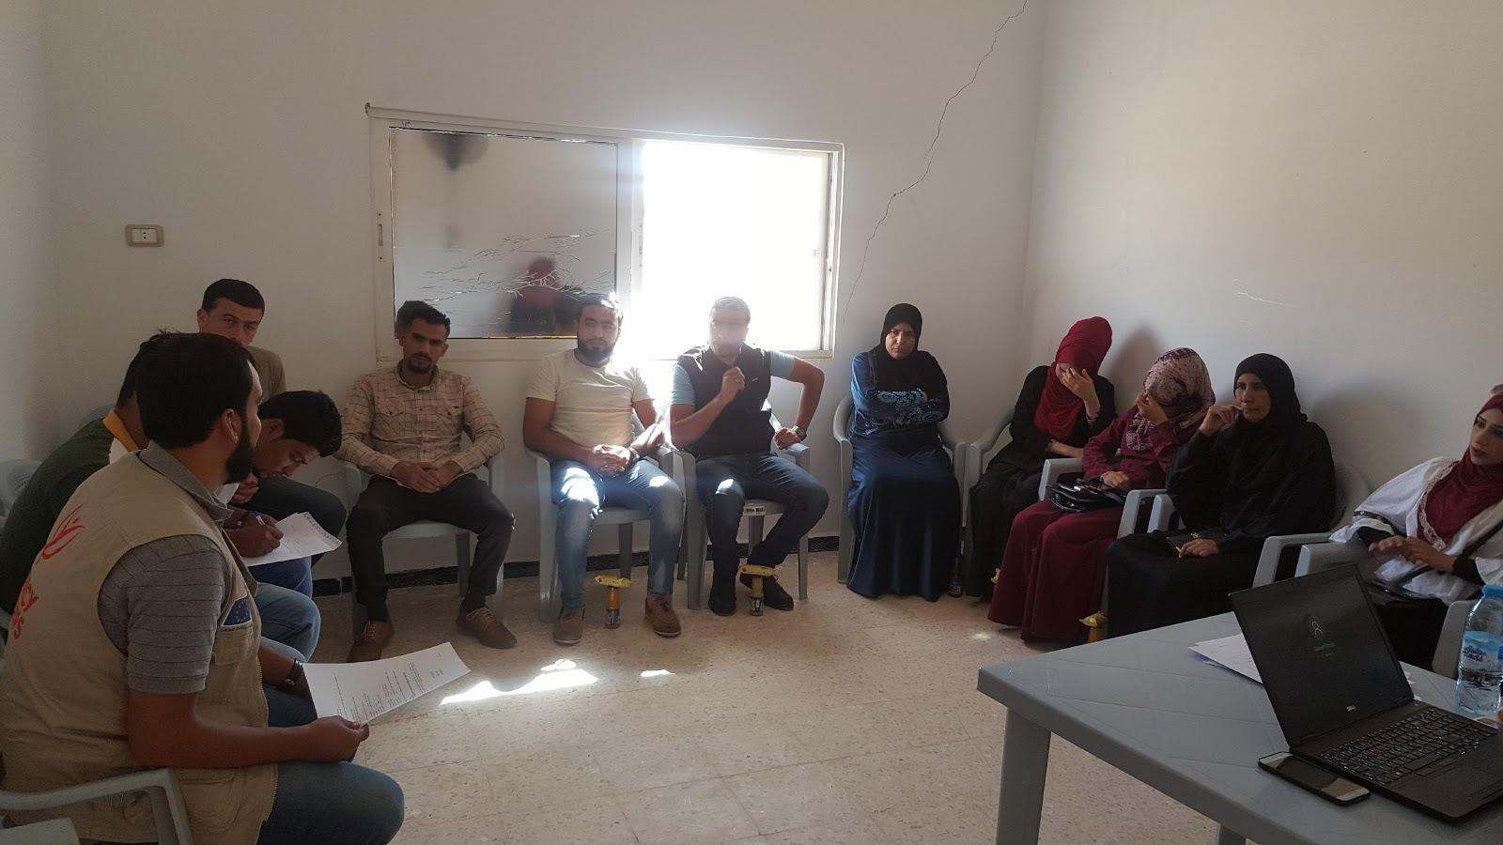
WATER INNOVATIONS TECHNOLOGIES (WIT)
Gender & Youth Analysis and Action Plan Report
Submission Date: October 26, 2017

Agreement Number: AID-278-A-17-00002
Contract/Agreement Period: March 23, 2017 to March 22, 2022
AOR Name: Evan Meyer, Water Resources and Environment Office, USAID/Jordan

Submitted by: Jeffrey Fredericks, Chief of Party
Mercy Corps
16, Samirra’ Street, Um Uthaina, Amman-Jordan
Tel: (+962 6) 554 8571/2
Email: jfredericks@mercycorps.org

Prepared by: Mai Abu Tarbush, Gender & Youth Consultant
Mercy Corps
Tel: (+962) 777610073
Email: abutarbushm@gmail.com

This document was produced for review and approval by the United States Agency for International Development / Jordan (USAID/Jordan). It was prepared by Mercy Corps. All photos are by Mercy Corps.

Contents

List of Table 4
Acronyms and Abbreviations 4
Summary 6
INTRODUCTION 7
Rationale for gender and youth integration in water sector 10
Objectives of the Gender and Youth Integration Plan 11
Who is responsible for implementing the Gender and Youth Integration Plan 11
USAID Gender Policy 12
Mercy Corps’ Gender Policy 12
Field work 14
Gender and Youth Analysis 16
Demographics of Program Area 16
Gender Survey Analysis and Findings 17
Profile of the Study Sample 17

Women Accessibility to Water Resources and Decision Making 18
Roles and Responsibilities in Household Water Management and Water Conservation 19
Access to Media/Social/Electronic Resources 21
Challenges women face in Water Sector 21

Opportunities for women in Water Sector 22
Youth Analysis 23
Profile of the Study Sample 23
Community Support in Water Sector 25
Access to Media/Social/Electronic Resources 26
Challenges Youth face in Water Sector 26
Opportunities for Youth in Water Sector 27
Gender and Youth Action Plan 29
Outcome #1: Increased adoption of water conservation technologies and practices by farmers, households, and communities 29
Outcome #2: Improved Access to finance for water conservation technologies 30
Outcome #3: Strengthened institution to further support water Conservation 30
Monitoring and Evaluation 34
Communication Plan 35
Annexes 35
Annex 1 – Women Door-to-Door Interview Questionnaire. 35
Annex II – Youth Door-to-Door Interview Questionnaire. 37
Annex III – Youth FGD’s Questionnaire 39
Annex IV – Women FGD’s Questionnaire. 41
Annex V – Publications: 45

List of Table
Table 1: Gender and Youth Assessment Summary 14
Table 2: Age Distribution in Gender and Youth Assessment 15
Table 3: Refugees Percentages Compared to Total Population in Northern Governorates 16
Table 4: Number of Women participants in D2D and FGD’s 17
Table 5: Number of Male/Female Participants in D2D Interviews and FGD’s 23
Table 6: FGD’s Participants Nationalities 24
Table 7: Youth Age Distribution in D2D Interviews and FGD's 24
Table 8: Gender and Youth Activities Entry Points and Action Plan 31

Acronyms and Abbreviations
WIT Water Innovation Technologies

D2D Door-to-door

FGD’s Focused Group Discussion

GYAP Gender and Youth Action Plan

USAID United States Agency for International Development

MFI’s Micro-finance Institutions

CBO’s Community Based Organization

SPSS Statistical Package for the Social Science

ToR Terms of Reference

SoW Scope of Work

JRF Jordan River Foundation

Summary
Women play an important role in water resource management and water conservation in Jordan. Governmental and non-governmental organizations alike have begun to involve local communities, especially women’s groups, in water resource management and water conservation activities.

Women’s participation in water management and water conservation programs were found to be highly effective in adopting and transferring knowledge of water conservation techniques to other community members, especially families, youth and children.

In March 2017, Mercy Corps launched the USAID funded Water Innovations Technologies (WIT) program. WIT is a five-year program that aims to conserve water in Jordan by increasing water efficiency in the agriculture sector, as well as at the community and household level.

The program goals are as follows:
- Increased adoption of water conservation technologies and practices by farmers, households, and communities.
- Improved access to financing for water conservation technologies
- Stronger institutional networks to further support water conservation.

To facilitate the project’s commitment to promoting gender and youth integration at all levels, Mercy Corps has conducted an initial Gender and Youth Assessment and then developed a Gender and Youth Analysis and Integration Action Plan, as required by USAID. The Gender and Youth Analysis and Action Plan was informed by the gender policies and guidelines of USAID and Mercy Corps.. This report analyzes the findings from the assessment and outlines the Gender and Youth Action Plan (GYAP) at the community, household and individual level.

The GYAP incorporate findings from the comprehensive gender and youth analyses; identifies a plan for regular, meaningful and inclusive consultations with women and young people; consolidates the findings and recommendations of project-specific gender and youth analyses; and delineates strategies for incorporating the findings of the gender and youth analyses into final project components.

INTRODUCTION
Jordan’s water scarcity has reached critical levels. The increased water demands of a rapidly modernizing society, coupled with the influx of Syrian refugees, has stressed Jordan’s already limited supplies. In some northern communities, water demand has quadrupled since the onset of the Syrian refugee crisis. Current unrest in Syria has resulted in a significant influx of Syrians to Jordan as of August 2014, the United Nations (UNHCR) had registered 619,000 refugees in Jordan, with over 80,000 registered in the refugee camp Za’atri.

Approximately 80 percent of Syrian refugees in Jordan live in urban areas in the north of Jordan, while the remaining 20 percent live in the Za’atari, Marjeeb al-Fahood, Cyber City and Al-Azraq camps.
Water conservation is critical, but in advance of price incentives and greater regulation, public and private sector entities urgently need an integrated effort to offer support and services to farmers, households and communities that facilitate the adoption of water-saving technologies.
The WIT program’s theory of change is based on the idea that engaging different stakeholders to systematically lower the barriers to adoption of water-saving technologies will help water-savings be achieved at scale and with permanence. The WIT theory of change puts the adoption of known and new water-savings technologies at the center of the program’s strategy: facilitating the uptake of financing and advisory services while using social marketing to overcome individual and institutional behavioral change barriers. We believe that market-based approaches have the greatest potential to lead to sustainable and scaled technology adoption and thus the greater conservation of water. WIT will target agriculture users in the North and the Jordan Valley (JV) and communities and households in the North who are hosting large numbers of Syrians.
Outcome 1: Water Conserved. WIT will improve access to water-saving technology for agricultural and household use by facilitating the supply of contextualized, cost-efficient and scalable technologies, effectively marketed and subsidized by private sector equipment suppliers. The program will establish networks of demonstration sites and early adopters to create permanent demand for technologies and build awareness of benefits such technologies offer. WIT will improve the capacity of public and private sector advisory services to sustainably provide technical support to those using the technologies. For households and communities, WIT will promote grey-water reuse, rainwater harvesting units, water-efficient fixtures, and other water management practices. Household interventions will target geographic areas hosting large numbers of Syrian refugees to improve water access and better manage the increasing tensions over water.
Outcome 2: Improved Access to Financing for Water Conservation Technologies. WIT will offer financing mechanisms to increase access to sustainable water-saving technologies at the farm, household and community levels. It will provide financing to several tiers of beneficiaries. Community Based Organizations (CBOs) will manage revolving loan funds so households can access small-scale technologies. To facilitate financing for farmers, WIT will work with commercial financing providers, including banks and Microfinance Institutions—MFIs, to design and market water-savings products, facilitate value-chain financing, and embed new financing options via technology suppliers. Small grants will enable communities to adopt water-savings technologies in public facilities. Occasionally, small grants will be used to incubate new water-saving technologies.
Outcome 3: Strengthened Institutions to Support Water Conservation. This final outcome will ensure the effective, lasting impact of WIT’s efforts. Looking beyond the duration of this program, WIT will sustain growth in water conservation across Jordan by strengthening governmental and non-governmental actors’ capacity to deliver, administer and oversee water networks and supplies. This includes the Ministry of Water and Irrigation (MWI), the Jordan Valley Authority and Water User Associations (WUAs), the Highland Water Forum (HWF), the Yarmouk Water Company (YWC), CBOs and the Royal Commission on Water. Coupled with improved capacity to monitor water use and benchmark progress.

WIT will collaborate with institutions such as the Water Demand Management Unit at the MWI, the projects department at the Ministry of Agriculture (MoA), the Ministry of Social Development (MoSD), and the Jordanian Cooperative Corporation (JCC) to ensure political, commercial and popular support throughout all stages of the program lifecycle, including design, implementation and learning. WIT’s Water Conservation Data Hub will collect real-time information on water use behaviors to continually inform water management decisions at the local, regional and national level, even beyond the program’s end. To promote permanent behavior change and adoption of new technologies, WIT will design and lead a national water conservation social marketing campaign that aims to entrepreneurial initiatives. The campaign will foster a “seeker's mentality”, rather than a” receiver's mentality”, encouraging engineers to innovate and contribute to the new cadre of water-saving technologies currently available in Jordan.
Background
Across cultures, women are very often the primary users of water in domestic consumption, subsistence agriculture, health and sanitation. Women generally take the primary role in educating children, in child and family health including sanitation and in caring for the ill or elderly, all of which have implications for the need for fresh water and access to reliable sanitation and wastewater disposal. Understanding gender roles helps plan water interventions and policies based on knowledge of how and why people make the choices they do in water use in order to meet their needs.

Women face barriers to technology adoption that are not always related to price sensitivity, such as access to information, irregular cash flows and consideration of household and personal security. Mercy Corps’ Tapped Out report found household-level water shortages were related to increased tension and domestic disputes, causing emotional and psychological stress for women. Thus, women will be the primary targeted beneficiaries of Outcome 1b activities. WIT will assist suppliers, finance providers and advisors to develop female-friendly marketing promotions that address women’s needs, motivations, lack of access to information, limits (placed on them by their income cycles) and desire for more personalized marketing (including personal testimonials).
Meaningful engagement of women and youth are critical to meeting program goals as they face unique barriers to adoption of water conservation technologies and equally represent opportunities to meet water conservation outcomes. It is essential to note that women and youth are not mutually exclusive audiences and gender inclusive programming inherently looks at the needs of communities from a sex and age perspective. As a result these audiences are obviously intertwined and interventions and language below assumes that programming through a gender lens aims for gender equity and as a result will include men, women, young women, young men and adolescent girls and boys. This therefore means that programming through a ‘youth lens’ requires age and sex disaggregation that applies to program design and programmatic outcomes.

Young people are also critical for programmatic outcomes, particularly sustainability outcomes - as youth will carry knowledge and practice forward to future generations. The population of Jordan is very young with over 70% of people under the age of 30. Of that number 22% are between 15 and 24. Due to sheer numbers this audience consumes considerable water resources and faces diverse barriers to uptake of new technologies. One barrier is a lack of knowledge and often resources. Young people developmentally are building their knowledge base through experience and near-scientifically have limited ability to assess the long-term impact of decisions made today. Therefore at this age, if young people are surrounded by hazardous conservation strategies they will carry these forward with into future. Alternatively if exposed to new technologies and ways of behaving they can alter their understanding and carry forward new conservation-based practices.

Young people also face considerable barriers in terms of accessing employment - and even more so in accessing employment that supports water conservation techniques and methods. The unemployment is chronically high in Jordan, hovering between 12.3 and 15.3 per cent, and seems to increase despite economic growth. Additionally young women face considerable barriers in accessing jobs. As a result the program will not only address the gap in skills for young people to access jobs in line with water conservation needs, but also expand jobs in this space that provide pathways for young women and young men to enter. Young people often face barriers to employment due to lack of skills and high levels of competition. As a result the program will provide training that matches the job market, linkages to employers and employment opportunities, advisory services, certification and internship placements.

WIT will consider the specific tools and channels to engage youth in behavior change campaigns, noting that they have cited experiential learning as the most effective means to engage them in conservation efforts. The program will work closely with JRF’s ongoing youth program for university students, which holds training camps for youth leaders on social topics with hands-on training and support for participants to bring the messages back to their communities.

On the agricultural side, a 2011 NCARE study revealed that women contribute up to 55% of labor for farm production. Yet their role in decision-making on farm technologies is often limited because they do not own the land. WIT will use community and CBO platforms to enhance their inputs on farm level technology adoption, especially in areas that have high potential for food processing, which can increase the role of women in influencing on-farm decisions. WIT will mandate at least 25% of targeted CBOs are women-led and at least 50% female membership.
To leverage existing programming and networks WIT will coordinate with regional and country level actors and working groups such as the No Lost Generation working group, of which Mercy Corps is a co-lead, livelihoods cluster, education and others as well as Mercy Corps’ youth portfolio of programming inclusive of GAC-funded 3 year youth and livelihoods initiative, the Dutch-funded ARC project, USAID’s Workforce Development programs, and the upcoming Youth Power program to ensure continuity of approaches, develop economies of scale, and share resources.
Rationale for gender and youth integration in water sector
The government of Jordan developed a policy level commitment to integrate gender and social considerations in their work. The Government of Jordan made national and international commitments to enhance the status of women within Jordan. Such policy commitments alone provide sufficient rationale for integrating gender into the work WIT Program. However, even in their absence, good practice and informed thinking would dictate that social and gender considerations are integrated throughout the life of this, or any water-related project.
Integrating a gender focus within water related projects consulting with men, women, and youth (inclusive of adolescent girls and boys) on their needs, seeking balanced employment and income-generation opportunities, ensuring space for participation in decision making and to derive equitable benefits – is both an economically effective as well as a rights-based approach, and in line with current international best practice. At the same time, it is well understood that failing to incorporate a consideration of different gender, social roles and levels of access to power and assets leads to replication of existing imbalances and at worst intensifies them.
Objectives of the Gender and Youth Integration Plan
The main objective of the Gender and Youth Integration Plan is to achieve gender and youth inclusive program results and develop targets for enhancing women’s and youth participation, representation, access to resources, and decision-making power, that are linked to program outputs, and can be amended based on field realities and incremental progress during program implementation. In addition, the plan is in place to ensure that beneficiaries are able to access and fully benefit from the program activities.

The GYAP will be implemented throughout the Program by addressing the following actions:
- Addressing knowledge and awareness of the rationale and practical tools for integrating gender and youth approaches into ongoing work through training (including for WIT Program and its consultants and partners as appropriate)
- Field visits and dialogue with community members inclusive of women and young people in the community will provide a useful source of ongoing feedback and input to guide GYAP implementation
- Cross-cutting mechanisms will be put in place within WIT Program to ensure women and youth input and involvement in, for example, the creation of SoW and ToR’s for WIT partners and in any of the Program frameworks
- Outreach and communication will take into consideration the sex and age of audiences to ensure uptake and accessibility.
- Any materials related to the program will underscore its commitment to gender equality and youth engagement
- Program reporting from, and to, WIT will contain a section on the progress and process of gender and youth integration, identifying emerging issues and lessons learned
- Ensuring gender integration and sensitivity are guidelines to shape activities that will meet the beneficiaries needs and overall objective of, mainstreaming gender within the WIT program as a cross cutting theme.
Who is responsible for implementing the Gender and Youth Integration Plan
WIT Project Gender Advisor, Youth Advisor, staff and Team Leads are responsible for the implementation, reporting and compliance with the GYAP.

Implementing Partners and Consultants must collaborate with WIT team leads to ensure that all sub components and activities under the program comply with the GYAP.
WIT Household Community Lead will have the key role for supervising and guiding the ongoing update of the GYAP and building the capacity and awareness amongst WIT staff and its partners on the GYAP purpose and implementation.

WIT Communication and Outreach Advisor and WIT Social Behavioral Change Advisor will have the prime responsibility to support promotion and awareness of the GYAP, and communicate results that arising from GYAP implementation into WIT communication plan.
WIT management and key staff will have ongoing role in complying with, contributing to and supporting the GYAP. In addition, track the specific gender and youth indicators to meet the intended gender and youth outcomes.
USAID Gender Policy
The United States Agency for International Development (USAID) has been active in the water sector in Jordan for many years, funding and executing projects throughout the country.
USAID’s gender policy, updated in March 2012, commits to integrating approaches that advance gender equality and women’s empowerment through an inclusive approach, partnership-building, harnessing science and technology to reduce gender gaps and addressing unique gender challenges in situations of conflict.
Mercy Corps’ Gender Policy
This gender and youth assessment seeks to fulfill the mandated Mercy Corps Gender Policy (2011) and recommend suggestions to align the project’s activities accordingly. As noted above Mercy Corps gender approach takes into consideration the unique needs of women, men, young girls and young boys and therefore aims to elevate the voices and unique needs of youth as a unique audience facing gendered barriers and opportunities. Mercy Corps recognizes that programs more effectively alleviate suffering, poverty and oppression when women, men, young girls and young boys are equitably engaged as active stakeholders in every aspect of the work that is carried out in collaboration with the communities it serves.
Accordingly, Mercy Corps developed a gender policy with a three-fold purpose:

- To confirm and communicate that gender equity is essential to its mission and vision for Change.
- To establish goals and principles for ensuring that gender equity is addressed consistently in all programs and organizational culture.
- To provide guidance on implementing the agency’s commitment to gender equity.

The recommendations in the proposed action plan are based on the gender and youth analysis. The program recommendations utilize the findings of the gender analysis to guide the programs and activities that the project will carry out in future to be aware of the gender sensitive considerations and the well-being of the men, women, youth, the disabled and other vulnerable groups- Jordanian and Syrian, it is seeking to serve in the communities it works in and to focus a gender lens of protection to those communities.

Methodology
The targeted groups are women, men, young girls and young boys in the northern governorates (Irbid, Mafraq, Jarash, Ajloun, and Azraq).
To prepare the baseline gender and youth analysis, and action plan recommendation, - it was recommended to use qualitative and quantitative research methodology with the following main steps:
- Reviewed program proposal, log frame and programmatic activities in depth.
- Completed a comprehensive analysis of existing data, studies, reviews, and reports.
- Conducted a participatory assessment through focus discussion groups and door-to-door interviews to understand and gather household and community level gender specific information.
Therefore, field work included:
- Door to Door (D2D) individual interviews which took place at the CBO’s premises. This was done to ensure participants safety, security and comfort throughout the assessment administration.
- Focus group discussions (FGD)
- Key informant semi-structured interviews
- Meeting with WIT Program senior management and key staff
The D2D interviews took place first, then followed by focus group discussion because of the nature of the D2D interviews Vs. FGD -open ended and close ended questions/initial collection of data and more in depth data collection. Each interview was planned to take 10 to 15 minutes in the first day at each governorate, then the same groups attended the FGD’s with additional invitees in the second day.

The FGD methodology for this assessment was added to the D2D interviews because the topic of gender has not been previously addressed by the project, and very minimum research was conducted out in the project areas from a gender perspective. Furthermore, the assessment will form a baseline on certain gender issues that will collect basic information and lay ground for future planning work on the Program. It will also help guide the gender and youth advisors to detect the gender gaps, a more gender lens approach and how activities can be contextualized to address the identified needs while ensuring no further harm.

The expected outcome of the gender and youth analysis and action plan will provide information that will guide the program strategy and program implementation decisions to integrate women and youth in program activities to ensure that USAID assistance makes the maximum optimal contribution to gender equality. This will also provide in-depth knowledge of gender and youth related issues within the sector, as well as providing practical recommendations to overcome gender and youth challenges, including defining the project-relevant gender challenges and opportunities; youth challenges and opportunities, and describing the best approaches for addressing both categories issues.

In order to accomplish these aims and allow the project to set gender and youth inclusive indicators, it was necessary to collect the household-level information, such as:

- Sex and age disaggregated data for both youth and women, in addition to the average income, and head of household.
- Women’s and men’s access to and control over water resources, including interaction with water providers.
- women’s and men’s access to finances and decision making processes within the household (and community)
- Gender differences between men and women roles and responsibilities, water conservation and water management at household and community level.
- Community support to gender and youth in water related issues
- Women and youth accessibility to media/social/electronic resources they can use to gather/share/communicate information and knowledge
- Challenges women and youth face in the water sector, and opportunities available for women in the water sector
- Cultural values at the household level that would constrain women’s benefitting from the project (for example, trainings, access to microfinance institution)
- Youth believe on gender differences between girls and boys in household roles and responsibilities, power dynamics and relation, decision making in-out the house, and over the financial decision inside the house.
- Employment opportunities available for youth in water sector.
Field work
The Jordan River Foundation was selected as an implementing partner during the data collection process, due to their extensive experience and capacity in this sector. JRF managed coordination with CBO’s in the field and supported participant identification. This is based on JRF reputation and familiarity in the field. All D2D interviews and - FGD’s meetings, collect data, and have all meetings arranged and hosted by the partners CBO’s. Table below illustrates a summary of related field work.

Table 1: Gender and Youth Assessment Summary
Gender and Youth Analysis Summary
Location | Women D2D Participants | No. of women FDG’s | No. of Women in FDG’s | Youth D2D Participants |  | No. of youth FDG’s | No. of Youth in FDG’s
 |  |  |  | Male | Female |  | Male | Female
Irbid | 26 | 4 | 61 | 10 | 19 | 4 | 13 | 15
Mafraq | 18 | 3 | 28 | 11 | 10 | 4 | 13 | 10
Jerash | 16 | 5 | 39 | 5 | 11 | 2 | 6 | 1
Ajloun | 18 | 3 | 26 | 9 | 9 | 4 | 9 | 26
Azraq | 17 | 4 | 42 | 23 | 13 | 2 | 17 | 0
 |  |  |  | 57 | 62 |  | 58 | 52
Total | 95 | 19 | 196 | 119 |  | 16 | 110

The total number of women participants in the D2D was 95, and 196 in the FGD’s, where total number of Youth participants in D2D was 119, and 110 in FGD’s distributed as shown in the above table. The total number of women, men and youth participants in the survey was 520.

Following is the age distribution amongst women and youth participants in both D2D interviews and FGD’s.

Table 2: Age Distribution in Gender and Youth Assessment
Age Group | Women D2D Participants | Women FGD’s Participants | Youth D2D Participants |  | Youth FGD’s Participants
 |  |  | Male | Female | Male | Female
18 - 28 | 25 | 59 | 48 | 50 | 48 | 50
29 - 38 | 30 | 58 | 6 | 6 | 6 | 6
39 - 49 | 28 | 53 | 3 | 5 | 3 | 5
50 and above | 12 | 23 | 0 | 1 | 0 | 1

As identified within the proposal target, youth between ages 15-24 were the focus however, much content was not within the assigned age group, where the data was used for the advantage of the report. Copy of the interview (annex I and II) and FGD (annex III and IV). Questionnaire used for both men, women and youth are attached.
The SPSS modeler was used as a supplement descriptive analyses to explore the data collected through interviews and FGD’s in greater depth.
It’s worth mentioning that this assessment and survey targeted families in the community at the household level only. Agriculture sector (farmers) were not a target under this study.

Gender and Youth Analysis

Demographics of Program Area
Jordan’s northern governorates (Irbid, Mafraq, Jarash, Ajloun, and Azraq) have been those most affected areas by the Syrian refugees’ reflux which increased the pressure on water resources and contributed to Jordan’s water scarcity. The increase in water demand necessitates the need for water conservation and water best management practices in agriculture sector, in community, and at household level. This reveals that water-saving devices, water recycling technologies, and water harvesting practices at the community and household level are crucial and present the best option for water-saving and water conservation. It support the need for behavioral change towards water management at both levels.

Below table summarizes refugees percentages compared to the total population in those governorates.

Table 3: Refugees Percentages Compared to Total Population in Northern Governorates
Governorate | Jordanian |  | Non-Jordanian |  | Total
 | Population | % | Population | % | Population | %
Irbid | 1,316,618 | 19.91 | 453,540 | 15.54 | 1,770,158 | 18.57
Mafraq | 314,164 | 4.75 | 235,784 | 8.08 | 549,984 | 5.77
Jerash | 167,751 | 2.54 | 69,308 | 2.38 | 237,059 | 2.49
Ajlun | 157,162 | 2.38 | 18,918 | 0.65 | 176,080 | 1.85
Zarqa (including Azraq Camp) | 923,652 | 13.97 | 441,226 | 15.12 | 1,364,878 | 14.32

Below data shows some important identifications to take based on DOS Census for 2015:
- Total population of Jordan is 9,531,712 with 96.4% Jordanian and 30% Non-Jordanian (Half of them Syrian Refugees).
- Irbid, Mafraq and Ajloun are the highest in jobs difficulties with nearly 3% increase more than other governorate.
- The men to women economic participation and involvement is 71 % to 21% respectively.
- The family size median number is almost 5 per family
- Syrian’s distribution amongst the northern governorates is (Irbid 27.14%, Mafraq 16.43%, and Jarash 0.86%)

Gender Survey Analysis and Findings
Profile of the Study Sample

Table 4: Number of Women participants in D2D and FGD’s
Gender Analysis Summary
Location | Women D2D Participants | No. of women FDG’s | No. of Women in FDG’s
Irbid | 26 | 4 | 61
Mafraq | 18 | 3 | 28
Jerash | 16 | 5 | 39
Ajloun | 18 | 3 | 26
Azraq | 17 | 4 | 42
Total | 95 | 19 | 196

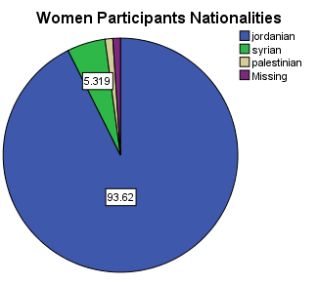
Ninety-five women participated in study (88 Jordanians, and 5 Syrians) in D2D interviews, and 196 women participated in the FGD’s.
Despite the fact that the northern governorates have high influx of refugees and Syrian families, Syrian women participation in the D2D interviews was low (5%) because, as CBO’s stated, they were concerned to participate because they believe that it will not be accepted by the Jordanian women, and therefore create tension between neighbors in the community. However, Syrian women participation was 11.3% in the FGD’s (159 Jordanians and 37 Syrians).

Although, 77% of the women reported that the male is the head of the house with 23 % female headed household, Irbid governorate household sample showed difference with almost 50% female household headed compared to 19% male household headed.

According to the Survey findings, the average Households income per month varies between 200 and 300 JDs.

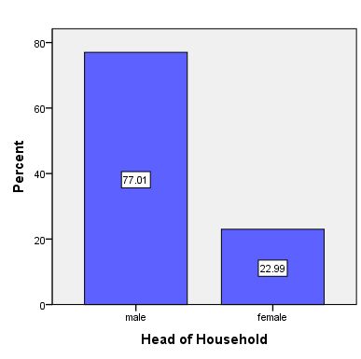
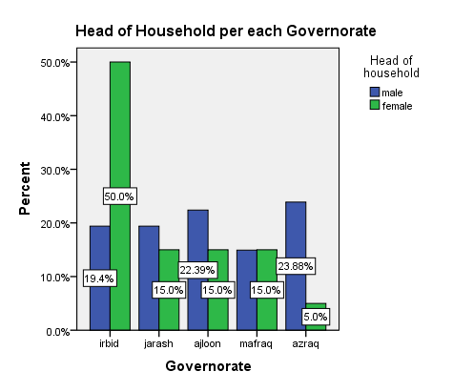
Women Accessibility to Water Resources and Decision Making
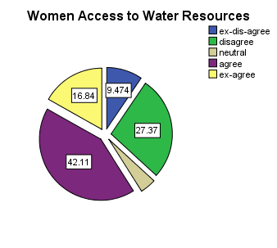
60 % of the participants in the D2D interviews, and in the FGD’s stated that women have equal rights and access to water, and have more control on water use because they spend most of their time at home.
Women in the FGD’s stated having one water day per week – except for Azraq (receives 24 hours, 7days a week), and the time of the water supply is about 12 hours running from afternoon until the morning of the next day.

All participants met during the field survey have at least one water tank located on the roof, and may buy extra water by tankers at an average cost of 3 to 5 JD per meter cube when supplies run low, or when they run out of water.

None of the participants reported to have tank for rainwater harvesting or for gray water recycling at home. They do some water conservation practices such as limiting the number of showers per week and reducing the frequency of cleaning at the house to the minimum as possible.

Roles and Responsibilities in Household Water Management and Water Conservation
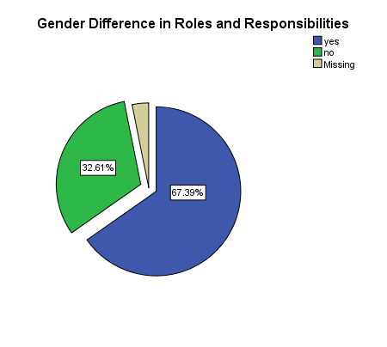
In FGD’s, and D2D interviews, women indicated a difference in gender division of labor with regards to household water. Almost 70% agreed that there are difference between men and women roles and responsibilities at the household level because women are responsible for cleaning, cooking, washing, and for the house hygiene. While they gave equal influence to power dynamic and control over water use.

Power Dynamic
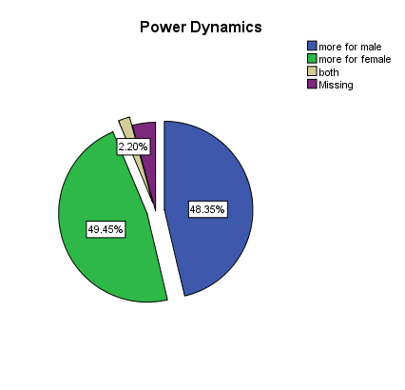
As for control over water related issues and decision making, women stated that it’s equally shared between men and women. Men reported usually being the ones who would call in outside services, such as maintenance and repair, though many women also reported doing this as necessary.

Financial Inclusion
In terms of financial decision and financial inclusion, 55% of women stated that the financial responsibility, including who pays the water bill or who actually does the payment at the service provider office, - is both men and women responsibility at home, 31.5% stated that it’s mainly men responsibility, and 13 % stated that its female responsibility.

The FGD’s n revealed that participants have lack of trust in the service provider, and have mixed perceptions towards service, and on the water supply service in general.
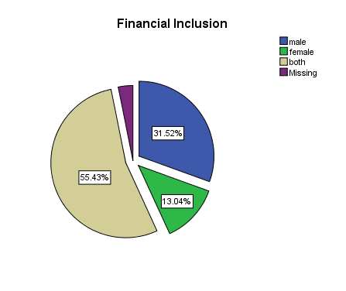
Moreover, participants have expressed their dissatisfaction with the services provided in terms of:

- Week flow, which requires using pumps most of the time to have water reach the tanks on the roofs.
- Not responsive when issues are raised
- Limited hours of supply, mostly during the night
- Management and administration malfunction

Community Support in Water Sector
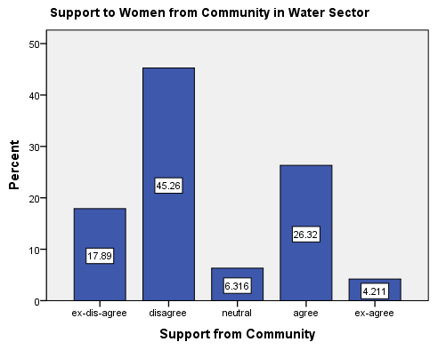
In D2D interviews, almost 63% of women participants said that there are no any means of support from the community in water sector. They have never been invited to attend any training or awareness session on water conservation, water-saving technologies or water management.
This finding supports the Market Assessment Survey findings that was conducted by Mercy Corps WIT project in August, 2017. It supports that the main constraints identified critical to household water conservation in the northern governorates are:
- Lack of information on water efficient practices, behaviors, and impacts.
- Lack of knowledge, awareness on water-saving devices and water supply, recycling technologies.
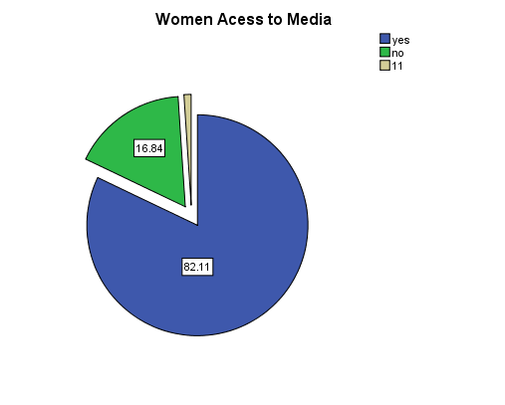
Access to Media/Social/Electronic Resources
Women participants and focused group discussions indicated that they have good/ sufficient access to social media, electronic resources (ex. TV, Radio, and mobile phones.) and that they can freely share and communicate information and knowledge. WhatsApp and Facebook were amongst the highest used social media.

It’s worth mentioning that almost all women participated in the interviews and focused group discussion have smart mobile phone devices which supports accessibility to the networks and social media

Challenges women face in Water Sector
The majority of women participants (82%) agreed that there are challenges that women face in the water sector in Jordan such as:

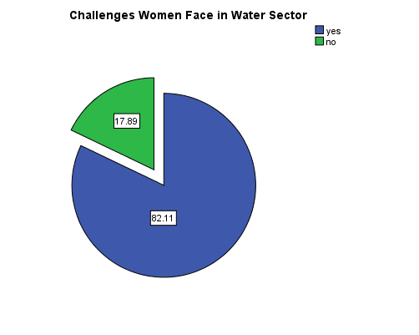
- Water shortage reported to be the main challenge faced by women and other family members at the household level.
- Limited hours of water supply.
- Limited employment opportunities for women in water sector with men being dominating the sector, ex. field engineers, field researchers, etc.
- High prices of external water tanks.
- Lack of knowledge on water conservation practices i.e. water-saving devices and water technologies, and water harvesting techniques. This finding align with what was concluded by the Market Assessment Survey.

Opportunities for women in Water Sector
Women participated in the interviews and in the FGD’s indicated explicitly that there are potential opportunities for women in the water sector in the following areas:

- Training and awareness related to water conservation practices and techniques
- Working as field researchers due to their presence in the geographic location.
- Employment opportunities at service provider offices and facilities
- Plumbing and maintenance courses.

Youth Analysis
Profile of the Study Sample
Total number of youth participants in D2D interviews is 112 (52 male, 60 female), and 110 participated in the focused group discussions distributed as shown in the table below:

Table 5: Number of Male/Female Participants in D2D Interviews and FGD’s
Location | Youth D2D Participants |  | No. of youth FDG’s | No. of Youth in FDG’s
 | Male | Female |  | Male | Female
Irbid | 10 | 19 | 4 | 13 | 15
Mafraq | 11 | 10 | 4 | 13 | 10
Jerash | 5 | 11 | 2 | 6 | 1
Ajlun | 9 | 9 | 4 | 9 | 26
Azraq | 23 | 13 | 2 | 17 | 0
 | 57 | 62 |  | 58 | 52
Total | 119 |  | 16 | 110

Among youth Syrian males showed higher participation rates than the Syrian females, 57% to 43% respectively while the Jordanian youth participation was the opposite with 55% male participation and 45% female.

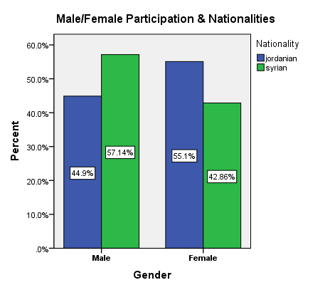
Table 6: FGD’s Participants Nationalities
Nationality | Male | Female
Jordanian | 44 | 52
Syrian | 8 | 6
Total | 52 | 58
95% of the male participants, and 71% of female participants fall in range of 18 to 28. This supports WIT program targeted group as set by USAID Jordan definition of youth.

Table 7: Youth Age Distribution in D2D Interviews and FGD's
Age Distribution | D2D Interviews |  |  | FGD’s Interviews
 | Male | Female | Total | Male | Female | Total
18 – 28 | 48 | 50 | 98 | 55 | 43 | 101
29 – 38 | 6 | 6 | 12 | 0 | 5 | 5
39 – 49 | 3 | 5 | 8 | 0 | 5 | 5
50 and above | 0 | 1 | 1 | 0 | 0 | 0
Total | 57 | 62 | 119 | 55 | 53 | 111

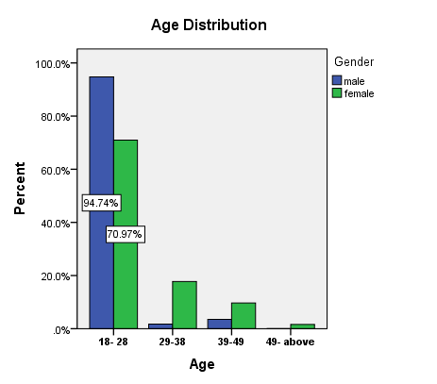

Roles and Responsibilities in Household Water Management and Water Conservation

Sixty-eight percent of youth agreed that women have more role and responsibilities at home because they do the cleaning, cooking, washing and taking care of the children.

However, there are some responsibilities that fall on men shoulders related to simple maintenance at home, washing cars, and managing any outside issues related to water at the household level.

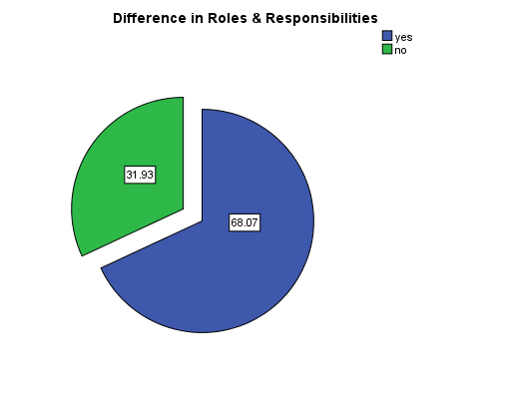
Men are more capable of doing work that requires strong physical interaction, i.e. cleaning the water roof tanks and fixing leaking pipes, but yet there are some roles that require mutual agreement between both men and women, i.e. buying water by external tankers, buying drinking water etc.

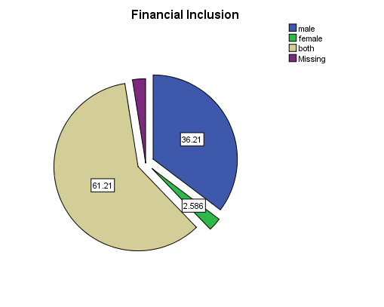
Financial Inclusion.

61 % of the youth participants indicated that the financial inclusion and financial responsibility is mutual between men and women at the household level. Other, 36% indicated that its men responsibility, and only 2.5% indicated that it’s women's responsibility.
In the FGD’s, both males and females, stated that woman could help sometime she has job, and can support water related decisions that have financial impact, such as paying the water bills.

Control and Influence

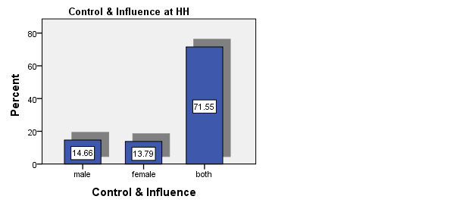
72% of youth (both males and females) agreed that women and men share the control and influence on water management within the house. During the FGD’s, they explained that the reason behind that is because women have better role and responsibility inside the house as a result of being responsible for doing the daily work at home while men have more control on the outside water related issues.
Community Support in Water Sector
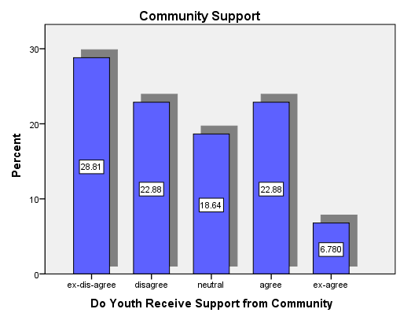
Most of the participants in D2D interviews (52% males and females youth) stated that there is no any community support related to water sector. No courses or awareness sessions on water conservation or water savings were provided related to the field. Another 30% stated that they have heard incidentally through media about water conservation and water management practices

During the FGD’s, females youth indicated that females are usually not allowed to attend public events and, therefore they have never heard about such things.

Participants added that this could be improved by advertising campaigns and initiatives through the CBO’s and NGO’s in the community.

Access to Media/Social/Electronic Resources

As the case in the women analysis above, youth highly indicated (86% both males and females) having access to social media and electronic resources like TV, radio, and mobile phones.
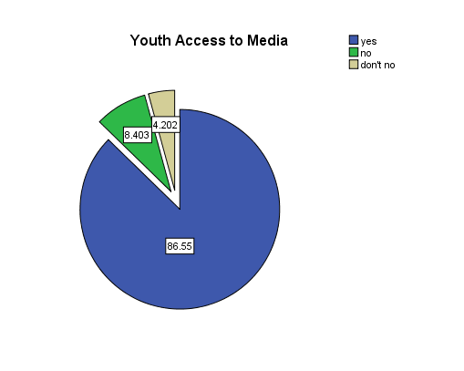
The majority of them agreed that Facebook, YouTube, and WhatsApp are amongst the highest in use.

In the FGD’s, youth added that social and digital media can be a powerful resource to support water sector initiatives. For example it could support advertising, coaching, and educating on issues related to the water sector and water resource management.
Challenges Youth face in Water Sector
Youth D2D interviews showed that 68% believed that youth face many challenges in the water sector, with 13.5% saying no challenges, and 18.5% don’t know whether there are challenges or not.

FGD’s revealed that the groups that said “no” and ‘’don’t know’’ in the D2D did not understand the question, or were lacking the knowledge and the information on water-related issues, and therefore later were involved in the FGD’s because more elaboration was given on each related question. The challenges were raised by the youth are stated below:
- Youth concerns and worries are not taken seriously by the community and the society in general.
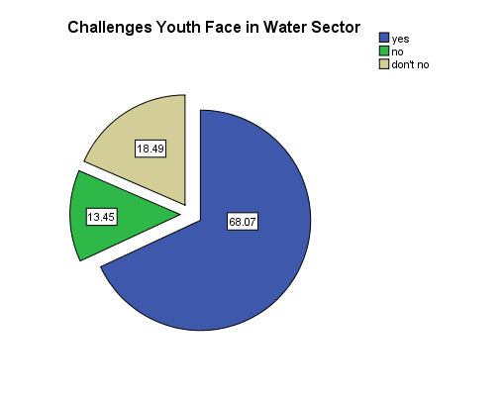
- Water shortage in Jordan is a crucial problem that every house faces. There is only one day of water supply per week with limited hours of supply
- High water consumption at HH level, specifically mentioned in Ajloun and Azraq.
- Lack of employment opportunities in general, and in water sector in specific. Jobs are mainly available in the cities of Amman and Zarqa. Employment depends on personal relations not on the individual qualifications.

- Lack of knowledge and awareness in water best practices and techniques.
- Women stated that they are not accepted to work in the water sector as field engineers, researchers, or similar type of jobs as with women in Amman city.
- Abuse of natural water resources available in areas like Ajloun by over-extraction and pollution..
- Society is male dominant and depends on male capability more than female in such field especially outside the house.
- High water prices for external water supplies by tankers.
- Lack of experience on water management practices, water-saving devices, and water recycling techniques.
- Poor water service, and weak response to water related claims. Service is not provided at the right time and the right cost.
- Difficulty in paying the water bills. Cost of transportation to reach the offices where bills can be paid is a burden.
- Service provider administration malfunction
- Difficulty in buying drinking water, not much shops available in the area of Azraq.
- No finance support to water related SME’s that might open opportunities for employment amongst youth.
Opportunities for Youth in Water Sector

Youth forms the biggest group of the society, and the most active one, therefore, should be targeted in a greater appropriate way.

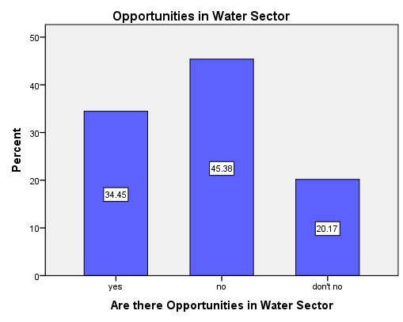
- CBO’s and NGO’s have critical role towards building the capacity of the youths in the society, therefore their role and responsibilities should be enhanced and maximized to support youth in areas related to water conservation, water harvesting, and water-saving techniques.
- Youth can help create new web-based and mobile phone-based applications to support water related initiatives and water awareness and informational campaigns.

Gender and Youth Action Plan
The Gender and Youth Action Plan is an integral part of the program and will be adopted to promote gender equity and equality, and youth involvement that is directly linked to overall project outcomes.

This document will also be used to mainstream gender and youth as a cross cutting theme. Also, will act as a strong contributor to identifying gaps and concerns (gender and youth) which will help the team and the advisor contextualize and shape the activities and actions to meet and address women and youth needs. However, also focusing on men. It will also assist in placing gender related indicators that will be used throughout the project, as well as provide us with better understanding of what is actually happening, what are the perceptions, where should we focus, what should we look forward to etc.

This section will identify opportunities and provide guidance on how to ensure a gender lens that addresses the unique barriers and opportunities faced by women and youth.
Outcome #1: Increased adoption of water conservation technologies and practices by farmers, households, and communities
Women play critical role in transmitting messages on water conservation and effective management to family and community members. Involving both women and men in water resources management and water conservation messaging will increase project effectiveness and efficiency. In addition young people are often the first to adopt new technologies and are best positioned to transfer messages to their peers, or younger youth. Therefore engaging young people in the design of youth-specific messaging will have a broad impact and link to program sustainability.

The key entry points identified under this outcome are:

- Promote Equal Employment opportunities for women and men to ensure complying with USAID Gender Policy (2012), Mercy Corps Gender Policy, and to be used by all consultants, retailer, supplier, etc.
- Promote indirect employment opportunities for women and youth by building the capacity of the CBO’s in water management practices and water conservation and by involving the market actors like retailers and materials suppliers in supporting CBO’s within the communities of the targeted geographic areas as part of women empowerment, and women and youth integration.
- Promote equal responsibilities of men and women in household water management and water conservation related activities by dispersing water management/conservation responsibilities to men, women and young people.
- Ensure participation of women and youth in the consultative process.
- Build capacity of youth to serve as leaders in the community to demonstrate and promote uptake of new technologies - as early adopters and adept social media users.
- Ensures that gender and youth related issues will be the primary considerations in the design of the activities and messages to be developed and implemented during the communication campaign.
- To include gender and youth specific information in all progress and annual reports, disaggregated by sex, age and geographic location.
- Implement affirmative measures for promotion of women and youth at decision-making level, awareness raising or support programs.
- Provide tailored trainings and educational courses on water conservation practices, rain water harvesting, and gray water reuse and recycling techniques - taking into account age and sex of audience
Outcome #2: Improved Access to finance for water conservation technologies
Enable women to access economic opportunities and microfinance programs that are linked to water conservation and water-saving outcomes.

The key entry points identified under this outcome are:

- Promote equal employment opportunities for women and men on any related activities
- Provide/develop pathways for young people to access employment opportunities linked to water conservation and management (internships, apprenticeships job shadowing and training)
- Include youth-led labor market assessment linked to water conservation market
- Include private sector training opportunities to introduce youth and women to market opportunities and develop networks as a way to address issues of WASTA/access to opportunities
- Ensure activities are sex and age appropriate for participants (women, youth - boys and girls)
- Work with CBO’s to support the MFI’s activities at HH and community level
- Work with young people, in particular, to leverage social media and electronic resources for messaging and interacting with the community.
- Provide assistance in developing and mainstreaming a gender participatory approach to encourage women and youth to access MFIs.
Outcome #3: Strengthened institution to further support water Conservation
The key entry points identified under this outcome are:

- Review gender related policy at the institution level (Water Service Providers)
- Institutional Capacity Building for service providers
- Build the capacity of service providers by organize specialized trainings for specialists responsible for elaboration of local plans and specialists who are involved in providing these services.
- Ensure content and materials are youth-friendly and engaging and leverage media outlets frequently used by young people (tv, youtube, instagram, facebook, among others)
- Work with youth to lead peer to peer educational campaigns, awareness sessions on water conservation and water management practices.
WIT Gender and Youth Action Plan:
Table 8: Gender and Youth Activities Entry Points and Action Plan
Program Activity | Gender & Youth Entry Points | Action Required
Outcome #1 Increased adoption of water conservation technologies and practices by farmers, households, and communities | Promote Equal Employment opportunities for women and men on any related activities | - Prepare a guidelines for the recruitment process to ensure complying with USAID Gender Policy (2012), and to be used by all consultants, retailer, supplier, etc.  - Make sure that all WIT Program job advertisements explicitly state that “Equal opportunities for Male and Female applicants”.
 | Promote indirect women's employment opportunities by supporting CBO’s | - Educate CBO’s and real market actors on the important role played by both women and youth (in HH, schools, and universities) in achieving the program objectives and goals.
 | Promote equal responsibilities of men and women in household water management and water conservation related activities. | - Ensures that men and women responsibilities will be the primary considerations in the design of the activities and massages to be developed and implemented during the communication and outreach campaign.
 | Ensure women and youth participation in the consultative process | - Introduce quotas and slogans in outreach and training programs, such as: “30% women’s and 30% youth participation”.
 | Gender information will be included in all progress and annual reports | - Ensure that all reported data and information are disaggregated by sex and geographic location.
 | Promotion of women and youth at decision-making level. | - Awareness raising or support programs to integrate women and youth in decision making level.  - Implement affirmative indicators and measures for monitoring women and youth integration.  - Build capacity of youth to serve as leaders in the community to demonstrate and promote uptake of new technologies - as early adopters and adept social media users.
 | Encourage the use of water-saving and conservation devices, rainwater harvesting, and water recycling and reuse techniques at the HH level. | - Market Actors to provide trainings and educational courses on water conservation practices, rainwater harvesting, and grey water reuse and recycling techniques.  - Provide technical training on simple plumbing and maintenance of such devices.
Component 2: Improved Access to finance for water conservation technologies | Promote Equal Employment opportunities for women and men on any related activities | - Prepare a guidelines for the recruitment process to ensure complying with USAID Gender Policy (2012), and to be used by all Micro Financing Institutes (MFI’s)  - Make sure that all WIT Program job advertisements related to implementation of the MFI’s Mechanism explicitly state that “Equal opportunities for Male and Female applicants”.  - Provide/develop pathways for young people to access employment opportunities linked to water conservation and management (internships, apprenticeships job shadowing and training)  - Ensure activities are sex and age appropriate for participants (women, youth - boys and girls)
 | Utilize CBO’s and market actors to support the MFI’s activities at HH and Communities. | - Build CBOs’ capacities in the micro financing related activities such as water management practices and water conservation and, by involving the market actors like retailers and materials suppliers in supporting CBO’s within the communities of the targeted geographic areas as part of women empowerment, and women and youth integration.  - Support CBO’s and market actors to assure the accessibility of both women and youth to the MFI’s activities.
 | Access to social media and electronic resources | - Enhance the adoption of the e-wallet application (e-fawateer).  - Encourage youth initiative in designing web-based and smart phone based applications.
 | Include youth-led labor market assessment linked to water conservation market | - Include private sector training opportunities to introduce youth and women to market opportunities and develop networks as a way to address issues of WASTA/access to opportunities  - Work with young people, in particular, to leverage social media and electronic resources for messaging and interacting with the community.  - Provide assistance in developing and mainstreaming a gender participatory approach to encourage women and youth to access MFIs.
Component 3: Strengthened institution to further support water Conservation | Review gender related policy at the institution level (Water Service Providers) | - Ensure gender and youth equity and equality in employment, and that policies are gender sensitive. Review gender related policy at the institution level (Water Service Providers)  - Ensure content and materials are youth-friendly and engaging and leverage media outlets frequently used by young people (tv, youtube, instagram, facebook, among others)
 | Institutional Capacity Building for service providers | - Organize specialized trainings for specialists responsible for elaboration of local plans and specialists who are involved in providing these services.  - Educational campaigns, awareness sessions on water conservation and water management practices.  - Build the capacity of service providers by organize specialized trainings for specialists responsible for elaboration of local plans and specialists who are involved in providing these services.  - Work with youth to lead peer to peer educational campaigns, awareness sessions on water conservation and water management practices.
Monitoring and Evaluation
The Monitoring and evaluation plan will include indicators and data that are age and gender disaggregated on both male and female level, and will identify gender related issues during the process of implementation throughout the entire duration of the project. The gender related indicators within the M&E reports should be reflected at both operations and results level.

Communication Plan
WIT Program communication plan and outreach campaign have to be gender and youth sensitive. They should reflect gender integration and youth involvement in all program branding as well as operational activities.

Annexes
Annex 1 – Women Door-to-Door Interview Questionnaire.
Name Signature_________________
Age
Average income
Employment / Unemployment
Head of House Hold (Female / Male)
Address
Contact information

Introduction:
Hi, my name is________ and I work with Mercy Corps / JRF. We are in the process of collecting information from random selection on water usage and conservation and how can we find solutions to Jordan water concern. May I take a maximum of 10-15 minutes of your time? The provided information will only be used for the purpose of this project survey, and it will remain confidential. Please feel free to stop me at any time if you do not want to proceed, or if you want more clarification on any of the mentioned below questions.

I do not mind USAID- Water Innovations Technologies (WIT) / MC to contact me again for FGD and/or for any other related recommended work for the project purposes.

Questions for door to door interviews for the USAID WIT Project
Target: Women
Topic: Water

Question 1: Do you believe women have equal rights and access to water resources and services?

- Strongly Disagree
- Disagree
- Neither agree or disagree
- Agree
- Strongly Agree

Question 2: Who does better better than women as leaders, decision makers, persons with responsibilities, and as individuals within the community?

- Male
- Female
- Both
- Based on Experience

Question 3: Are there gender difference between women and men?

- Household roles and responsibilities (Yes/ No)
- Men have more Power / Women have more Power
- Decision making (in-out house)
- Financial Inclusion (Men / Women / Both)
- Control and influence making

Question 4: Do you receive support within your community? Do you have a good supportive network they can depend on?

- Strongly Disagree
- Disagree
- Neither agree or disagree
- Agree
- Strongly Agree
Question 5: Do you connect with communities and societies in water sector other than your direct interactions?

- Yes
- No

Question 6: Do women have access to media/social/electronic resources they can use to gather/share/communicate information and knowledge?

- Yes, name them
- No

Question 7: Are there challenges women face in the water sector?

- Yes
- No

Question 8: Are there opportunities available women for in the water sector?

- Yes
- No

Comments:____________________________________________________________________________________________________________________________________________________________________________________________________________

Thank you for taking the time to answer the questions asked. Do you have any further inquiries? Would it be possible to contact you again for a FGD (explain) this coming week? You will be contacted. This session will help us gather more information relevant to our work. I appreciate your honesty and time.

Thank you again

Participate in the FGD (YES / NO)

Annex II – Youth Door-to-Door Interview Questionnaire.
Name
Age
Nationality
Working / Not working
Address
Contact information

Introduction:
Hi, my name is________ and I work with Mercy Corps / JRF. We are in the process of collecting information from random selection on water usage and conservation and how can we find solutions to Jordan water concern. May I take a maximum of 10-15 minutes of your time? The provided information will only be used for the purpose of this project survey, and it will remain confidential. Please feel free to stop me at any time if you do not want to proceed, and/or if you want more clarification on any of the mentioned below questions.

I do not mind USAID- WIT / MC to contact me again for FGD and for any other related recommended work for the project purposes.

Questions for door to door interviews for the USAID WIT Project
Target: Youth
Topic: Water
Question 1: Are there gender difference between girls and boys?

- Household roles and responsibilities
- Power dynamics and relations
- Decision making (in-out house)
- Financial Inclusion
- Control and influence making

Question 2: Do youth receive support within their community? Do they have a good supportive network they can depend on?

- Strongly Disagree
- Disagree
- Neither agree or disagree
- Agree
- Strongly Agree
Question 3: Do youth connect with communities and societies other than their direct interactions?

- Yes
- No
- I do not know

Question 4: Do youth have access to media/social/electronic resources they can use to gather/share/communicate information and knowledge?

- Yes, name them
- No
- I do not know

Question5: Are there challenges youth face in the water sector?

- Yes
- No
- I do not know

Question 6: Are there opportunities youth find in the water sector?

- Yes
- No
- I don’t know

Comments:______________________________________________________________________________________________________________________________________________________________________________________________________________________________________________________

Thank you for taking the time to answer the questions asked. Do you have any further inquiries? Would it be possible to contact you again for a FGD (explain) this coming week? You will be contacted. This session will help us gather more information relevant to our work. I appreciate your honesty and time. Thank you again
Participate in the FGD (YES / NO)

Annex III – Youth FGD’s Questionnaire
Name Signature___________________________________
Age
Nationality
Working / Not working
Address
Contact information

Introduction:
Hi, my name is________ and I work with Mercy Corps / JRF. We are in the process of collecting information from random selection on water usage and conservation and how was can find solutions to Jordan water concern. May I take a maximum of 10-15 minutes of your time? Your information will only be used for the purpose of this project, and I will remain confidential. Please feel free to stop me at any time if you do not want to proceed, and if you want more information on any of the mentioned below questions.

I do not mind USAID- Water Innovations Technologies (WIT) / MC to contact me again for FGD and other related recommended work for the project purposes.

Questions for Focus Group Discussion Session for the USAID WIT Project
Target: Youth
Topic: Water
Question 1: Are there gender difference between girls and boys

- Household roles and responsibilities

- Power dynamics and relations

- Decision making (in-out house)

- Financial Inclusion

- Control and influence making

**Explain each section and identify these differences further than yes and no**

Question 2: Do youth receive support within their community? Do they have a good supportive network they can depend on?

- Strongly Disagree
- Disagree
- Neither agree or disagree
- Agree
- Strongly Agree
How and from where can this be accessed? What can be done in order to strengthen communication network within the youth’s communities?

Question 3: Do youth connect with communities and societies other than their direct interactions?

- Yes, how?

- No, why? (barriers and challenges) Culture acceptance?

Question 4: Do youth have access to media/social/electronic resources they can use to gather/share/communicate information and knowledge

- Yes, name them (how do they access them?)

- No, why? (barriers, challenges, culture understandings? Taboo? Access?)

Question 5: Are there challenges youth face in the water sector?

- Yes (name them with details on how are they seen as a challenges)

- No (why? Was this issue tackled?)

Question6: Are there opportunities youth face in the water sector?

- Yes (name them with details on how are they seen as an opportunity)

- No

Question 7: define your community from a youth perspective

Question8: How do you see youth playing an important role within the community to allow change to take place from water usage and conserving perspective?

Question9: Why should we work alongside with youth? What advantages will it bring the community if we start young?

Comments:______________________________________________________________________________________________________________________________________________________________________________________________________________________________________________________

Thank you for taking the time to answer the questions asked. Do you have any further inquiries? You will be contacted for further information if needed. This session helped us gather more information relevant to our work. I appreciate your honesty and time. Thank you again
Participate in further work related to WIT-USAID / MC and JRF (YES / NO)

Annex IV – Women FGD’s Questionnaire.
Name
Address
Contact information

Introduction:
Hi, my name is________ and I work with Mercy Corps / JRF. We are in the process of collecting information from random selection on water usage and conservation and how was can find solutions to Jordan water concern. May I take a maximum of 10-15 minutes of your time? Your information will only be used for the purpose of this project, and it will remain confidential. If the time is not suitable now, would you prefer I visit you on another time and date (if participant says no)? Please feel free to stop me at any time if you do not want to proceed, and if you want more information on any of the mentioned below questions.
I hereby consent to share my information for the purpose of the project.

I do not mind USAID- Water Innovations Technologies (WIT) / MC to contact me again for FGD and other related recommended work for the project purposes.

Sample Questions for Focus Group Discussion session for the USAID WIT Project
Target: Women
Topic: Water
Question 1: Women should have equal rights and access to water resources and services ** count number of answers to each and identify reasons for answers**

- Strongly Disagree

- Disagree

- Neither agree or disagree

- Agree

- Strongly Agree

Explain why this would be significant in women life:

Question 2: On a whole, men do better than women as leaders, decision makers, persons with responsibilities, and as individuals within the community? ** count number of answers to each and identify reasons for answers**

- Strongly Disagree

- Disagree

- Neither agree or disagree

- Agree

- Strongly agree

Explain: why is this perception as identified

Question 3: Are there gender difference between women and men
** identify under each selected answer why it is perceived as such / count and document number of answers per section**

- Household roles and responsibilities

- Power dynamics and relations

- Decision making (in-out house)

- Financial Inclusion

- Control and influence making

Question 4: Do women receive support within their community? Do they have a good supportive network they can depend on? ** count number of answers to each and identify reasons for answers**

- Strongly Disagree

- Disagree

- Neither agree or disagree

- Agree

- Strongly Agree

Explain why it is perceived as such

Question 5: Do women connect with communities and societies other than their direct interactions?

- Yes (how- and if possible, how did it start and evolve)

- No (why? Barriers? Challenges? Cultural understandings and constraints?)

Question 6: Do women have access to media/social/electronic resources they can use to gather/share/communicate information and knowledge

- Yes, name them (how- if possible, how did it start and evolve)

- No (why? Barriers? Challenges? Cultural understandings and constraints?)

Question 7: Are there challenges women face in the water sector?

- Yes (name them- how are they seen as challenges)

- No (did the community overcome any?)

Question 8: Are there opportunities women face in the water sector?

- Yes (name them, how are they seen as opportunities?)

- No (why? What is restricting)

Questions 9: Can we and how can we overcome the challenges women are facing within their communities?

Questions 10: How can we increase women’s access and employment to water usage and conservation?

Question 11: How can we increase women ability to decision make while working at farms and water sectors? (discussion women participation and ownership – limitations?

Question 12: Do we need to increase women skills and knowledge when it comes to working with water?

Question 13: What can women do? What can women not do?

Comments:______________________________________________________________________________________________________________________________________________________________________________________________________________________________________________________

Thank you for taking the time to answer the questions asked. Do you have any further inquiries? Would it be possible to contact you again for a FGD (explain) this coming week? You will be contacted. This session will help us gather more information relevant to our work. I appreciate your honesty and time. Thank you again
Participate in the FGD (YES / NO).

Mainstreaming Gender in Water Management, version 2.1, November 2006, UNDP
Mainstreaming Gender in Water Management, version 2.1, November 2006, UNDP
Gender and Water: Mainstreaming gender equality in water, hygiene and sanitation interventions. Swiss Agency for Development and Cooperation
http://www.jo.undp.org/content/jordan/en/home/countryinfo.html
https://www.amazon.com/Teenage-Brain-Neuroscientists-Survival-Adolescents/dp/0062067850
http://www.greengrowthknowledge.org/sites/default/files/downloads/resource/Green_Economy_Jordan_UNEP.pdf
http://www.jo.undp.org/content/jordan/en/home/countryinfo.html)
Social and Gender Integration Plan, Millennium Challenge Account-Jordan, 2015
Gender Equality and Female Empowerment Policy, USAID. March 2012
population and housing census, 2015, conducted by Department of Statistics (DOS)
Total numbers do not add because some of the participants did not fill in the required field in the questionnaire

