Problem Tree Exercise
What is a Problem Tree? A diagram that provides an overview of known causes and effects of an identified problem.
Why create a problem tree? There is often more than one cause to a problem. A problem tree helps identify the context in which a project, Activity, or intervention is to be implemented. Combined with contextual analysis, the problem tree can help better understand the problem, and also help break the problem down into more manageable and definable issues to address.
Steps:
- Discuss an issue to address with your project/Activity.
- Determine the core problem
  - Brainstorm and list problems related to your chosen issue on sticky notes.
  - Place sticky notes on the flip chart or wall.
  - Discuss and determine within your group what seems to be the core problem behind the issue
    - Select/define a core problem that your project/activity will address.
      - Be specific! A vague or broad problem will have too many causes for a project/activity to meaningfully address.
- Place the core problem in the center of the paper or wall.
- Arrange direct causes of the problem below the core problem
- Arrange direct effects of the problem above the core problem
- Draw lines between the core problem and its causes (below) and effects (above) to illustrate how each cause or effect is linked to the core problem or together

*Problem trees are often closely linked to “objective” or “solution” trees to help identify interventions.

Problem Tree Examples:
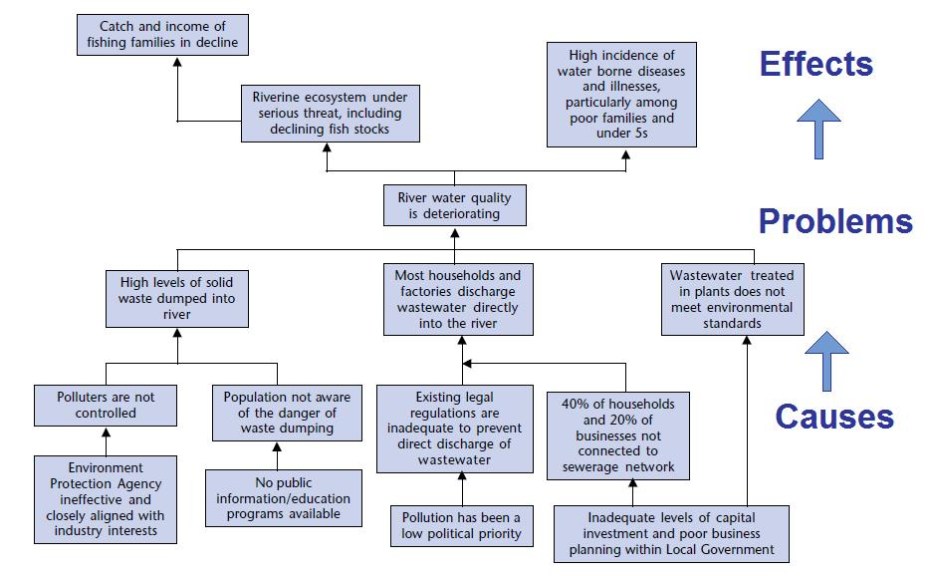
Source: European Commission (2004) https://www.sswm.info/humanitarian-crises/prolonged-encampments/planning-process-tools/decision-making-tools/problem-tree-analysis

