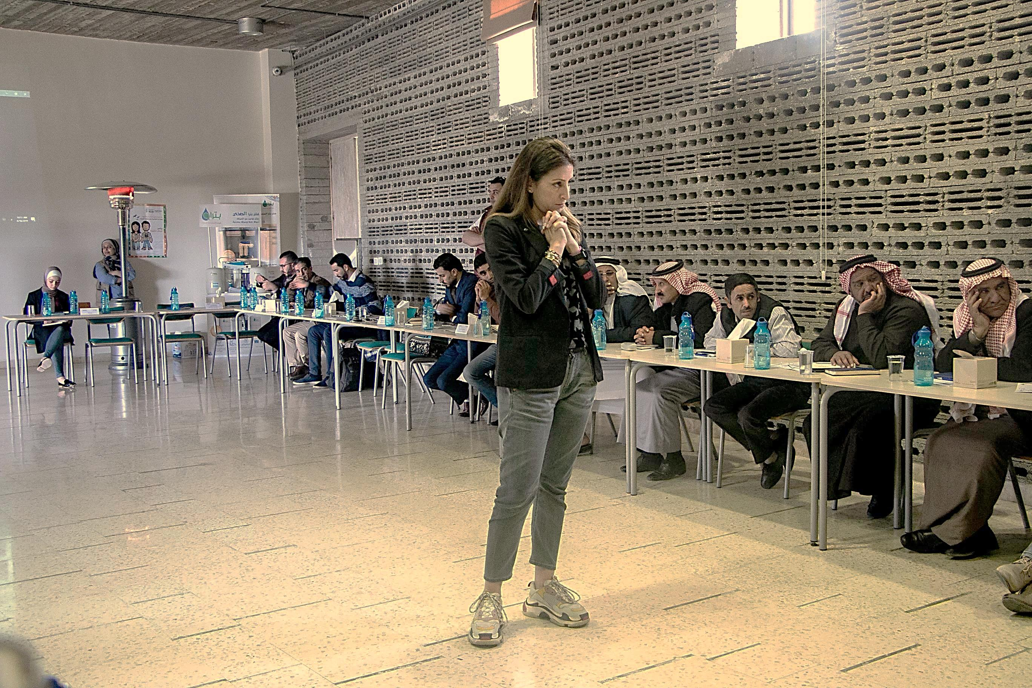

Business to Business network event
  - HH Technolgies Suppliers, Contractors and CBOs

18TH April 2019

Introduction
Business to business networking event’s aim is to bridge and link between market actors (suppliers, CBOs/point of sales) who might have the interest in investing in water sector in the targeted areas. In this regard, WIT previously made the effort of identifying household technologies suppliers through two different approaches (investment fund and market assessments).
The second B2B event was held on April 18, 2019, where total participants reached 42 (17 CBO and five water saving technologies suppliers representing 23 Male & 19 Female) combined between CBOs and suppliers.

Objectives
The aim of the event is to bring together Market actors to achieve the following:
- Linking the CBOs with the household suppliers and contractors to create new business opportunities
- Introducing the contractors and suppliers to the CBOs Having a full day event would have provided more time for suppliers to answer more questions coming from the community (CBOs).
- Addressing and responding to the CBOs technical questions about the Water saving technologies and devices.
- Defining the role of the CBOs as a point of sale

Workshop Outcomes
All five suppliers presented their water saving products using power point presentation, illustration model, broshures and leaflets. Community based organizations (CBOs) were curious to ask suppliers regarding technical issues based on feedback coming from their communities and interested beneficiaries who are interested in adopting certin technologies.
Noting that suppliers showed willingness to visit each invidual HH in order to assess the HH sitiuation and provide price offer that do not exceed the ceiling price, which was submitted by the suppliers in the selection phase request for quotations.

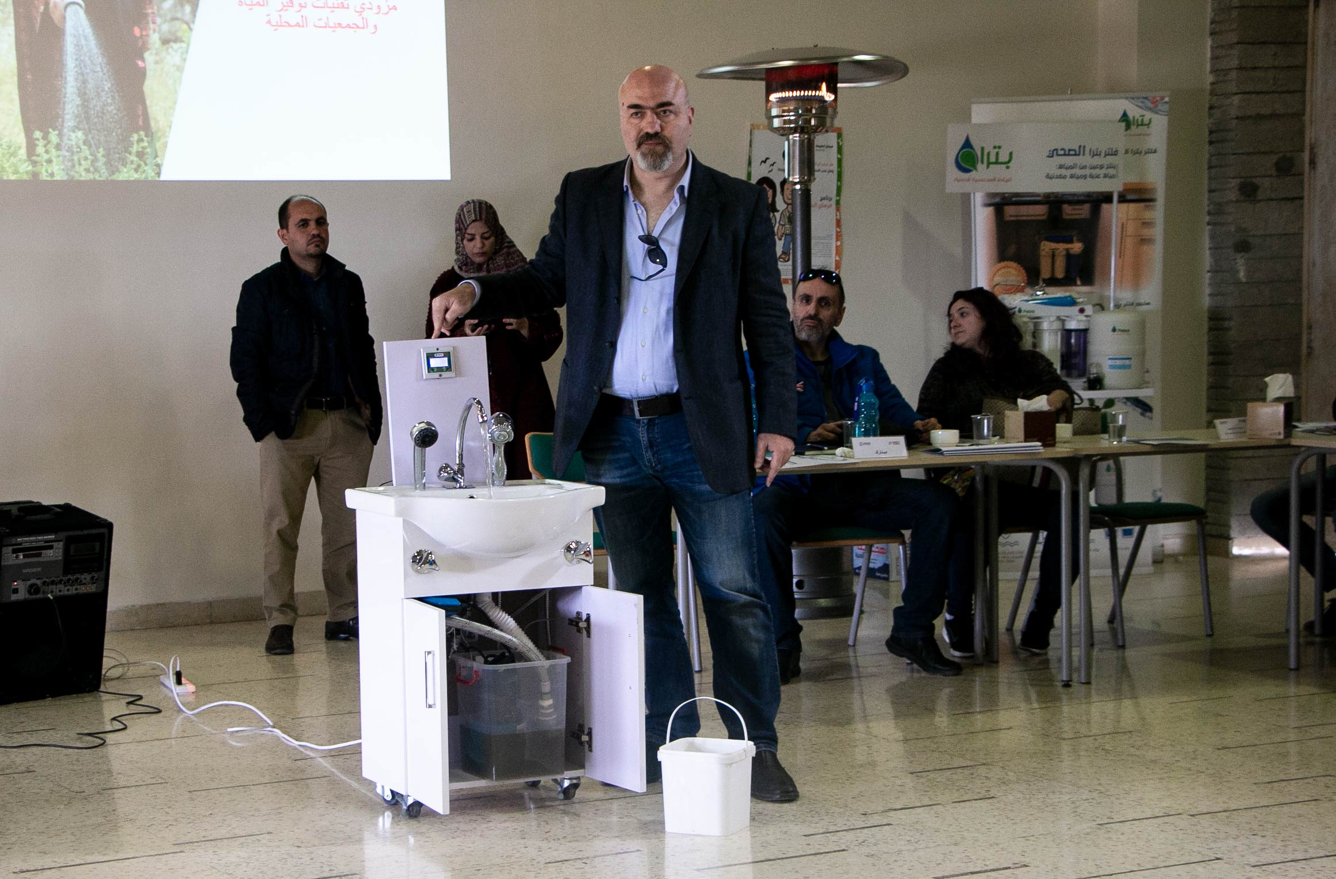
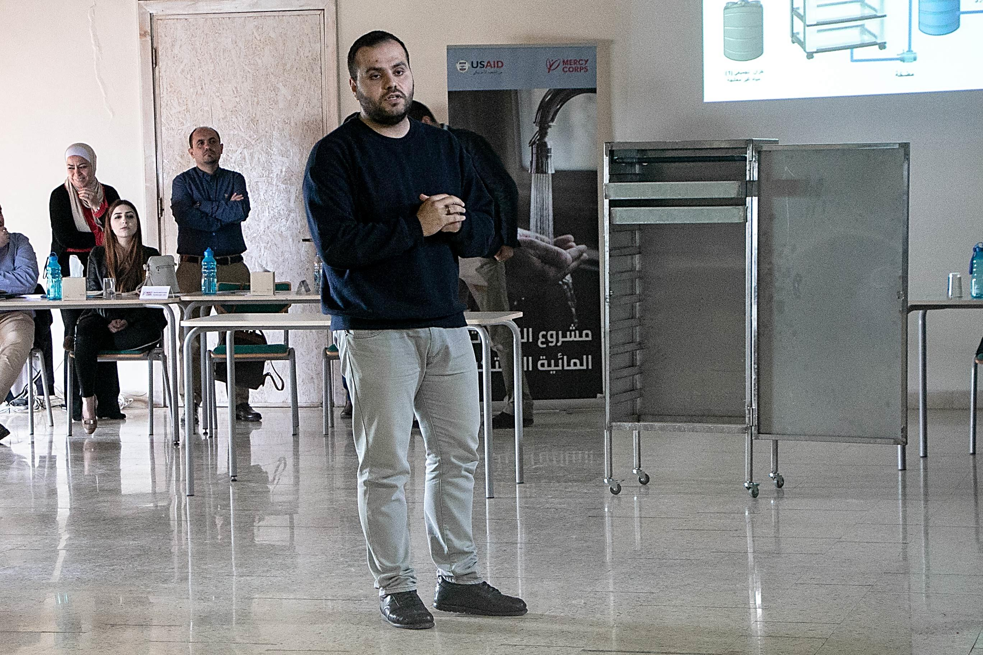
Bringing illustration models for the technologies allowed CBOs to have a clear vision of the products they are to promot for the technologies (RO Filters, WSD, Grey water reuse system, a sample of the plastic tanks material).

There were companies who need to have sales points in the targeted region in order to have their products available in the market of Mafraq and Ajloun, hence Al-Aman Company collected a list of interested CBOs who are willing to be a point of sale in order to promote and sell Al-Aman water saving devices (Areators, Showerheads and toilet).
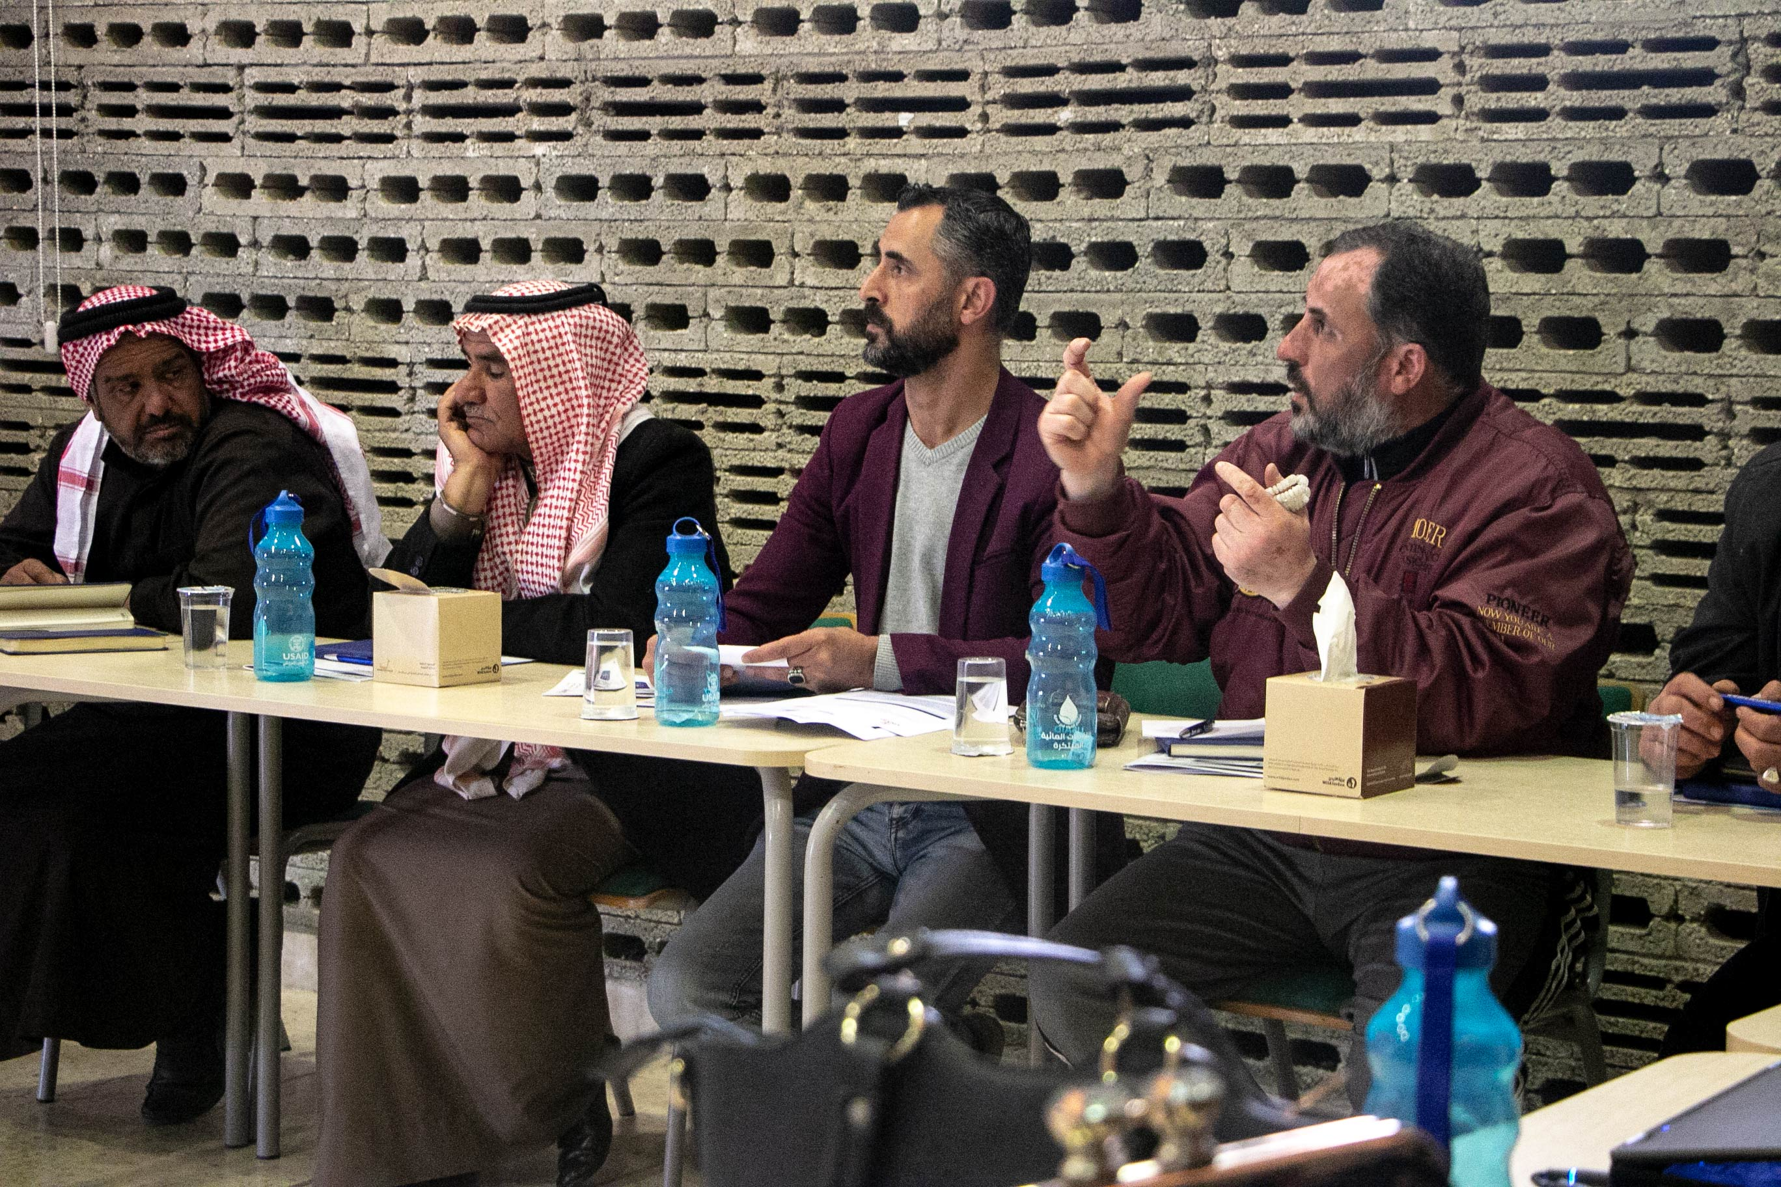
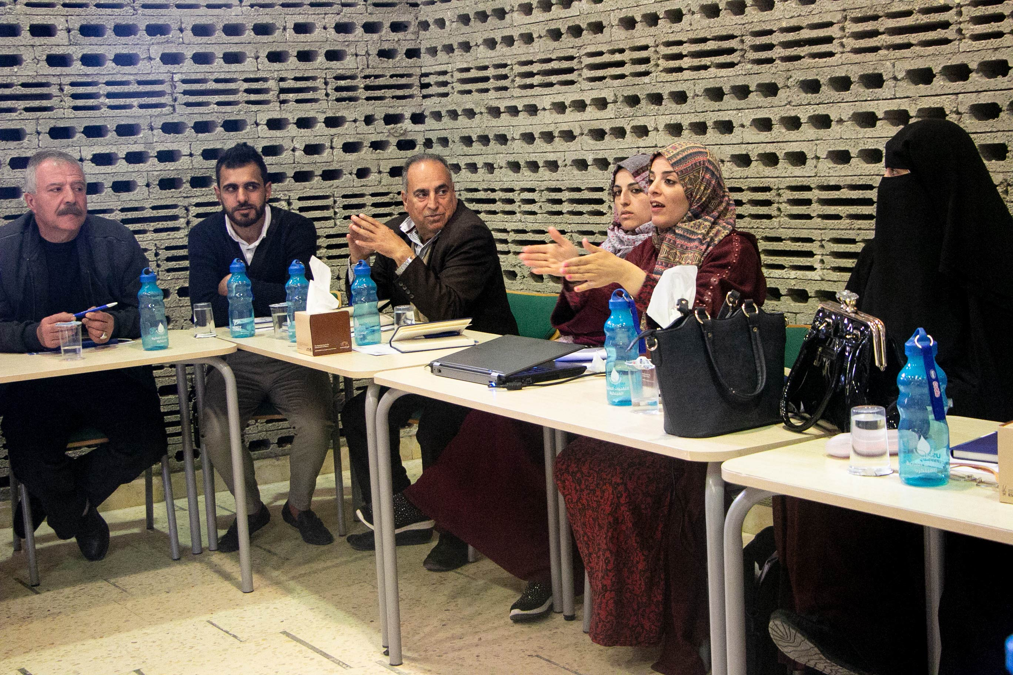
Community based organizations (CBOs) were very interested to have the companies’ products in their CBO base. Knowing that after conducting awareness sessions for the communities they receive requests from attendees on where to find water saving devices (WSD). In addition having the technologies at their CBO facility will help to sell the WSD and make the WSD availbale right after the sessions.
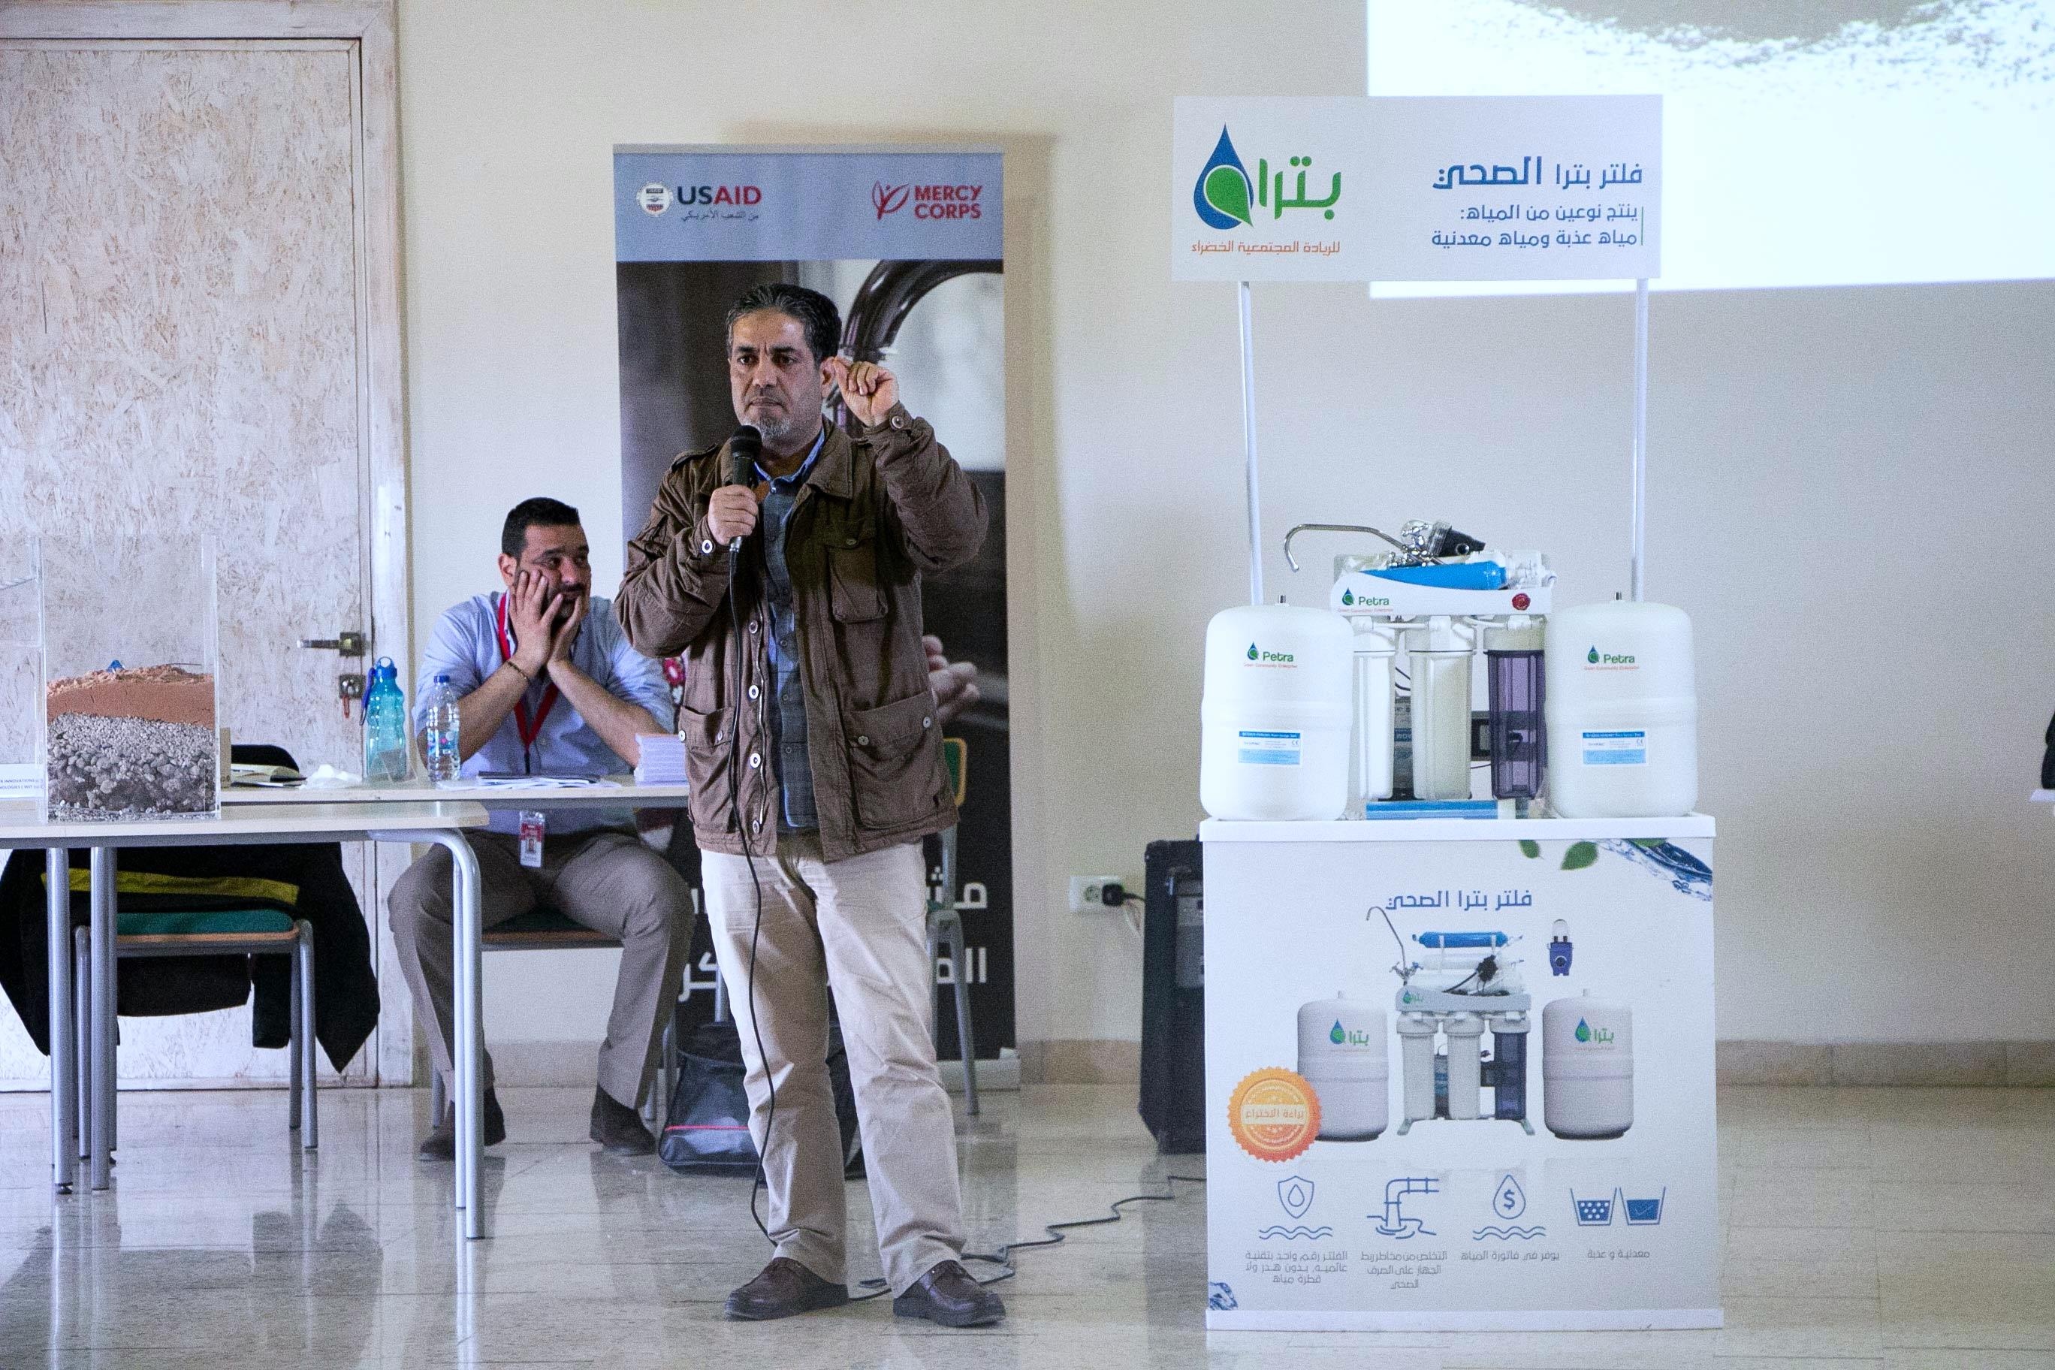
The RO filters supplier (Petra green co.) was able to engage the paricipants in a random selection for 25 household winners from Irbid who will win free RO filter installation. The company initiated a creative action by implementing one of the investment fund activities. Which includes installation of demos in HHs, but for the fact that none of the attendees are from Irbid, petra green added another five filters (out of the demos) to be installed at the CBOs representative HH to reconcile the participants whose origins from Mafraq and Ajloun. The CBOs can support in marketing and promoting the filters in their areas, as they will be point of sales.

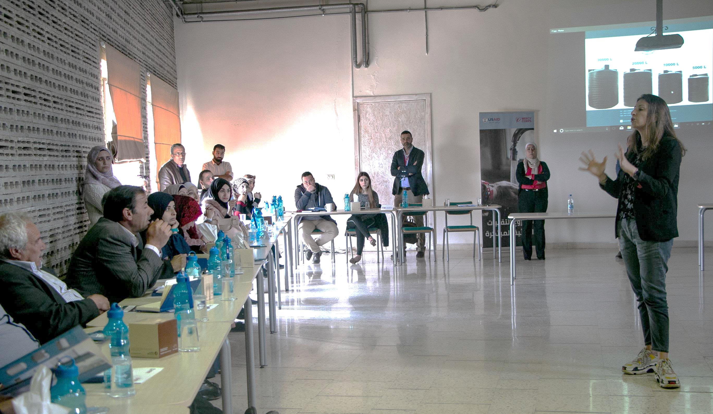
Nonetheless, the plastic tanks supplier received many technical questions because the community are not used to such technology, which is using polyethylene tanks for rainwater catchment. This was a good opportunity to have the plastic tanks suppliers to prove the efficiency of the tanks with evidence based tests that the tanks are tested and could be installed underground and there will be no effect on the water quality as long as the tanks are well insulated against humidity and sunlight.
Dinarak (Digital financing entity) took the chance to open E-Wallets for the suppliers on the spot for all also provided CBOs with a book that help the CBOs to open E-Wallets for beneficiaries. Knowing that money transference for revolving loans will be through E-Wallets.

Lessons learned
- Although suppliers were prepared and they have made their best to illustrate and explain the technologies, but early invitation would have given the supplier more time to prepare and provide better presentation content.
- For the next B2B event, the team should revise the presentation to make sure the presentations are focuseing on technologies’ specifications and technicalities.
- Having a full day event would have provided more time for suppliers to answer more questions coming from the community (CBOs).
- For the effectiveness of workshop, it is preferable to separate old CBOs that have full knowledge about the project and water saving technologies from new CBOs that do not have the same level of knowledge.

Follow Up
- Follow up on the developed linkages between CBOs and Al-Aman Company
- Facilitate visits for suppliers to the individual HHs who are interested to assess and provide price quotation
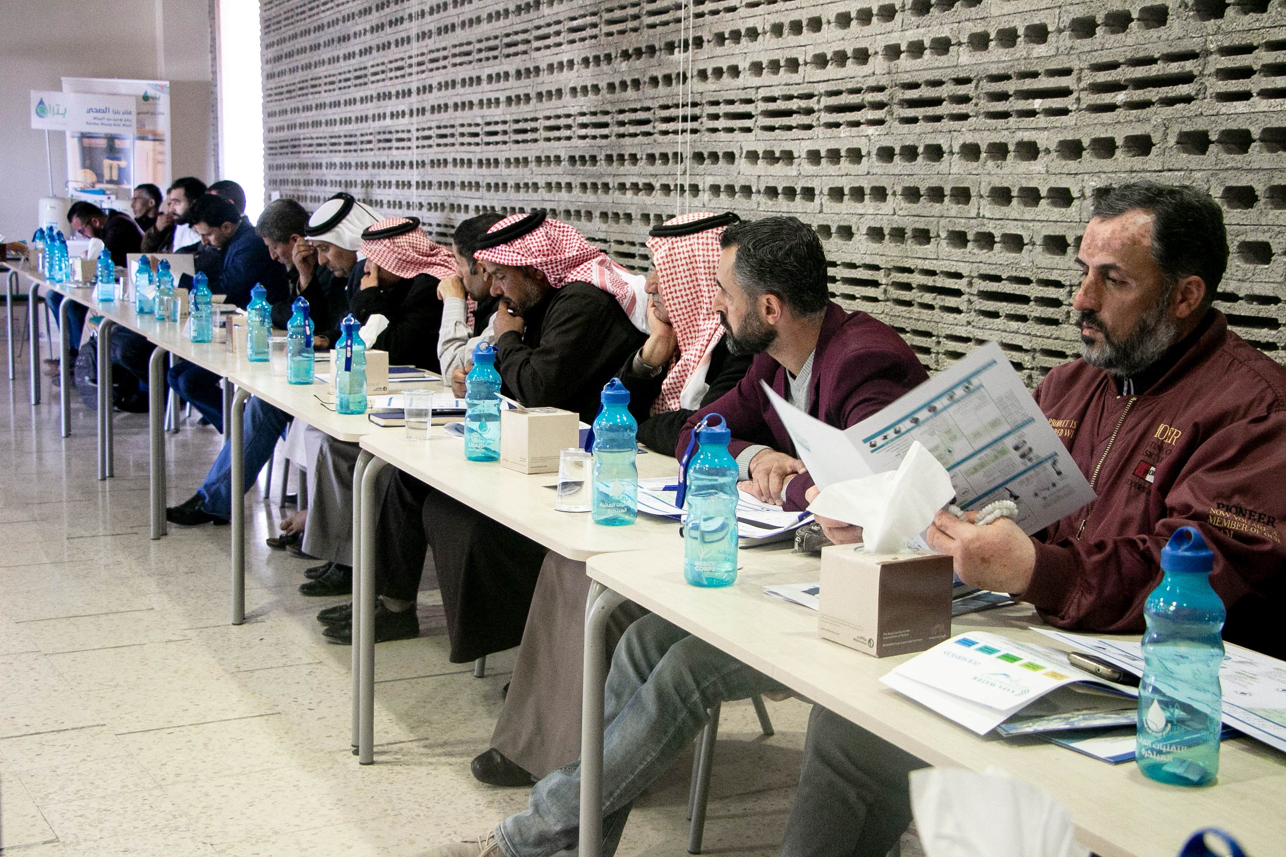
Conclusion
The event was successful and it achieved the set goal of having this kind of event, as CBOs/ distributors expressed their satisfaction in term of having the needed information directly from the suppliers where most of the community’s quiries answered and fulfiled by the suppliers. On the other hand, suppliers were able to observe the need from the community side which inturn prove that there is high demand in the targeted areas (Mafraq and Ajloun).

Having the project partners (RSS and JRF) was helpful as RSS were part of testing and certifying the supplier’s technologies and JRF were responsible to select CBOs and conduct the trainings that also included water technical part conducted by RSS. In addition, it was a good collaboration and sharing the knowledge with partners so that all parties being on the same page in term of understanding supply and demand side in the targeted areas.

Annex 1: Agenda

Annex 2: Attendance sheet

