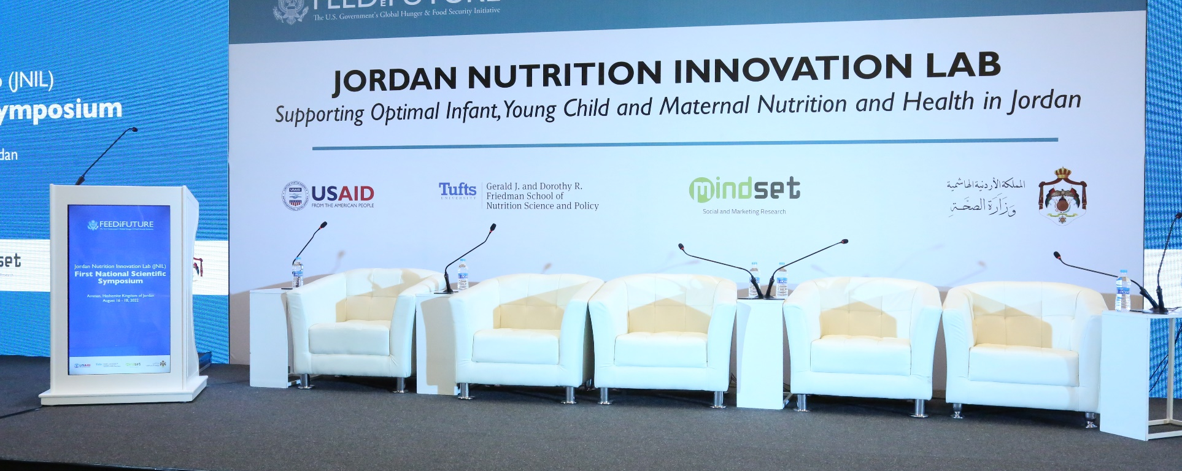

Photo credit: Bidaya

jordan nutrition innovation lab

supporting optimal infant, young child and maternal nutrition and health

BACKGROUND
The Jordan Nutrition Innovation Lab (JNIL) is funded by the United States Agency for International Development (USAID) Jordan and is as part of the Feed the Future Innovation Lab for Nutrition at Tufts University. As one of over 20 Feed the Future Innovation Labs, the Nutrition Innovation Lab pursued applied research, built institutional capacity for analysis and policy formulation in developing countries, and supported individual and institutional capacity development through training and formal education. Tufts University’s Friedman School of Nutrition Science and Policy served as the Management Entity for the Nutrition Innovation Lab from 2010 through 2021. The Jordan Nutrition Innovation Lab was an associate award of the Lab and will continue through 2026.
GOALS
JNIL aims to generate evidence on the impact of the USAID-supported Community Health and Nutrition (CHN) program and build academic capacity to support research on optimal health and nutritional status of pregnant and lactating women (PLW) and children under two in Jordan. JNIL is achieving these objectives through rigorous research and capacity building activities in the realm of maternal and infant young child nutrition (MIYCN).

intermediate results 1
As part of its research activities, JNIL implements a comprehensive evaluation of the impact, process and performance, and sustainability of the USAID CHN program. JNIL also conducts analyses to ascertain determinants of breastfeeding, complementary feeding practices, and quality of diets in infants and young children in Jordan using existing data sets.

intermediate results 2
As part of the capacity building initiatives, JNIL builds individual and institutional research capacity in the realm of MIYCN by offering competitive fellowships, policy seminars, webinars, and scientific symposia to bring together key stakeholders from academia, line ministries, UN agencies, local and international non-governmental organizations, and other critical in-country partners in Jordan.

KEY/ANTICIPATED RESULTS
Table 1 describes the project’s key/anticipated results. To achieve its objectives, JNIL utilizes a strategic approach that includes the following:
- Continued engagement with CHN implementers & in-country partners
- Adoption of a rigorous, relevant & feasible evaluation design that consider all elements of the CHN activity
- Adoption of a multi-sectoral approach to implement individual & institutional research capacity building activities
- Adoption of a research uptake/dissemination strategy at individual, sub-national & national levels
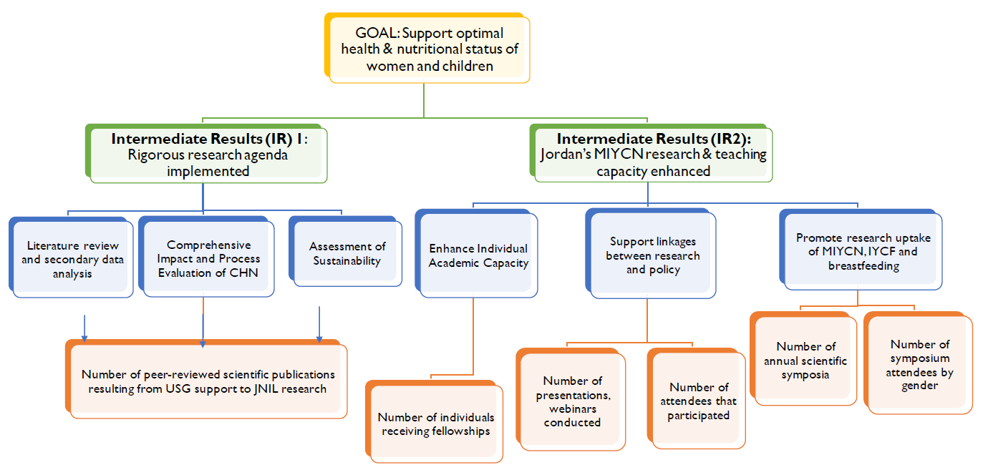
Table 1: JNIL’s Logic Model

