Jordan Water Infrastructure

Milestone #1: Ministry of Water and Irrigation and USAID Inaugurated a New Facility in North Aqaba Wastewater Treatment Plant
January, 2022
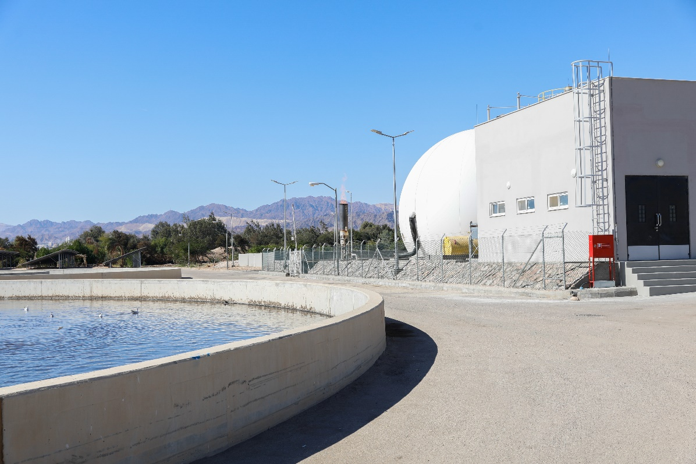
In 2022, through the USAID Jordan Water Infrastructure, and with the support of the German Agency for International Cooperation (GIZ), the activity constructed new facilities to increase the treatment capacity of the plant from 12,000 to 40,000 cubic meters per day. The facility uses a combination of solar power and biogas produced through the treatment of wastewater to support the sustainability and affordability of the plant. The plant improved the quality of treated wastewater to serve as an alternative water source for industrial uses, urban reuse, and landscaping, increasing the amount of water available for 150,000 residents in Aqaba by an estimated of 25 percent.

Milestone #2: Jordan Water Infrastructure Provided Technical Assistance for the Aqaba Amman Water Desalination and Conveyance Project.
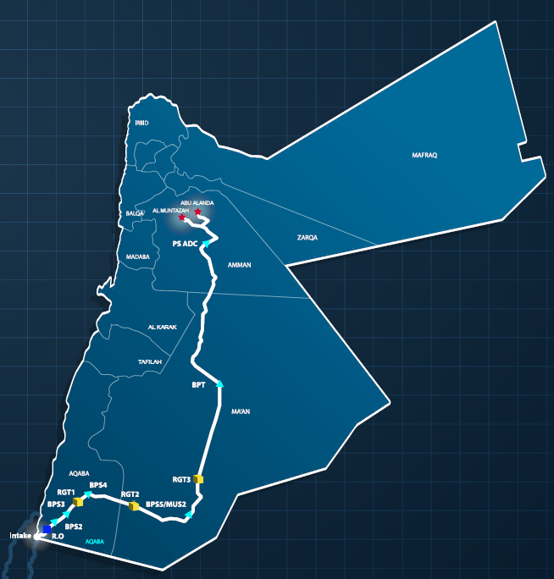
USAID Jordan Water Infrastructure (JWI) supported the Ministry of Water in preparing for the Aqaba-Amman water desalination and conveyance project. The project is one of the largest desalination projects in the world and is the largest one in Jordan. Upon completion, it will provide Jordan with 300 million cubic meters per year of desalinated water from the Red Sea, meeting the demands of approximately 4 million people in Jordan. The conveyance system will carry potable water from Aqaba to Amman, over a route that extends to 450 kilometers. To uphold climate change management, the project is implementing a first of its kind carbon footprint requirement which will limit the allowable carbon emissions per unit of water delivered, which will require a largescale renewable energy facility.
JWI Activity supported the Ministry with establishing the technical, financial, and legal framework for the Project, prequalification of qualified bidders, development of the tender documents, market sounding and donor support, and will conclude with bid evaluation, negotiation and transaction support to reach financial close.

Milestone #3: Jordan Water Infrastructure Trained Technicians on health and safety Procedures in Response to COVID-19 Outbreak
April, 2021
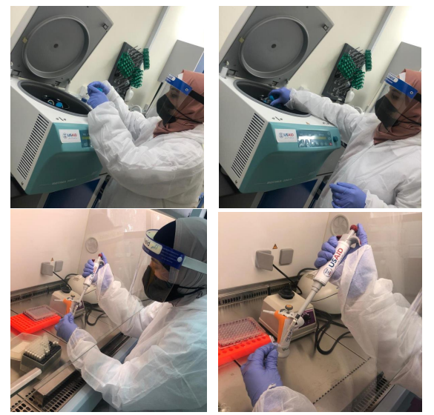
During the outbreak of the COVID-19 pandemic in Jordan, USAID JWI collaborated with relevant government stakeholders in monitoring COVID-19 using wastewater surveillance. The activity designed a training program in which field, monitoring, and lab technicians were trained on health and safety, sample collection, sample concentration, and analysis. The collaboration was important not only to detect and manage outbreaks of diseases, such as COVID-19, but also other human viral pathogens that can be detected through wastewater. JWI was able to assess the capacity of the Water Authority of Jordan laboratory to determine the health and safety practices, as well as procedures related to wastewater sampling, preparing, and testing stapes, as well as established measurement of quality assurance and control.

Additionally, the activity developed a practical and hands-on training for the relevant staff, analyzed the wastewater plant, conducted field verification visits in coordination with relevant agencies, and developed a surveillance plan for the plant with procedures on how to expand it to other facilities within the wastewater system in Jordan.

