|  |
| --- |
| Lockup_JORDAN_RGB_HIGH |
| USAID/Water Management Initiative (WMI) Project  **Implementation of a Population-based Knowledge, Attitudes and Practices (KAP) Baseline Assessment Study**  **Final KAP Study Findings Report** |

**-**

[January, 2018]

This report was produced for review by the United States Agency for International Development and Tetra Tech International Inc./ WMI Project. Data was gathered by the Market Research Organization and analyzed by To-Excel Consulting as per Task Order No. 002/2017, KAP Survey

**TABLE OF CONTENTS**

[Acronyms and Abbreviations 6](#_Toc500356154)

[Executive summary 7](#_Toc500356155)

[Introduction 14](#_Toc500356156)

[Section I: Baseline Assessment Study Objectives 14](#_Toc500356157)

[Section II: Methodology 14](#_Toc500356158)

[Findings 17](#_Toc500356159)

[**General Characteristics of the Targeted Population 17**](#_Toc500356160)

[Sample Geographical Location 17](#_Toc500356161)

[Nationality 20](#_Toc500356163)

[Age group 21](#_Toc500356165)

[Length of Stay 22](#_Toc500356166)

[Gender 22](#_Toc500356167)

[Head of Household 23](#_Toc500356168)

[Occupation 24](#_Toc500356169)

[Education Level 25](#_Toc500356170)

[Family Size, House Type and Ownership 25](#_Toc500356171)

[**Baseline Assessment Study Questions 27**](#_Toc500356172)

[Conclusions 103](#_Toc500356173)

[Annexes 108](#_Toc500356174)

[Annex 1: Focus Group Discussion Guide 108](#_Toc500356175)

[Annex 2: Household KAP Questionnaire 112](#_Toc500356176)

[Annex 3: FGDs Sample Details 128](#_Toc500356177)

[Annex 4: Comparison Matrix Per Gender 131](#_Toc500356177)

[Annex 5: Comparison Matrix Per Age Group 134](#_Toc500356177)

[Annex 6: Comparison Matrix Per Family Size 137](#_Toc500356177)

[Annex 7: Comparisons Per Nationalities Per Districts 138](#_Toc500356177)

[Annex 8: Comparison Matrix Per Districts 146](#_Toc500356177)

**TABLE OF TABLES**

[Table 1Overall Sample Distribution per Districts and Localities 18](#_Toc500307461)

[Table 2 Overall Sample Distribution per Age Group 21](#_Toc500307462)

[Table 3 Overall Sample Distribution per Occupation of the Head of Household 24](#_Toc500307463)

[Table 4 Overall Sample Distribution per Education level 25](#_Toc500307464)

[Table 5 Overall Sample Distribution per Family Size 25](#_Toc500307465)

[Table 6 Overall Sample Distribution per House Type 26](#_Toc500307466)

[Table 7 Overall distribution of respondent’s usage of some machines or water saving techniques 37](#_Toc500307467)

[Table 8 Knowledge about Key Water Projects in Jordan per overall sample and per Governorate 63](#_Toc500307468)

[Table 9 distribution of respondents’ knowledge of amount of money/fees subjected as penalty for illegal use 74](#_Toc500307469)

[Table 10 Respondents perception of the amount of money/fees to be paid as a penalty 75](#_Toc500307470)

[Table 11 Distribution of respondents who would report water leakage when encountered 79](#_Toc500307471)

[Table 12 Distribution of respondents who would report water wastage 80](#_Toc500307472)

[Table 13 Distribution of Usage of Application (3oun) 89](#_Toc500307473)

[Table 14 Overall Sample knowledge about water related initiatives and activities 96](#_Toc500307474)

**TABLE OF FIGURES**

[Figure 1 Overall Sample Distribution Map per Geographical Location 17](#_Toc500355083)

[Figure 2 Overall Sample Distribution per Locality Description 19](#_Toc500355084)

[Figure 3 Overall Sample Distribution per Nationality 20](#_Toc500355085)

[Figure 4 Nationality Distribution per Governorate 20](#_Toc500355086)

[Figure 5 Nationality per District 20](#_Toc500355087)

[Figure 6 Length of Stay of Syrian Respondents 22](#_Toc500355088)

[Figure 7 Overall Sample Distribution per Gender 22](#_Toc500355089)

[Figure 8 Overall Sample Distribution of Gender per Governorate and Nationality 23](#_Toc500355090)

[Figure 9 Overall sample distribution per Relationship with Head of Household 23](#_Toc500355091)

[Figure 10 Overall Sample Distribution per Family Size and Nationality 26](#_Toc500355092)

[Figure 11 Overall Sample Distribution per House Ownership Type 26](#_Toc500355093)

[Figure 12 Overall distribution of Respondents perception of water shortage problem existence in Jordan 27](#_Toc500355094)

[Figure 13 Distribution of perception of water shortage problem existence in Jordan per Governorate 27](#_Toc500355095)

[Figure 14 Perception of the criticality of the water shortage problem in Jordan 28](#_Toc500355096)

[Figure 15 Perception of the criticality of the water shortage problem in Jordan per Governorate and Nationality 28](#_Toc500355097)

[Figure 16 Reasons for the existing problem of shortage in water resources in Jordan 29](#_Toc500355098)

[Figure 17 Overall Distribution of Respondents knowledge of the existing water resources in Jordan 31](#_Toc500355099)

[Figure 18 Overall Distribution of water saving methods awareness 32](#_Toc500355100)

[Figure 19 Overall Sample distribution of currently used saving methods 34](#_Toc500355101)

[Figure 20 Overall distribution of respondents reasons for not doing anything to save water 36](#_Toc500355102)

[Figure 21 Overall Distribution of Respondents experiencing water supply problem per Sample and Governorate 41](#_Toc500355103)

[Figure 22 Overall Sample distribution of duration for water unavailability 42](#_Toc500355104)

[Figure 23 Overall distribution of water tank numbers per Household 43](#_Toc500355105)

[Figure 24 Overall sample distribution of available water tank(s) per household 44](#_Toc500355106)

[Figure 25 Overall distribution of availability of water float valve(s) on water tank(s) at households 44](#_Toc500355107)

[Figure 26 Distribution of respondents reasons for not having water float valves on their water tanks 45](#_Toc500355108)

[Figure 27 Overall perception of quality of water 46](#_Toc500355109)

[Figure 28 Overall distribution of main source of drinking water per overall sample 47](#_Toc500355110)

[Figure 29 Distribution of reasons for not drinking directly from the tap water 48](#_Toc500355111)

[Figure 30 Distribution of Households’ Connection to Sewer System per Overall Sample 49](#_Toc500355112)

[Figure 31 Distribution of Ways to get rid of Wastewater in Houses 49](#_Toc500355113)

[Figure 32 Overall Distribution of Frequency to get rid of Wastewater in Houses 50](#_Toc500355114)

[Figure 33 Distribution of respondents who conduct regular maintenance on their house water network 51](#_Toc500355115)

[Figure 34 Overall Distribution of Frequency to conduct regular checks/ maintenance for house water network 52](#_Toc500355116)

[Figure 35 Overall Distribution of Duration spent till conducting maintenance or fixing leak in house network 53](#_Toc500355117)

[Figure 36 Overall distribution of garden availability per households 55](#_Toc500355118)

[Figure 37 Sources of Water Used in Irrigating Gardens 55](#_Toc500355119)

[Figure 38 Method Used in Irrigating Gardens 57](#_Toc500355120)

[Figure 39 Overall sample knowledge of water bill calculation 58](#_Toc500355121)

[Figure 40 Overall sample knowledge of the cost per cubic meter of water that the government pays 59](#_Toc500355122)

[Figure 41 Distribution of perceptions of main elements of water cost per cubic meter 60](#_Toc500355123)

[Figure 42 Overall Distribution of how respondents would compare the water supply for their governorate with other governorates 61](#_Toc500355124)

[Figure 43 Overall Distribution of reasons for considering water supply less than other governorates 62](#_Toc500355125)

[Figure 44 Overall sample perception on projects positive effect on improving water supply 65](#_Toc500355126)

[Figure 45 Overall distribution of perception on projects positive effect per Governorate 65](#_Toc500355127)

[Figure 46 Perception Distribution towards Government Actions to Improve Water Supply 67](#_Toc500355128)

[Figure 47 Perception Distribution towards Illegal Practices of Water Use 71](#_Toc500355129)

[Figure 48 Overall sample knowledge of penalties for illegal water usage 73](#_Toc500355130)

[Figure 49 distribution of respondents knowledge of amount of money/fees subjected as penalty for illegal use 74](#_Toc500355131)

[Figure 50 Overall sample perception of penalties incurred for not paying water bill 76](#_Toc500355132)

[Figure 51 Overall Distribution of respondents who pay their water bill regularly 76](#_Toc500355133)

[Figure 52 Overall sample distribution of where or how respondents usually pay their water bill 77](#_Toc500355134)

[Figure 53 distribution of respondents who would report any water stealing incidents or illegal usage of water 81](#_Toc500355135)

[Figure 54 Overall respondents level of trust in water meter 82](#_Toc500355136)

[Figure 55 Perceptions towards meter reading improvement if changed to an electronic type 83](#_Toc500355137)

[Figure 56 Perceptions towards meter life span improvement if changed to an electronic type 84](#_Toc500355138)

[Figure 57 Overall sample distribution of respondents who would be willing to download mobile application on their mobile and use it to report about such incidents 85](#_Toc500355139)

[Figure 58 Sample Distribution in awareness of female plumbers 86](#_Toc500355140)

[Figure 59 Overall Sample Distribution of respondents experience of dealing with a female plumber 86](#_Toc500355141)

[Figure 60 Distribution of respondents who are willing to call a female plumber to repair a plumbing problem at their house per Overall Sample and Governorate 87](#_Toc500355142)

[Figure 61 Distribution of total survey respondents who have heard of the 3oun mobile application: 88](#_Toc500355143)

[Figure 62 Distribution of Reasons for not Using Application (3oun) 90](#_Toc500355144)

[Figure 63 Distribution of Trusted Sources to get Water Related Information 91](#_Toc500355145)

[Figure 64 Distribution of Followed Media Sources to get Water Related News and Information 92](#_Toc500355146)

[Figure 65 Access Level of Main Authorities Websites and Social Media Pages 93](#_Toc500355147)

[Figure 66 Respondents Recalled initiatives/activates 97](#_Toc500355148)

[Figure 67 Extent level of hearing about initiatives designed for the youth and focused on water topics 98](#_Toc500355149)

[Figure 68 Kind of activities or initiatives youth would personally like to participate in 99](#_Toc500355150)

[Figure 69 Overall sample respondents perceptions of how they see the water situation in Jordan in 10 years’ time 101](#_Toc500355151)

# Acronyms and Abbreviations

|  |  |
| --- | --- |
| BCC | Behavior Change Communications |
| DOS | Department of Statistics |
| IWSMG | Improved Water Sector Management and Governance Project |
| FG/FGD | Focus Group Discussion |
| GOJ | Government of Jordan |
| KAP | Knowledge, Attitudes and Practices |
| MWI | Ministry of Water and Irrigation |
| MRO | The Market Research Organization/ Farsoun Market Research Organization |
| Study | Baseline Assessment Study |
| To-Excel | To-Excel Consulting |
| USAID  WMI Project | United States Agency for International Development  Water Management Initiative Project   |  |  | | --- | --- | |  |  | |

# Executive summary

Improved Water Sector Management and Governance (IWSMG) Project is a USAID funded project, commonly known as the **Water Management Initiative (WMI)** that aims to support the GOJ to address its most pressing water sector needs, while developing critical capacity, improving sector performance, and developing broad-based support for immediate and longer-term reform. Behaviour change and strategic communications activities support all facets of project implementation, including a focus on gender mainstreaming and youth engagement.

This report is based on the results of a baseline assessment study that aimed at collecting information about the **population based- knowledge, attitudes and practices** (KAP) toward water conservation in communities served by Yarmouk Water Company and Miyahuna in order to:

1. Establish a baseline on knowledge about water resources and supply issues, attitudes and practices towards water consumption amongst the population in each targeted governorate
2. Provide a comparative analysis of Jordanians and Syrian practices toward water usage
3. Identify a range of priority behaviours that would help increase households water efficiency and conservation behaviours
4. For each of these behaviours, identify a range of target groups that influence the decision on water consumption
5. Design the behaviour change campaigns which can be achieved through social marketing and communication methodologies

Where the findings of the baseline are expected to be used as: 1- the **basis for designing a variety of WMI’s future programming** including those related to outreach, education, behaviour change communications, gender, youth, and stability. 2- In addition to the prospected **integration of the baseline outcomes** into future reporting to inform decision makers of the **impact that WMI has had** on the target community during its implementation period.

The study depended on a mix research approach comprising of quantitative and qualitative tools that got administered across 3 governorates (Amman, Irbid and Zarqa). Where the quantitative approach had covered a representative random sample of 2,000 face to face household interviews comprising 1,614 Jordanian and 386 Syrian, as designed by MRO team based on DOS 2015 Census population results.

Quantitative data was collected on tablets, via the Common Application Programmer's Interface. While, the qualitative research had relied on 11 focus group discussions distributed into 7 with Jordanian and 4 with Syrian. Overall fieldwork was carried out over a period of 20 days by 20 members of MRO team where lots of efforts were made to ensure the quality of collected data through following a quality assurance process plan consisting of actions taken before, during, and after data collection. Data analysis followed next by To-Excel for further 20 days where trend pattern analysis and comparative analysis of the data were conducted and data was triangulated as far as possible to ensure accuracy of findings.

**Overall**,

The attained sample was representative with a sound distribution of respondents across age, gender and education level. Findings differed with varying significance across the three governorates depending on the type of question being asked, where **Irbid governorate** appears to be experiencing the worst water situation of the three governorates and appear to have more water supply issues than the other two governorates as 43.5% of its overall sample confirmed facing times during this year where their houses have not been supplied with water.

The majority of **Syrian** respondents in the study turned out to have been in Jordan with their families for a long period (three years or more) at 87.6% of their overall sample, which is considered as a sufficient period to assess their knowledge, attitudes and practices towards water conservation and thus reflected on having better results. Syrians appeared to be living in conditions which are not that comparable with their Jordanian counterparts, which is perhaps a consequence of many of them living in rented accommodation and experiencing higher levels of unemployment. The analysis also implies that they do go about water usage in some different ways to Jordanians, but their practices and knowledge become more akin to Jordanians the longer they spend in the country.

Qualitative research put in **some population prospects** towards needed government’s actions to improve water supply as many of the Jordanians and Syrians felt that the **government** is **not yet doing enough to tackle the problem** and would like to see a significant shake-up in terms of management of water resources, performance of regular maintenance, check-ups and infrastructure projects and setting better distribution mechanisms. They also reaffirmed the need for greater **enforcement of regulations** and penalties and **advocating** for water saving methods and good consumption practices through directed and informative awareness campaigns at all levels. And it worth citing that many participants predicted a **raise in water prices** in the coming years.

There are also a number of disparities between **age groups,** **gender** and **urban and rural areas**, which are discussed in more detail in the categories below:

Population knowledge and Awareness about Water Resources and Supply Issues

The assessment of the population knowledge and awareness about water resources and supply issues in Jordan were organized around several pillars including **awareness** about: water shortage problem, water resources, water saving methods, bill and cost calculation, illegal water usage practices and penalties, water supply, available mega water projects, female plumbers availability, the mobile application (3oun) and water related initiatives/activities. This has come up with the following general conclusions:

The study has demonstrated that 61.3% of the respondents are **aware that there is a water shortage problem** in Jordan rated by most of them between high to medium **criticality levels** and reaching the highest at Zarqa governorate where 97.9% of its sample considered the problem as a positively critical one followed by Irbid and Amman at 96.5% and 96% serially. Furthermore, it appeared that rating the water shortage problem critically tends to increase with aging, where those respondents aged 50+ consider the most the water shortage problem in Jordan to be “a very critical problem” followed by middle aged groups. When delving deeper, it is evident that Jordanians believe it is more of an issue than their Syrian counterparts. And many **Jordanians** are of the belief that the predominant **cause** of the water shortage problem in Jordan is “**the existence of other nationalities**” in the country, which mainly focuses on the Syrian refugee population. While for **Syrians**; the water shortage problem has been foreknown in Jordan since decades and it was mainly found allied to **resources** related reasons as per Jordan’s little rainfall and scarcity of existing water resources.

By far the most known **water resource** in Jordan among the overall sample is that of rain water (at 41.7%) followed by underground water and dams. There is a significant disparity between governorates perceptions of their water supplies; where only Amman respondents compared their governorate supply as same or more than other governorates. Whilst close to three quarters of Irbid and Zarqa respondents are of the belief that their water supply is same or less than the other Governorates.

Respondents were much more aware of simple indoor **water saving methods than outdoor methods** at a total of 72.3% of the overall sample compared to a total of 27.7% for the outdoor methods. With little variation between Governorates in this regard while **Syrians** tend to be more aware than **Jordanians** of certain saving methods as “water re-use” and “water tanks regular fixing and proper closing”.

Lack of knowledge was apparent in **water bill calculation** and this cognition reached the minimum at Irbid governorate where only 15.8% of its sample knows how to calculate their water bills. **Syrians** were even less of aware of that than their Jordanian counterparts.

Approximately two thirds of respondents knew that the suggested water usage practices (of: connecting water drainage pipe to the sewage network or connecting the household sewage network to main sewage network without subscription or connecting the household sewage network to rainwater drainage network) were **illegal**. Respondents from Amman and Zarqa Governorates were the most aware of what constitutes as illegal water usage (at an average of 70.6% and 62.8% of each overall sample respectively), the same could be said for locality description, with fewer respondents from rural areas knowing right from wrong in comparison to those in urban areas. And with more recognition perceived by **Jordanians** than **Syrians** (at an average of 65.4% and 59% of each overall sample respectively) and by **males** than **females** (at an average of 66.8% and 61.9% of each overall sample respectively. And over half of the sample recognized that the penalties for illegal water usage is incurring fines whilst over a third also supposed that they could incur 1-3 years in prison. Yet the majority (86.8%) were ignorant of the **amount** of that fee to be paid.

Surveyed and interviewed participants had heard the most about “**Disi Water Project**” among key **water projects** in Jordan (at a total of 83.7% of overall sample).While the sample information about “Re-habitation/Sanitation Network Projects” and “North Water Supply Projects” looked very narrow and hardly existed.

Less than quarter of the overall sample were aware of **female plumbers**, with the fewest of those coming from Zarqa Governorate. And remarkably, the vast majority of respondents were unaware of the **mobile application** (3oun) at (95%). Likewise, in respect to **water related initiatives/activities**, very similar results revolved up where almost 96% of the respondents were unaware of any related initiatives/activities especially those from Irbid governorate or **Syrians**.

1. **Population Attitudes towards Water Related Issues**

The assessment of the population **attitudes** towards water related issues in Jordan were organized around several pillars including **perceptions** about: water quality, mega projects and government actions effectiveness, electronic water meters, new water sector related mobile applications, dealing with female plumbers, participation in water related initiatives and water situation in Jordan in 10 years. This has come up with the following general conclusions:

The significant majority of respondents perceive their water supply to be **undrinkable**, by over three quarter of the total sample reaching the maximum at Irbid governorate where **87%** considered the quality of water arriving to their household tanks as undrinkable, especially those at (Bani Kenanah and Koura District) and (Kafer Yuba, Malka and Suhom Localities). Interestingly, many participants stressed on their readiness to pay more to get water of good quality.

While in regard to the prospected **impact/effect of “Water Mega Project”** on improving water supply; the majority were notably **positive** and **optimistic** trusting that the projects will be helpful in addressing the water shortage issue in Jordan and enhancing the water quality and supply, though they were expected to consume long **durations till** completion and subject an **increase to** the water cost per household. Furthermore, the **government’s effort** in relation to major **water projects** was perceived as the most agreed with action to improve water supply by almost 89% of respondents.

A high level of trust was professed by respondents in their current **water meters**, with no clear expectations in terms of meter reading improvement if changed into an electronic type. While almost half of the sample believed that changing into an electronic type would be better in terms of life span.

Remarkably, **60%** of respondents expressed their keen in downloading and using a new water sector related **mobile application** ranging from interest levels of 65% by Zarqa responses to 51% of Irbid and more by **males** than females at 64.6% compared to 56.8% serially. Furthermore, willingness was foreseen decreasing with aging reaching 53.3% of elderly compared to an interest rate of 67.4% by youth. Furthermore, similar results appeared for respondents’ willingness to **deal with female plumbers**, however it varied between governorates; where in **Irbid Governorate 75.6%** would be happy to use a female plumber if one was available, followed by **58.2%** in **Amman** and less than half of the respondents at **48.5%**, in **Zarqa**.

Lack of youth interest in personally participation in any **water related activities or initiatives** was admitted by one third of the sample and was apparent among **Syrians** more than **Jordanians** and among **females** more than males. This was relayed to time constraints and jobs commitments. While for the interested Jordanian youth (counting at 394), the kind of **activities or initiatives** that they would be attracted to partake in were mostly related to participating in a campaign (at 19.8%) or attending training sessions (at 15.7%). While “social media channels” or “sharing with friends” were the more desirable kinds by **Syrians** at 15.5% and 10.3% serially.

**Amman** population were the most optimistic in regard to the **water situation in Jordan in 10 years**. While **Irbid** population were the most pessimistic, as around half of its sample are certain that the situation will become “somewhat worse” or “much worse”. And, generally speaking, **Syrians** were more optimistic than **Jordanians** about the water situation.

1. **Population Practices in Water Usage and Consumption**

The assessment of the population **practices** in water usage in Jordan were organized around: water saving methods, main sources of drinking water, getting rid of wastewater, periodic maintenance, garden irrigation, bills payment, reporting about water related incidents, dealing with female plumbers, using 3oun application and getting water related information.

This has come up with the following general conclusions:

Research results brought up that the followed practices in **water saving methods** was somehow consistent among governorates and was mainly focused about **indoor** methods as “closing water faucets”, “testing water networks” and “using water saving devices in the bathroom and kitchen”. **Syrians** tend to be following certain saving methods more than **Jordanians** as “water re-use” and “water tanks regular fixing and proper closing”. The minimal consumption of water and poor supply were found to be the key motivations behind not doing anything for saving by overall residents. And as a reason for not doing anything to save water; **Syrians** considered “the expensive cost of water efficient products” as more of a reason than **Jordanians** at **6.2%** compared to **3.6%** respectively.

**Water efficient washing machines** turned to be the most used water saving technique. While other technologies are very rarely used since many consider them as expensive and in need for regular maintenance. However, some participants expressed their willingness to inves**t** in water saving technologies if provided at reasonable prices since they are aware of its saving advantage.

**Jordanian** participants considered that the situation was much worse during the initial influx of Syrians as **Syrians** were not used to having a water shortage problem and thus tend to use water inefficiently, but afterwards many of them started to adapt their behaviors and became much more resource-conscious. The matter that got **reconfirmed** by Syrians themselves.

As a **main source for drinking**, population counted on bottled water and **filtered** tap water.

While in regard to practices in **getting rid of wastewater** by the very few who are not connected to sewage system; “Cesspool pit” turned out to be the main way, but surprisingly, the utmost of them did not get rid of wastewater accumulated till now.

For **maintenance**, Irbid residents seemed the most active in maintaining water network at 67.2% of its overall sample, while those in Zarqa were the least proactive at 42.3%. And, though survey findings reflected that **Jordanians** do conduct maintenance and regular check-ups more than **Syrians** but those implementing Syrians conduct that maintaining more frequently. A difference was noticed in conducting maintenance between those who are owners of the houses and those who are renters; where maintenance was conducted by 61% of the owners compared to 49.4% of the renters.

Whereas, for **garden irrigation** practices, water authority water was the main source of that water used in irrigation by almost half of the sample. Furthermore, water hose tended to be the extremely used method in irrigation by almost 66% of the overall sample followed by utilizing the buckets, while drip irrigation was almost not used.

**Regular bills payment** was the most common practice among the majority, ranging from a rate of 88% for Amman residents to 80.2% for those in Irbid. And more by respondents in Urban areas than those at rural areas at **86.6%** compared to **75%** serially.

Besides, water utility office was the main **destination** for **water bills payment** by almost 57% of the sample followed by post office for another quarter of the sample. However, payment through banks or e-fawateerkom was hardly carried out and tend to be more by professionals than others.

**Reporting about water leakage** in the streets or public places was agreed upon by more than three quarters of the sample, which turned out to be more practiced and accepted than reporting about (water stealing incidents/illegal usages or water wastage by individuals). Amman residents and elderly were the most interested in reporting water leakage at 79.3% and 84.3% of each sample correspondingly.

The majority have never dealt with any **female plumbers** at almost 94% of the sample. And very equivalent results appeared for **experiencing** the **usage of mobile application** (3oun) where only 13.7% of those who ever heard of that application have ever used it.

As for **sources of water related information**; some discrepancies appeared across governorates where “Miyahuna” was the most trusted source at Amman and Zarqa while for Irbid; the “Ministry” came first followed by “Family/Friends/Neighbors”, while “Yarmouk Water Company” came in the 3rd rank. On the other hand, lack of trust in any sources was remarkably apparent at Zarqa at 13.8% of its overall sample. As for the case for **Syrians**, “Family/Friends/Neighbors” was the most trusted source to refer to for information, the matter that could be due to their unawareness of available information sources. By means of **media sources** followed to get news and information about water in Jordan; Jordan TV was the most followed source by almost half of the sample. While follow-up rate for water news through social Media and internet websites was not very notable and mostly preferred by youth.

**Recommendations**,

A set of generic recommendations were derived directly from the findings of this research to support the WAJ team in planning its programs and associated activities while setting specific targets for the upcoming duration. These are centred around raising awareness and enhancing water authorities’ service delivery and performance.

In **raising awareness**, it is encouraged to improve the communities’ understanding of impacts resulting from improper water usage, and drive them towards rationalization practices. As population knowledge is considered a core ingredient of solving water-related problems and will definitely lead to actions that improve the overall situation. This could be conducted by implementing **education programs** on:

* 1. Up taking water saving devices and strategies more broadly and to be covering a variety of indoor and outdoor techniques by bringing together real cases on how to consume more efficiently and showing the advantages of suggested devices/techniques/habits in reducing water consumption. In addition to placing a special focus upon the good gardening habits as efficient irrigation methods, rainwater harvesting and planting techniques.

1.2 How to calculate water bills and the main elements contributing to that cost and how money can be saved by saving water; and to be directed for females as well

1.3 Amounts of penalties incurred for illegal water usage practices and the importance of population support in reporting such incidents to government for action

1.4 Key mega projects in Jordan, through presenting some of these projects updates and facts through periodic newsletters/Ads/short videos etc. showing projects’ (implementation duration, importance, expected benefits/impact etc.)

In addition to;

1.5 Spreading the knowledge about the female plumbers available at a wider scale through circulating their contacts information and capabilities among communities

1.6 Making efforts to promote the Mobile application (3oun) and other existing water related applications through advertising and social networks or official authorities’ websites

* 1. Using participatory techniques in water related initiatives/activities by having initiatives ambassadors (from society/community) from both genders or building partnerships with community groups (NGOs, Youth) to enable delivery, sustainability and success of initiatives/activities. And preferably to be in the form of full **campaigns** rather than other forms.
  2. Develop an annual national water related events and occasions calendar at schools and universities
  3. Focusing on the use of Jordan TV and Roya TV in any upcoming campaigns as they turned out to be the most monitored media sources followed by social media and websites.

While in terms of enhancing water authorities’ service delivery and performance; it is strongly recommended to;

* 1. Advocating water-efficient technologies and facilitate the adoption of new innovative and proven technology at affordable prices and with incentive systems to encourage their use
  2. Implementing a water quality monitoring program by official authorities and demonstrate appropriate water quality improving technologies and methods
  3. Making efforts to promote the “Unified Complaint Center” and improve the water companies’ effectiveness in handling information requests and complaints
  4. Enhancing the trust in Ministry and Water Companies websites and social media pages as sources for water related information by producing, updating, and sharing timely, consistent and policy-relevant water and water-related data and information. And be engaging platforms that provide answers in due time.
  5. Encouraging citizens to approach electronic bill services and banks for water bills payment
  6. Increasing the communities’ knowledge about “the Amiri Law” and its benefits in improving the water supply

# Introduction

## Section I: Baseline Assessment Study Objectives

Improved Water Sector Management and Governance (IWSMG) Project is a USAID funded project, commonly known as the Water Management Initiative (WMI) that aims to support the GOJ to address its most pressing water sector needs, while developing critical capacity, improving sector performance, and developing broad-based support for immediate and longer-term reform. Behaviour change and strategic communications activities support all facets of project implementation, including a focus on gender mainstreaming and youth engagement.

This is the analysis report for the **“Population Based- Knowledge, Attitudes and Practices (KAP) Baseline Assessment Study”** toward water conservation in communities served by Yarmouk Water Company and Miyahunathat is implemented on behalf of WMI and in cooperation with MWI. And, that depended on a **mix research approach** to collect data about targeted geographical areas to accordingly enable the MWI’s proper design and introduction of positive behavioural changes.

The main purpose of the (KAP) Baseline Assessment Study was to provide **baseline data** and evidence that will be used as the basis for designing a variety of WMI’s future programming including those related to outreach, education, behaviour change communications, gender, youth, and stability.

Additionally, the baseline assessment study will be responding to the following **objectives**:

1. **Helping** the project measure the **impact** of its activities over years of implementation
2. **Establishing** a **baseline** on **knowledge** about water resources and supply issues, **attitudes** and **practices** towards water consumption amongst the population in targeted governorates
3. **Identifying** a range of **priority behaviors** that would help increase households water efficiency and conservation behaviors
4. **Providing** a **comparative** analysis of **Jordanians** and **Syrian**s practices toward water usage
5. **Gathering** data as a prelude to **instituting programs** of education and changing public behaviors in key water issues facing targeted communities (behavior change campaigns)

## Section II: Methodology

Considering the aims of the study, a **two stage research a**pproach was followed;

1. **A qualitative approach** (**Focus Group Discussions**) to allow for a deeper understanding of the behaviors of the Jordanians and Syrians in regards to their water consumption habits, the possible barriers which restrict water conservation and aiding in identifying the main influencers. **Eleven** FGDs were carried out between August 13th and August 20th 2017
2. **A quantitative approach** (**Survey**) to allow for measurable results that would identify key attitudes and behaviors in regards to water consumption, and awareness of current supply issues, and also provide results which will identify significant differences in opinion and behaviors between Jordanians and Syrians. Quantitative data collection was carried out between October 9th and October 23th 2017.

Considering the focused upon **pillars/sections** within the two approaches;

1. **The qualitative approach** (**Focus Group Discussions**)[[1]](#footnote-1)

**Section 1: Water Shortage Problem in Jordan**

* Existence of Problem and Reasons
* Problem Responsibility, Potential Solutions and Government Measures

**Section 2: Mega water projects in Jordan**

**Section 3: Youth programs or activities related to water**

**Section 4: Sources of Information related to water**

**Questions Pillars**

**Section 5: Water Bills**

**Section 6: Received Water**

* Frequency/Duration and Quantity
* Quality

**Section 7: Attitudes and Practices**

* In Water Usage and Consumption
* In Periodic Maintenance
* The Syrians in Jordan

**Section 8: Water Situation in Jordan in 10 years**

1. **The quantitative approach** (**Survey**)[[2]](#footnote-2)

A series of 61 questions were developed covering;

**General characteristics of the Population Surveyed**

* Geographical Location (governorate, district, locality, locality description)
* Age - Nationality - Length of Stay (for Syrians)
* Gender - Relationship with the Head of Household
* Occupation - Education Level

**Questions Pillars**

* Family Size - House Type - House Ownership

**Population Knowledge/ Awareness of**

* Existence of Water Shortage Problem, its criticality Level and reasons
* Available Water Resources
* Water Saving Methods
* Water Bill and Cost Calculation
* Penalties of Water Bills Non-Payment
* Illegal Water Usage Practices and Penalties
* Governorate Water Supply
* Mega Water Projects
* Female Plumbers Availability
* Mobile Application (3oun)
* Water Related Initiatives/Activities

**Population** **Attitudes regarding**

* Quality of Water
* Mega Water Projects
* Government Actions to Improve Water Supply
* Water Meter (trust, accuracy, life span)
* Now mobile application usage
* Dealing with Female Plumbers

**Questions Pillars**

* Participation in Water Related Initiatives/Activities
* Water Situation in Jordan in 10 years

**Population** **Practices in**

* Water Saving Methods
* Main Sources of drinking Water
* Connection to Sewage System/Sewer Network
* Periodic Maintenance
* Garden Irrigation
* Water Bills Regular Payment
* Reporting about water leakages, water stealing and illegal usage of water
* Dealing with Female Plumbers
* Using Mobile Application (3oun)
* Source of water related information

Further details about the followed methodology in field work are elaborated within “MRO Project Summary and Description Report” that was delivered to WMI on October 10th 2017.

While the upcoming sections present the **quantitative and qualitative findings** based on the analysis conducted by To-Excel for the data gathered about the above described pillars while considering the cross **disaggregation** (e.g. per geographical location, nationality, gender or other relevant factors.). In addition to supporting findings with some quotations coming out of FGDs.

# findings

## General Characteristics of the Targeted Population

## Sample Geographical Location

1. **The quantitative approach**

The KAP survey had achieved completed interviews with **2,000** respondents. The figure below illustrates the geographical distribution of the 2,000 respondents surveyed across **3 Governorates** of Jordan; **Amman**, **Irbid** and **Zarqa**, according to each governorate total sample allocation and its corresponding population percentage. Overall, the sample has consisted of a proportional representation of the three governorates, where **Amman** governorate counted the highest at **51.5%** of overall sample, followed by **Irbid** governorate at **28.5%** and finally **Zarqa** governorate at **20%**.

Figure 1 Overall Sample Distribution Map per Geographical Location

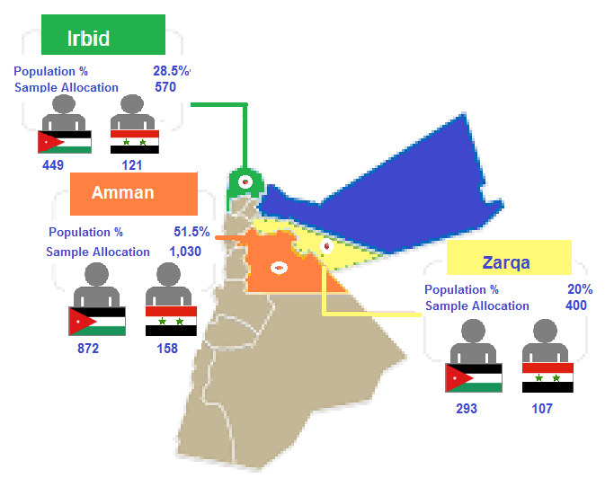

Governorates were further split into 13 **Districts**; **6** in Amman, **5** in **Irbid** and **2** in Zarqa.

These were again disaggregated into 41 **localities**; **19** in Irbid, **17** in **Amman** and **5** in Zarqa.

Disaggregation per districts and localities is presented in the table hereunder;

Table 1 **Overall Sample Distribution per Districts and Localities**



Based on the above distribution per districts and localities, the overall sample was divided between **Urban** localities at 94% and **Rural** localities at 6% of the overall sample as per the below pie chart:

Figure 2 Overall Sample Distribution per Locality Description

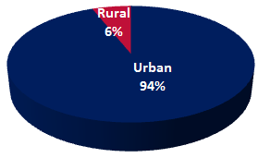

## It is worth mentioning that all the interviewed respondents were the ones responsible for managing the household and all were subscribed with the Water Authority

1. **The qualitative approach**

The qualitative approach had achieved **11 completed FGDs[[3]](#footnote-3)** with **around 86** participants (at an average of 8 participants per FGD) from the targeted **3 Governorates**; **Amman**, **Irbid** and **Zarqa.**

The 11 FGDs were **distributed** as follows:

**39 participants 23 participants 24 participants**

## Nationality

1. **The quantitative approach**

|  |  |
| --- | --- |
| **D3.** | **Could you please tell me what is the nationality of head of household?** |

Overall, the surveyed sample has targeted **Jordanian** and **Syrian** respondents; where **Jordanians** counted at **80.7%** (**1,614** respondents) of the overall sample, whilst **Syrians** counted **19.3%** (**386** respondents) of the overall sample, as shown in the figure below:

Figure 3 Overall Sample Distribution per Nationality

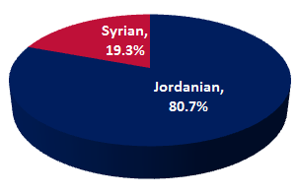

* Looking at the nationality distribution per Governorate, we can see the following:

Figure 4 Nationality Distribution per Governorate

* 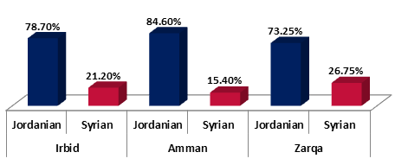Surveyed Syrians size of the overall sample was mostly higher in **Zarqa** Governorate by **26.75%** of the Governorate overall sample size, followed by **Irbid** at **21.2%** and finally Amman at **15.4%**.

While for the distribution of Jordanians and Syrians per District:

Figure 5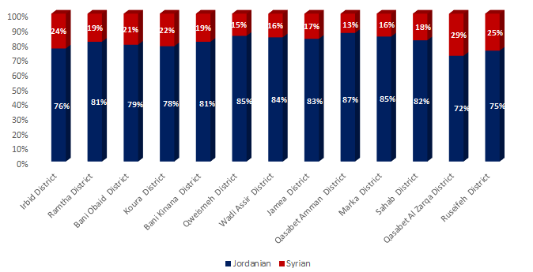 Nationality per District

* Syrian percentages were highest in **Zarqa** District at **28.5%**, followed by Rusaifeh District at 25%, then Irbid District at 23.5%, while they were lowest in Amman, Qweismeh and Marka.

**B. The qualitative approach**

The qualitative approach had covered;

**Code**

**Code**

**3 with Jordanians**  **2 with Jordanians**  **2 with Jordanians**  (FG1, FG2, FG4) (FG8, FG9) (FG5,FG7)

**2 with Syrians**  **1 with Syrians**  **1 with Syrians**

(FG3, FG11) (FG10) (FG6)

## Age group

1. **The quantitative approach**

|  |  |
| --- | --- |
| **D2.** | **Respondent age** |

As for the pattern of age distribution per overall sample, the table below illustrates this distribution:

Table 2 Overall Sample Distribution per Age Group



* The highest proportionwas from the age group between 30-49 years at **50.6%**, followed by the age group 50+ years at **25.5%**. And then the age group between 19-29 years at **24.0%**.
* This reflects a healthy sample distribution covering all age segments from (youth adults, medium aged adults, and elderly).
* Looking at the age distribution per nationality, it can be seen that the surveyed Syrians were younger than their Jordanian counterparts, with **84.4%** of Syriansunder the age of 49 years old, versus **72.1%** of Jordanians under the age of 49 years old.

1. **The qualitative approach**

* The FGDs included 6 groups with participants between 18-30 years and 5 groups with participants above 30 years old.

## Length of Stay

|  |  |
| --- | --- |
| **D4.** | **How long have your family been in Jordan?** |

For the **386 Syrians surveyed**, when asked about the length of their family stay in Jordan, it turned out that the majority of them (**87.6%**) have been here for three years or more, as show in the figure below:

Figure 6 Length of Stay of Syrian Respondents

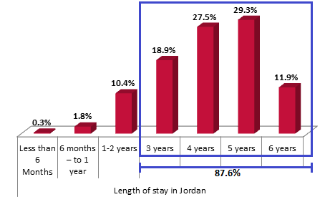

## Gender

1. **The quantitative approach**

|  |  |
| --- | --- |
| **D9.** | **Respondent’s gender** |

Overall, the sample was split very closely in half between males and females (**47%** and **53%**) respectively as shown in the figure below:

Figure 7 Overall Sample Distribution per Gender

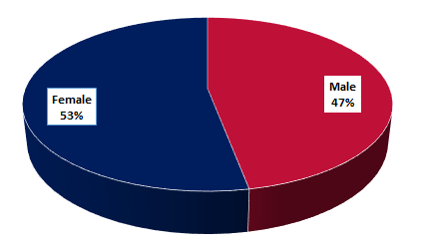

* Looking at the distribution of gender per Governorate and Nationality, we can see that:

Figure 8 Overall Sample Distribution of Gender per Governorate and Nationality

* 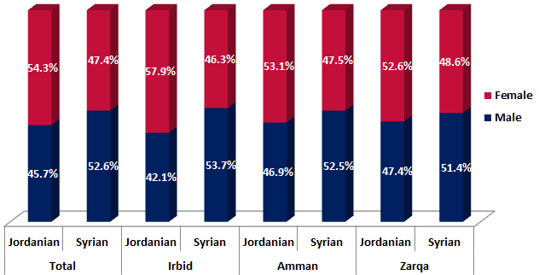**Jordanian** **females** were higher than **males** per overall sample and per all Governorates.
* While for **Syrians**; **males** were higher per overall sample and per all Governorates, especially in Irbid Governorate at **53.7%** of males compared with **46.3%** of females.

1. **The quantitative approach**

* The FGDs included **6 groups** of **Males** and **5 groups** of **Females**.

## Head of Household

|  |  |
| --- | --- |
| **D10.** | **What is your relationship with the head of your household?** |

All interviewed respondents were responsible for managing the household and meeting its needs and when asked about their relationship with the head of the household, the sample was disaggregated as follows:

Figure 9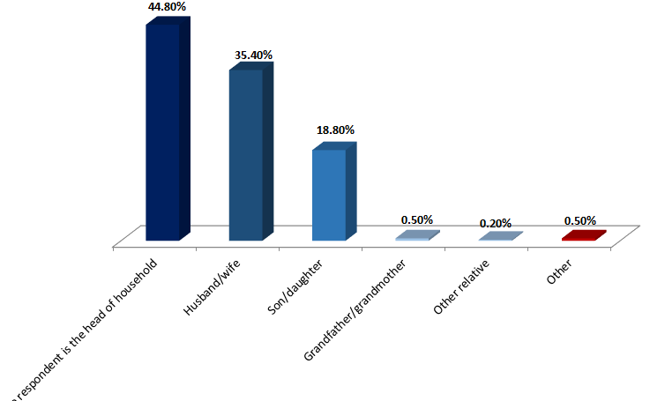 Overall sample distribution per Relationship with Head of Household

* The highest proportion of respondents represented the head of household (**44.8%**), followed by the spouse (**35.4%**), and then those who were either the son or daughter of the head of household (**18.8%**). Only **0.5%** of respondents were grandparents of the head of household and **0.2%** were other relatives. Those respondents under the **0.5%** category of “other” had been either brother/sister of the head of household at **0.4%** or mother of the head of household at **0.1%**.

## Occupation

|  |  |
| --- | --- |
| **D11.** | **What is the current occupation of the head of household?** |

The surveyed sample disaggregation per current occupation of the head of household is presented as follows:

Table 3 Overall Sample Distribution per Occupation of the Head of Household

|  |  |  |  |  |  |
| --- | --- | --- | --- | --- | --- |
| **Occupation** | ***%***  ***Of Overall Sample*** | ***%***  ***Of Jordanian Sample*** | ***%***  ***Of Syrian Sample*** | ***%***  ***Of Male Sample*** | ***%***  ***Of Female Sample*** |
| **Skilled labour** | ***18.8%*** | ***16.9%*** | ***26.7%*** | ***18.1%*** | ***19.3%*** |
| **Business owner** | ***18.3%*** | ***21.1%*** | ***6.5%*** | ***29.8%*** | ***8.0%*** |
| **Retired** | ***12.7%*** | ***14.9%*** | ***3.4%*** | ***11.4%*** | ***13.8%*** |
| **Semi-skilled/unskilled** | ***12.3%*** | ***7.3%*** | ***33.2%*** | ***12.3%*** | ***12.3%*** |
| **Clerical, other office worker** | ***10.8%*** | ***12.1%*** | ***4.9%*** | ***8.4%*** | ***12.8%*** |
| **Managerial** | ***10.7%*** | ***12.6%*** | ***2.6%*** | ***7.7%*** | ***13.4%*** |
| **Professional (doctor, lawyer, engineer)** | ***7.5%*** | ***8.4%*** | ***3.4%*** | ***5.6%*** | ***9.1%*** |
| **Unemployed** | ***6.7%*** | ***4.5%*** | ***15.8%*** | ***6.0%*** | ***7.4%*** |
| **Housewife** | ***2.0%*** | ***1.5%*** | ***3.6%*** | ***0.5%*** | ***3.2%*** |
| **Other** | ***0.5%*** | ***0.6%*** | ***0.0%*** | ***0.2%*** | ***0.8%*** |

* Among all respondents, the highest proportionwas from head of households working as “Skilled laborers” at **18.8%**, followed by “Businesses owners” at **18.3%**. And then “Retired” at **12.7%**, and “Semi-skilled or unskilled” at **12.3%**.
* Respondents in “Clerical,” “Managerial” and “Professional” roles counted **10.8%**, **10.7%** and **7.5%** respectively of the overall sample.
* Only **6.7%** of the total sample were Unemployed which represents a low share of the sample. Similarly, respondents who are “Housewives” equated to only 2% of the total sample, with no students within the sample.
* While **0.5%** of respondents gave “other” occupation as an option and mainly represented those working in the armed forces/security.

**Per Nationality:**

Disaggregation per nationality has shown than;

* For **Jordanian** respondents, the highest proportion was working as **Business owners** at **21.1%**, followed by skilled labor at **16.9%** and retired at **14.9%**.
* For **Syrian** respondents, the highest proportion was working as **semi-skilled labor** at **33.2%**, followed by skilled labor at **26.7%** then **unemployed** at **15.8%**.
* Unemployed **Jordanian** respondents were lower than those for **Syrians**; **4.5%** compared to **15.8%** respectively.

## Education Level

|  |  |
| --- | --- |
| **D12.** | **What is your level of education?** |

The overall surveyed sample disaggregation per education level is presented as follows:

Table 4 Overall Sample Distribution per Education level

**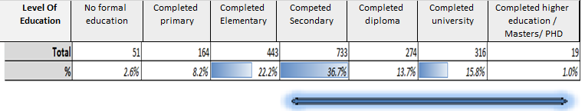**

* Among all respondents, the highest proportionwas from those who have “completed secondary” education level at **36.7%**, followed by those who completed elementary education at **22.2%** and then those who “completed university” at **15.8%**.
* Respondents who have “**completed diploma**” education level totaled **13.7%** of the sample, while respondents who have “completed higher education (Masters/PHD)” were at **1.0%** of the overall sample.
* On the other hand, those who have “**completed primary**” education level counted at **8.2%** and only **2.6%** of the total sample had “no formal education” which represents a low share of the sample.

* Based on this we can say that the majority of the overall sample **67.1%** can be considered **upper secondary educated** (having completed secondary education and above).
* When looking at **nationality**, **70.6%** of **Jordanian** respondents are upper secondary educated, having completed secondary education and above, compared to **52.6%** of **Syrians**.

## Family Size, House Type and Ownership

|  |  |
| --- | --- |
| **D13.** | **Family size?** |

Table 5 Overall Sample Distribution per Family Size



* From the respondents surveyed, the highest group of family size by a significant margin was between “4 to 6” family members with **61.5%** of the overall sample. This was followed by family size of “7 to 10” individuals in the household and then “1 to 3” individuals at **19.5%** and **17.4%** respectively.
* Only **1.7%** of respondents came from a family with “10+” family members.

Some comparisons per family size were added under Annex 6

Looking at disaggregation per nationality, we can find that:

Figure 10 Overall Sample Distribution per Family Size and Nationality

**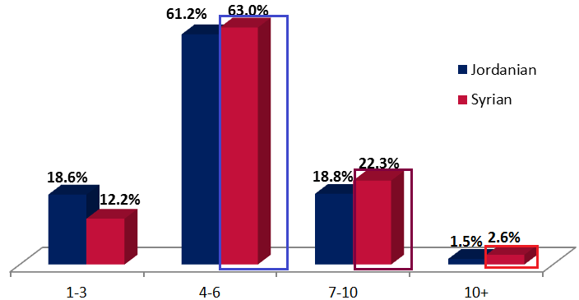**

* **Jordanian** and **Syrian** family sizes are quite similar among those who got surveyed, though there is a bit of a trend of having **larger family sizes** among **Syrians** as shown above.

|  |  |
| --- | --- |
| **D14.** | **House type?** |

Table 6 Overall Sample Distribution per House Type

**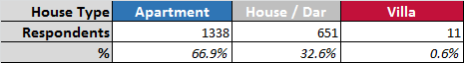**

* **66.9%** of those surveyed live in “apartments” whilst **32.6%** live in “houses/dars” with only **0.6%** living in “villas”.
* **79.3%** of **Syrian** respondents live in “**apartments**” compared to **63.9%** of **Jordanian** respondents**.** While **20.2%** of Syrians live in **house/dar** compared to **35.5%** of Jordanians.

|  |  |
| --- | --- |
| **D15.** | **Is this house owned or rented?** |

As seen below, the distribution of those that live in owned accommodation versus those that occupy rented accommodation showed that **59%** of the respondents have owned houses, whilst **41%** live in rented accommodation.

Figure 11 Overall Sample Distribution per House Ownership Type

**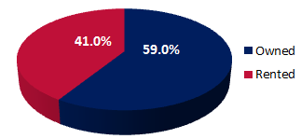**

Looking at the house ownership type according to **nationality**:

* For **Syrians**; the highest proportion was of those living in **rented accommodation** at **90.4%** compared to only **29.2%** of corresponding **Jordanian** respondents.
* While for **Jordanians**; **70.8%** have **owned houses**.

## Baseline Assessment Study Questions

|  |  |
| --- | --- |
| **Q1.** | **In general, do you think that there is a shortage problem in water in Jordan?** |

The **survey** response regarding a water shortage problem existence in Jordan was as shown below:

Figure 12 Overall distribution of Respondents perception of water shortage problem existence in Jordan

**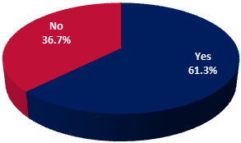**

* Where; **61.3%** of respondents believe that there is a water shortage problem in Jordan, while **36.7%** feeling that it is not an issue and only **2%** **don’t know** if it is a problem.

The below figure further disaggregates this perception into each governorate;

Figure 13 Distribution of Respondents perception of water shortage problem existence in Jordan per Governorate

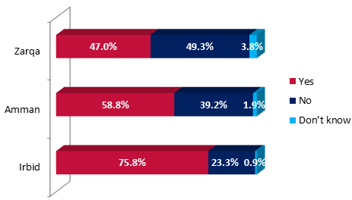

* It is interesting to note that the perception of survey respondents in **Irbid Governorate** shows that the majority believe that water shortage is an issue in Jordan, with **75.8%** of the respondents expressing that they do believe it is an issue/problem.
* **Amman Governorate** residents followed in second with **58.8%** of respondents believing in having a water shortage problem in Jordan. In contrast, less than half of the respondents from **Zarqa Governorate** do believe that water shortage in Jordan is an issue, at **47%**, while **49.3%** saying that it is not a problem.
* Overall, **Jordanian** respondents tend to believe more that there is a water shortage problem in Jordan **much more** than **Syrian** respondents (**62.4%** compared to **56.7%** for the later).
* **Gender:** Very comparable results appeared among both; **61.5%** of males surveyed are aware of the existence of a water shortage problem in Jordan compared with **61.1%** of females.
* **Middle aged** groups and **elderly** are more aware of the water shortage problem in Jordan than **youth at 63.2%, 61% and 57.6%** serially**.**

**As per the quantitative approach**

**FGDs have shown similar finding to survey where;**

Almost all the participants strongly agreed that there is a **significant water shortage** in Jordan across all governorates and by both nationalities

|  |  |
| --- | --- |
| **Q2.** | **How would you rate the problem of shortage in water resources in Jordan?** |

The figure below shows how the **1,226 respondents** who believe that water shortage in Jordan is an issue **rate** the criticality level of the situation/problem:

Figure 14 Perception of the criticality of the water shortage problem in Jordan

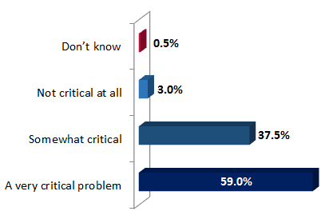

* **59%** of those surveyed believe that the water shortage problem in Jordan is a “very critical problem”. This is followed by **37.5%** considering the problem as a “**somewhat critical issue”**.
* While only **3%** of those surveyed believe that the water shortage is “not critical at all” for Jordan and **0.5%** don’t know whether it is a critical issue or not.

The figure below shows a breakdown per **nationality** and **governorate**:

Figure 15 Perception of the criticality of the water shortage problem in Jordan per Governorate and Nationality

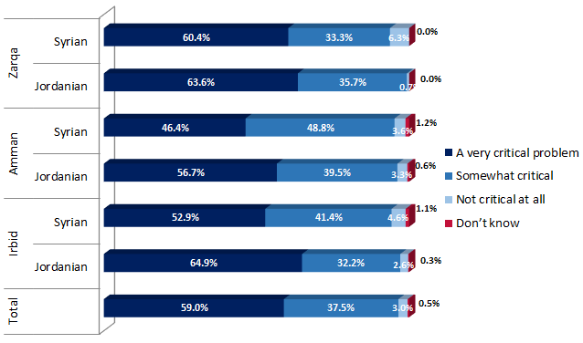

* **Per Geographical Location:**

The highest to believe that water shortage is “a very critical problem” were respondents from **Zarqa Governorate** at **62.8%** of its overall sample followed by **Irbid Governorate** respondents at **62.5%**, while **55.3%** of **Amman Governorate** respondents rated water shortage as “a very critical problem”.

* Respondents from Koura District in **Irbid Governorate** are the highest to rate the water shortage as “**a very critical problem**” at **73%**. This was followed by **Ramtha** **District** in **Irbid Governorate** at **68.1%** and Marka District in **Amman Governorate** at **67.9%**.
* Respondents from Quweismeh District in Amman Governorate are the lowest to rate water shortage as “**a very critical problem**” at **44.7%**, followed by **Amman District** at **48.9%**, and Sahab District at **52.4%**.
* **68.8%** of respondents in Rural areas rate the water shortage as a **very critical problem**, versus **58.3%** in Urban areas.
* **100%** of respondents in Janeen Al Safa (Irbid) see the water shortage as a very critical issue, followed by **88.2%** in Jdeeta (Irbid), followed by **83.8%** of those in Al Duleil (Zarqa Governorate) and **75.7%** of those in Iraq Al Ameer (Amman).

**Per Nationality:** Overall, **Jordanian** respondents rate the water shortage problem in Jordan as a **much more serious issue (a very critical problem)** at all governorates levels than **Syrian** respondents (**60.5%** compared to **52.1%** for the later).

**Age**: Rating the water shortage problem critically tends to increase with aging, where; among the different age groups, those respondents aged 50+ consider the most the water shortage problem in Jordan to be “a very critical problem”, at **62.1%**

**Gender:** **61.2%** of males surveyed believe the existence of a water shortage problem in Jordan is a “**very critical problem**” compared with **56.9%** of females.

|  |  |
| --- | --- |
| **Q3.** | **In your opinion, what are the reasons for the existing problem of shortage in water?** |

Of those respondents that believe the water shortage in Jordan is an issue to some extent, the reasons cited for which are shown below:

Figure 16 Reasons for the existing problem of shortage in water resources in Jordan

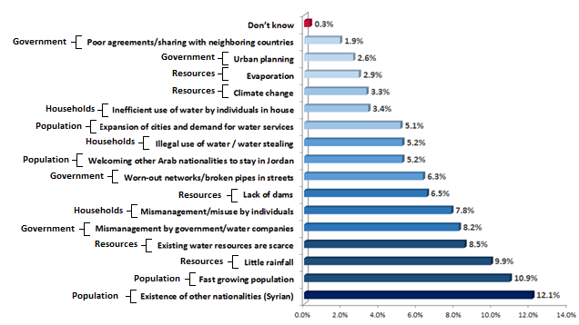

* The highest of all these reasons for the existing problem of water shortage in Jordan is cited as **Population** related reason and specifically related to the existence of other nationalities in Jordan (including Syrian refugees) at **12.1%** of respondents, followed closely behind by the rapidly expanding population at **10.9%**.
* Behind these, **Resources** related reasons followed presented by little rainfall at **9.9%**, then scarcity of existing water resources at **8.5%**, then **Government** related reasons presented by mismanagement by the government and water companies atand **8.2%**, then **Household** related reasons with Mismanagement/misuse by individuals at **7.8%**.
* While the remaining **42.6%** of respondents have given various “**other**” reasons as shown in the above figure. And Only **0.3%** of respondents expressed that they “don’t know”.

**Per Nationality:** The highest number of respondents (**12.5%**) among the **Jordanians** surveyed believed that the existence of other nationalities in Jordan (Syrian refugees) is the biggest cause of water shortages in the country; this was followed by the rapid growth in population (**10.7%**).

* In contrast, **Syrian** respondents felt that the lack of rainfall or little rainfall (**13.5%**) is the biggest reason for water shortage problem. This was closely followed by the scarcity of existing water resources at (**12.4%**) and then the rapidly expanding population (**11.9%**).
* In contrast to the Jordanian respondents, **Syrians** consider the existence of other nationalities including Syrian refugees as a reason at **9.7%** of their overall sample.

**Per Gender and age groups:** Very comparable results appeared among both genders and age groups; where the top three reasons were as per the general sample for all groups as aside and below;

**Other nationalities as a reason 11.2% 12.9%**

**Fast growing population as a reason 10% 11.8%**

**Little rainfall as a reason 9.7% 10.1%**

|  |  |  |  |
| --- | --- | --- | --- |
|  | **Age Group** | | |
|  | **19-29** | **30-49** | **50+** |
| Aware that existence of other nationalities is a reason | *12.0%* | *11.9%* | *12.5%* |
| Aware that the fast growing population is a reason | *11.8%* | *10.6%* | *10.8%* |
| Aware that little rainfall is one of the reasons | *10.2%* | *9.8%* | *9.7%* |

**As per the qualitative approach:**

**FGDs have shown similar finding to survey in that aspect where;**

1. A number of contributing **reasons/factors** were cited as reasons for water shortage problem including;

*“It is definitely a serious problem since there is an increase in population and they are receiving a lot of people”. (FG 6)*

The increase in population (same amount of water is used for more people)/ Water exploitation/misuse (examples of how some people wash their cars with hoses)/ Scarcity of rainwater during most winter seasons/ Water evaporation and Lack of natural resources/ Not having enough dams and wells;

***“Even though the dams fill up during winter but we need more dams to accommodate the quantity of water”. (FG 4)***

- Climate change and global warming/ Difficulty in extracting underground water due to soil rocky nature/ Infrastructure is old/ Poor distribution of water;

***“I called them to ask why our neighbours have water and we do not even though we live on the same street. Unfortunately, there is poor distribution”. (FG 5)***

- Desalination of water is costly and difficult due to the economic hardship in Jordan;

- Poor management of water resources

1. The majority of **Jordanians** blamed the water shortage on the significant increase in **population** in recent years from Syrian refugees and stated this as being the **main reason**:

***“More people are coming to Jordan and we only have a limited amount of water, and it will be hard to divide the same amount to more individuals – in addition to the increase in the number of Syrians and their families”. (FG 1)***

1. While for **Syrians**; the majority of **them** blamed the water shortage on the **scarcity of water resources** in Jordan as a main reason followed by the Syrian influx.

***“The Jordanians suffered from the scarcity of water for not less than 40 years; and when we came to Jordan the burden increased on them” (FG 3)***

|  |  |
| --- | --- |
| **Q4.** | **What are the water resources in Jordan that you’re aware of?** |

The figure shows the surveyed respondents knowledge of the existing water resources in Jordan:

Figure 17 Overall Distribution of Respondents knowledge of the existing water resources in Jordan

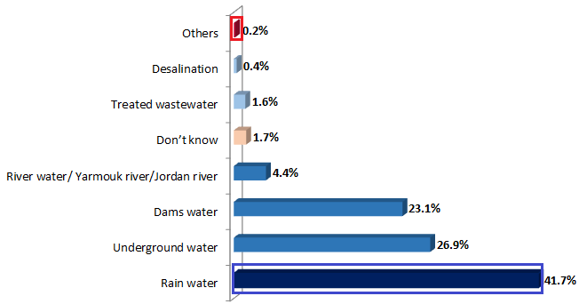

* It is evident from the above figure that “**rain water**” is the most known water resource among the survey respondents, at **41.7%**, followed by “underground water” and “dams water” as resources at **26.9%** and **23.1%** respectively.
* Only **4.4%** of respondents are aware of “river water” as a resource (Yarmouk River/Jordan River), whilst **1.7%** of respondents don’t know of any resources.
* The least known resources are “treated wastewater” at **1.6%** and “desalination” at **0.4%**.
* **0.2%** gave other resources as “Disi aquifer”.

**Governorate:**

* **47.6%** of those in **Irbid Governorate** are mostly aware of “rain water” as a water resource in Jordan, followed by “dams water” at **24.1%**.
* While for those in **Amman Governorate**, mostly are aware of “rain water” as a resource in Jordan at **40.9%**, followed by “underground water” at **28.3%** of its sample.
* In **Zarqa Governorate** “underground water” is the most known water resource in Jordan at **35.5%** followed by “rain water” at **35.2%**.

**Nationality:**

* **45.5%** of **Syrians** are aware of rainwater as a water resource in Jordan compared with **40.9%** of **Jordanians**, while **24.2%** of **Jordanians** are aware of Dams water being a resource in Jordan compared with **17.6%** of **Syrian** respondents.
* **Per Gender and age groups:** Rain water and underground water were acknowledged as the first two sources of water by both genders and among all age groups as per the following percentages;

**Rain water as a source 39.3% 43.8%**

**Underground water as a source 28.9% 25.2%**

**Rain water as a source**

**Underground water as a source**

|  |  |  |
| --- | --- | --- |
| **19-29** | **30-49** | **50+** |
| *41.4%* | *42.7%* | *39.9%* |
| *26.8%* | *25.4%* | *30.1%* |

|  |  |
| --- | --- |
| **Q5.** | **In regards to water saving methods, what methods are you aware of?** |

Figure 18 Overall Distribution of water saving methods awareness

**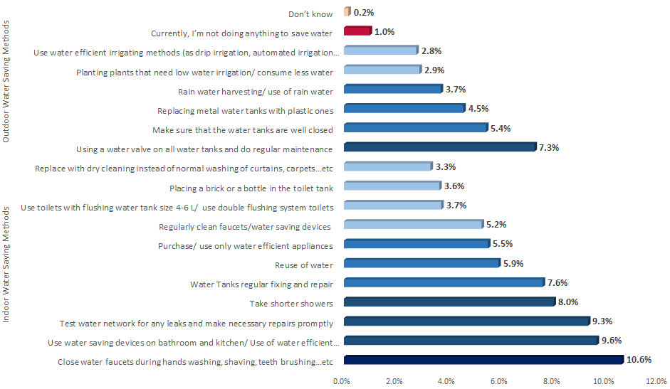**

Regarding sample awareness of water saving methods;

* “***indoor water saving methods***” came in the first ranks, where “closing water faucets” was the most aware of method at **10.6%** of the overall sample followed by “using water saving devices in the bathroom and kitchen” at **9.6%**, “testing water network for any leaks and making necessary repairs promptly” at **9.3%**, “taking shorter showers” at **8%** and then “water tanks regular fixing and repairs” at **7.6%**.
* While regarding the “***outdoor water saving methods***”; respondents were more aware of “using a water valve on all water tanks and do regular maintenance” at **7.3%**, followed by “making sure that the water tanks are well closed” at **5.4%** and then “replacing metal water tanks with plastic ones” at **4.5%**.
* On the other hand; the least aware of saving methods were: “Using water efficient irrigating methods (such as drip irrigation, automated irrigation, sprinkler systems)” at **2.8%** and then “planting plants that need low water irrigation/ less water” at **2.9%** and then “replacing with dry cleaning instead of normal washing of curtains, carpets, bed covers…etc.” at **3.3%**.

**Per Governorate:**

* “**Closing water faucets** during washing of hands, shaving, teeth brushing…etc.” is the most aware of water saving methods across the **three Governorates**, followed by “using water saving devices on bathroom and kitchen” in **Amman** and **Irbid Governorate**. While “testing water network for any leaks and making necessary repairs promptly” followed in **Zarqa Governorate**.

**Per Nationality:**

* “**Closing water faucets**” is the most aware water saving method among **Syrians** and **Jordanians**, at **11.9%** and **10.3%** respectively.
* “Using water saving devices on bathroom and kitchen” and “testing water network for any leakage and making necessary repairs” came next by both Jordanians and Syrians.
* However, **Syrians** were **more aware** than **Jordanians** of **regular maintenance** as a saving method whether through “testing water network for any leaks” or “tank regular fixing”. Further comparisons between Jordanians and Syrians are shown in the matrix below:

|  |  |
| --- | --- |
| **Jordanians More Aware**  **than Syrians in** | **Syrians More Aware**  **than Jordanians in** |
| * Using water Saving devices on bathroom/kitchen * Purchasing/Using water efficient appliances * Regularly Cleaning faucets * Using toilets with water tanks size 4-6 L etc. * Replace with dry cleaning * Replacing metal water tanks with plastic ones * Using a water valve on all water tanks * Planting plants that need low water * Use water efficient irrigation methods * Rain water harvesting | * Close water faucets during hand washing etc. * Test water networks for any leaks etc. * Placing a brick or a bottle in the toilet tank * Take shorter showers * Water tanks regular fixing etc. * Re-use of water * Make sure water tanks are well closed |



* **Per Gender and age groups:** Awareness about water saving methods between genders and among age groups showed that **closing water faucets** was the more aware of method for both genders and among all age groups followed by **using saving devices** within bathrooms and kitchen then **testing water networks for leaks** as per the percentages aside and below;

**Closing water faucets 10.2% 10.9%**

**Using Saving Devices 9.2% 10.1%**

**Testing Networks for Leaks 9.4% 9.2%**

* **Youth** are the most aware of “closing water faucets” and “using saving devices in bathrooms and kitchens” as saving methods than the other 2 age groups as per the percentages below;

|  |  |  |  |
| --- | --- | --- | --- |
|  | **19-29** | **30-49** | **50+** |
| Closing Water Faucets | *10.8%* | *10.5%* | *10.6%* |
| Using saving devices | *10.0%* | *9.6%* | *9.5%* |
| Testing network for leaks | *9.2%* | *9.1%* | *9.7%* |

|  |  |
| --- | --- |
| **Q6.** | **And which of these methods are you currently using to save water in your house?** |

Figure 19 Overall Sample distribution of currently used saving methods

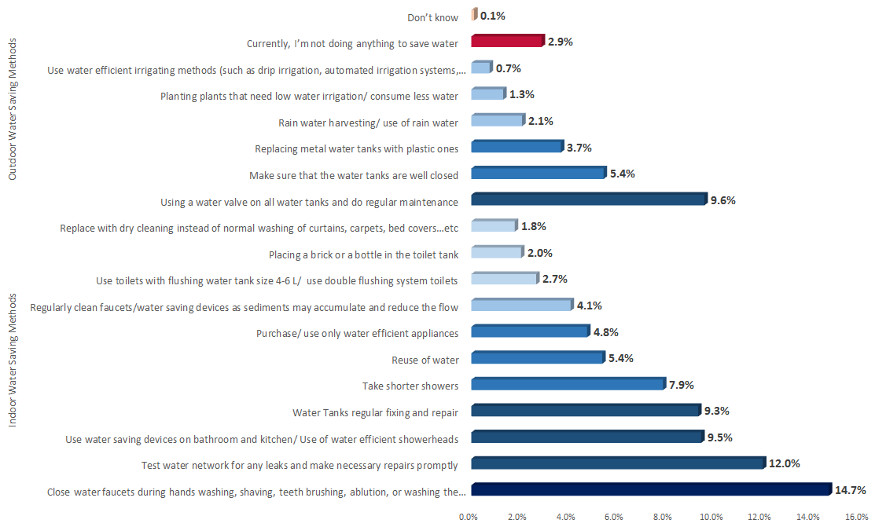

Regarding the current **use of water saving methods** by the surveyed sample;

* **Two** “***indoor water saving methods***” came in the first ranks, where “**closing water faucets**” was the most frequently used water saving method at **14.7%**, followed by “testing water network for any leaks and making necessary repairs promptly” at **12%**.
* Then came an “***outdoor water saving method***”; “using a water valve on all water tanks and doing regular maintenance” at **9.6%**.
* Then followed another **three “*indoor water saving methods***”, which are: “using water saving devices” at **9.5%**, “water tank regular fixing and repair” at **9.3%** and “taking shorter showers” at **7.9%**.
* On the other hand, the least used water saving methods were “using water efficient irrigation methods” at **0.7%**, followed by “planting plants that need low irrigation/consume less water” at **1.3%** and “Replace with dry cleaning instead of normal washing of curtains, carpets, bed covers…etc” at **1.8%**. **2.9%** of respondents confessed being “currently not doing anything to save water”.
* Looking back at surveyed sample **awareness** of “***water saving methods***” and respondents **current real usage** of water saving methods; it is apparent that there is a **big match** between both (**awareness** versus **usage)**. As most surveyed respondents are using mostly the methods they are most aware of its water saving benefits.

**Governorate:**

* “Closing water faucets” and “testing water network” are the **most used** water saving methods **across all three Governorates** and **Zarqa Governorate** has shown the highest percentage of usage of these mentioned methods among the three Governorates at **15.1%** and **13.3%** respectively.
* However, those who are **currently not doing anything to save water** were the highest in **Zarqa Governorate** at **5.9%** of its overall sample.

**Nationality:**

* “Closing water faucets” and “testing water networks for any leaks and making necessary repairs promptly” are also the **most used** water saving methods among **Jordanians** and **Syrians**.
* **Syrians** are more following “taking shorter showers” as a water saving method than **Jordanians** at **10.7%** compared with **7.3%** for the latter. While **Jordanians** are less implementing “regular maintenance” as a water saving method compared with **Syrians** whether through “testing water leaks” or “water tanks regular fixing and repair”.
* **Syrians** who are “**currently not doing anything to save water**” were more than **Jordanians**, at **4.7%** compared to **2.5%** for the latter. Further comparisons between Jordanians and Syrians are shown in the matrix below:

|  |  |
| --- | --- |
| **Water Saving Methods** | |
| **More Used by Jordanians** | **More Used by Syrians** |
| * Using water Saving devices on bathroom/kitchen * Purchasing/Using water efficient appliances * Regularly Cleaning faucets * Using toilets with water tanks size 4-6 L etc. * Replace with dry cleaning * Replacing metal water tanks with plastic ones * Using a water valve on all water tanks * Planting plants that need low water * Use water efficient irrigation methods * Rain water harvesting | * Close water faucets during hand washing etc. * Test water networks for any leaks etc. * Placing a brick or a bottle in the toilet tank * Take shorter showers * Water tanks regular fixing etc. * Re-use of water * Make sure water tanks are well closed |

* **Per Gender:** Current **practices** of water saving methods between genders showed that **closing water faucets** was the most used method by both genders followed by **testing network for leaks, using water valve on tank and using saving devices serially** as per the percentages aside;

**Closing water faucets 13.9% 15.5%**

**Testing Networks for Leaks 12% 12%**

**Using Water Valve of Tanks 9.5% 9.7%**

**Using Saving Devices 9.3% 9.6%**

* **Per Age:** **Youth** are the most to use “closing water faucets” as a saving method than the other 2 age groups as per the percentages below. While youth **test networks** and **use water valves** (less in comparison with middle age and elderly) as below;

|  |  |  |  |
| --- | --- | --- | --- |
|  | **19-29** | **30-49** | **50+** |
| Closing Water Faucets | *14.9%* | *14.8%* | *14.4%* |
| Testing network for leaks | *11.2%* | *12.1%* | *12.4%* |
| Using water valve on tanks | *8.9%* | *9.8%* | *9.7%* |
| Using saving devices | *10.5%* | *9.6%* | *8.4%* |

|  |  |
| --- | --- |
| **Q7.** | **Why are you currently not doing anything to save water?** |

Of the **259 respondents** who said they are currently doing nothing to save water, this question has followed to investigate further the reasons behind that, results were as per the following chart:

Figure 20 Overall distribution of respondents reasons for not doing anything to save water

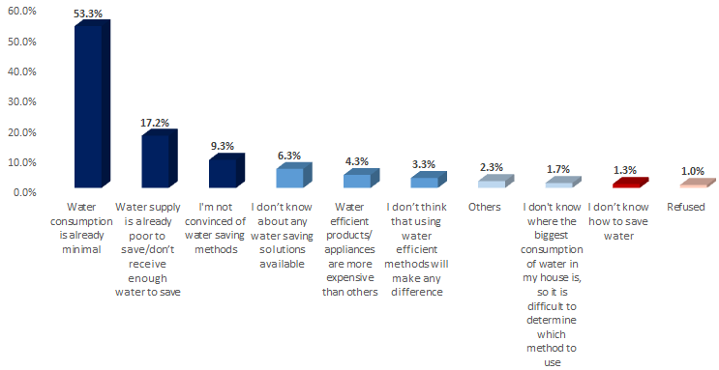

* By far the **most prevalent reason** for not doing anything to save water is cited as “**water consumption is already minimal**”, at **53.3%** of overall responses.
* Following this, the next most prevalent reason is that “water supply is already too poor to save and there is not enough water to save”, at **17.2%**.
* “Not being convinced of water saving methods” followed as the third reason for not using saving methods at **9.3%**, then “don’t know about any water saving solutions available” at **6.3%**, then “water efficient products/appliances are more expensive than others” at **4.3%**.
* While, only **3.3%** “don’t think that using water efficient methods will make any difference” and **2.3%** gave “other” reasons as “living in rented houses” or “expensive cost of changing old pipes”. On the other hand, **1.7%** of expressed that they “don’t know where the biggest consumption of water in their house is, so it is difficult to determine which method to use”.
* Finally, **1.3%** declared that they “don’t know how to save water”.

**Governorate:**

* The most prevalent reason for not doing anything to save water came consistent with the overall sample results for **Amman** and **Zarqa Governorates** where “water consumption is already minimal” as the main reason within these Governorates.
* While for **Irbid**, it was considering “water supply is already poor to save/don’t receive enough water to save” in 1st place, followed by “water consumption is already minimal”.
* “**Not knowing about any water saving solutions**” was apparently the highest at **Zarqa Governorate** at **15.5%** of its sample and also “**not knowing how to save water**” was at **1.9%**.
* While “**not being convinced of water saving methods**” was the highest in **Irbid Governorate** at **10.9%** of its overall sample. In addition, **Irbid Governorate** was the most to consider “water efficient products/appliances are more expensive than others” as a reason for not doing anything to save water, at **6.5%** compared with **Amman** and **Zarqa Governorates**, both at **3.9%**.

**Nationality:**

* **Jordanians** and **Syrians** shared the most prevalent reason for not doing anything to save water of “water consumption being already minimal” and “water supply is already poor/don’t receive enough water to save”.
* **Syrians** considered “the water efficient products are more expensive than others” as more of a reason than **Jordanians** at **6.2%** compared to **3.6%** respectively.

**Gender:**

* The most prevalent reason for not doing anything to save water was “water consumption being already minimal” for both genders by very similar results (by 53.2% of males and **53.4%** of **females**). Followed by “water supply being already poor” for both genders as well and more by **males** than **females** at **19.9%** compared to **14.4%** for the later. While females who **were not convinced of using saving methods** counted more for **females** than **males** at **10.3%** compared to **8.3%** for the later.

**Age:**

* The most prevalent reason for not doing anything to save water was “water consumption being already minimal” for all age groups reaching the maximum by elderly at **57.1%** of its sample. Followed by “water supply being already poor” for all groups as well. While elderly who **were not convinced of using saving methods** counted more than middle aged groups and youth at **11.9%** compared to **9.1 an 6.7%** for the others serially.

|  |  |
| --- | --- |
| **Q7A.** | **Please tell me whether you currently use it in your house or not?** |

Table 7 Overall distribution of respondent’s usage of some machines or water saving techniques

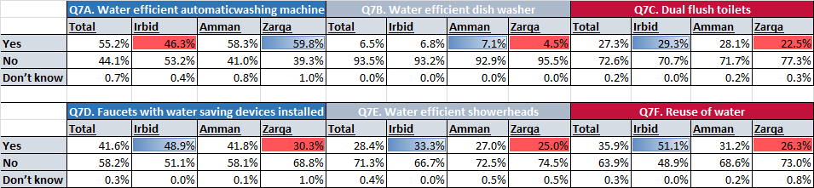

Where;

1. **Water efficient automatic washing machine**

* **55.2%** of respondents of the overall sample said they do use an automatic washing machine, compared with **44.1%** who do not.
* **59.8%** of respondents in **Zarqa Governorate** use an automatic washing machine (the **highest** among Governorates), compared with **46.3%** in **Irbid Governorate** (the **lowest**).

1. **Water efficient dish washer**

* **6.5%** of respondents of the overall sample said they do use a water efficient dish washer, compared with **93.5%** who do not.
* **7.1%** of respondents in **Amman Governorate** use a water efficient dish washer (the highest), compared with **4.5%** in **Zarqa Governorate** (the **lowest**).

**C. Dual flush toilets**

* **27.3%** of respondents of the overall sample said they do use a dual flush toilet, compared with **72.6%** who do not.
* **29.3%** of respondents in **Irbid Governorate** use a duel flush toilet (highest), compared with **22.5%** in **Zarqa Governorate** (**lowest**).

**D. Faucets with water saving devices installed**

* **41.6%** of respondents of the overall sample said they do have faucets with water saving devices installed, compared with **58.2%** who do not.
* **48.9%** of respondents in **Irbid Governorate** said they do have faucets with water saving devices installed (highest), compared with **30.3%** in **Zarqa Governorate** (**lowest**).

**E. Water efficient showerheads**

* **28.4%** of respondents of the overall sample said they do use water efficient showerheads, compared with **71.3%** who do not.
* **33.3%** of respondents in **Irbid Governorate** use water efficient showerheads (**highest**), compared with 25% in **Zarqa Governorate** (**lowest**).

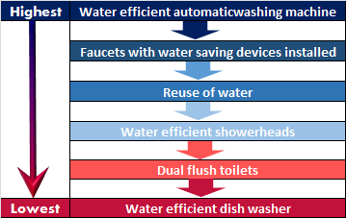

**F. Reuse of water**

* **35.9%** of respondents of the overall sample said they do reuse water, compared with **63.9%** who do not.
* **51.1%** of respondents in in **Irbid Governorate** do reuse water (**highest**), compared with **26.3%** in **Zarqa Governorate** (lowest).

**Nationality: Jordanians** are generally using machines and water saving techniques more than Syrians, except for water reuse where Syrians reuse water more at **39.1%** compared to **35.1%** of Jordanians.



**Gender;**

* **Females** are generally using machines and water saving techniques more than **Males**, and for all the mentioned techniques from A to F as shown;

|  |  |  |  |
| --- | --- | --- | --- |
| **Q7A** | Usage of efficient washing machine | *53.1%* | *57.0%* |
| **Q7B** | Usage of efficient dish washer | *5.7%* | *7.2%* |
| **Q7C** | Usage of dual flush toilets | *25.5%* | *28.9%* |
| **Q7D** | Usage of faucets with saving devices | *40.5%* | *42.5%* |
| **Q7E** | Usage of efficient showerheads | *26.6%* | *30.0%* |
| **Q7F** | Re-use of Water | *33.2%* | *38.2%* |

**Age Groups;**

* **Youth** are generally using machines and water saving techniques more than **the other age groups.** Where **elderly**

|  |  |  |  |  |
| --- | --- | --- | --- | --- |
|  |  | **19-29** | **30-49** | **50+** |
| **Q7A** | Usage of efficient washing machine | *59.3%* | *53.0%* | *55.5%* |
| **Q7B** | Usage of efficient dish washer | *7.5%* | *6.4%* | *5.7%* |
| **Q7C** | Usage of dual flush toilets | *27.8%* | *27.5%* | *26.5%* |
| **Q7D** | Usage of faucets with saving devices | *41.8%* | *43.3%* | *37.8%* |
| **Q7E** | Usage of efficient showerheads | *28.8%* | *29.6%* | *25.7%* |
| **Q7F** | Re-use of Water | *30.1%* | *37.3%* | *38.4%* |

**As per the qualitative approach:**

* **In Water Usage and Consumption**

On the days **when participants receive water**, many of them tend to do cleaning, laundry, car washing and the majority of household members shower. Opinions varied between participants whether to recognise that as a quite inefficient or efficient use of the water resources on that day.

***“You know that the area received water from the smell of Persil and the flooded streets!” (FG1)***

***“I don’t think water is wasted on that day, on the contrary, people postpone all their house work for 1-2 day a week and use water heavily just in that period… This is called efficient use” (FG2)***

Participants again spoke of the importance of **education and raising awareness** for water related conservation issues and how this will help to overcome Jordan’s water shortage. As many **Jordanians** see that water is not used efficiently.

Some of the **Jordanians** referred to their conservation of water through some attitudes and practices as: water re-use, placing a bottle in toilet tank, organizing household chores, and children consumption monitoring. And many agree that water is not that efficiently used:

***“I use one bathroom at home to monitor how children use the water” (FG1)***

***“I use the water coming out of the washing machine to clean the stairs or water the plants” (FG1)***

***“There is a chaos in water consumption, just maybe 40% use it efficiently” (FG4)***

While, most of the **Syrians** referred to their conservation of water through similar attitudes and practices to Jordanians. However, **Syrians** felt that water is more wasted in Jordan (by the locals) than in Syria as they see lot of water running down the streets.

Regarding the use of **water saving technologies**;

* **Very few** stated their only **use** of a certain appliance for taps to save water; while other technologies are very rarely used since many consider them as expensive and in need for regular maintenance. However, some participants **are willing to invest** in water saving technologies if provided at reasonable prices since they are aware of its saving advantage.

Participants cited some **social behaviours/norms as reasons** for a lack of efficient use of water, as:

* Numbers of residents per household;
* Abundance of children in a household and their ages;
* Social gatherings, such as holidays and occasions;
* Showing off wealth
* Showing off cleanliness
* Ignorance

Participants also stated that **social class and wealth** had a lot to do with water wastage, as those living in more affluent areas spend water **more inefficiently** since they own more cars, have maids and gardeners, have larger gardens and even swimming pools.

* **The Syrians in Jordan**

The majority of **Jordanian** participants felt that Syrians **do not use water resources efficiently**, as they were not used to having water shortages in Syria. Many participants stated that Syrians wash too regularly, clean their houses too often and many of the refugees do not value the resources, as for some of them the water bills are paid by other entities/agencies (especially those within camps). However, some Jordanian participants concluded that the situation was much worse during the initial influx of Syrians, but stated that many of them **are now adapting** their behaviours and becoming much more resource-conscious.

***“In Irbid, the areas where Syrians live have turned almost like a river”! (FG9)***

***“Syrians adapted to situation and changed their practices, they have been enforced to” (FG1)***

***“Now Syrians use bottled waters a lot for cleaning dishes as well because they have been used on clean water in dish washing” (FG7)***

**Syrian** participants admitted that they were not used to living with such water scarcity when moving to Jordan, as they had been used to having water readily available 24/7 when in Syria, often washed twice a day in summer, and cleaned their houses considerably more regularly.

***“Syria does not have a water shortage problem, we used to clean the carpets daily but this changed in Jordan” (FG6)***

***“In Syria, water is available always, we used to shower 2-3 times a day! But here we changed” (FG3)***

***“We felt how much we have been blessed when we arrived here. Syria was a heaven in terms of water” (FG3)***

***“We do not dare to use the hoses here in Jordan, unlike the situation in Damascus”. (FG 3)***

***“As Syrians, we are used to consume more water and this is proven by looking at the water bills – as Syrians pay more than Jordanians”. (FG 10)***

However, the **Syrian** participants stated that they **have learnt to adapt their behaviours** and were now very conscious of the water situation in Jordan, so did what they could in order to conserve water supplies.

|  |  |
| --- | --- |
| **Q8.** | **Now thinking about water supply at your house. During this year, have there been times when your house has not been supplied with water?** |

Figure 21 Overall Distribution of Respondents experiencing water supply problem per Overall Sample and per Governorate

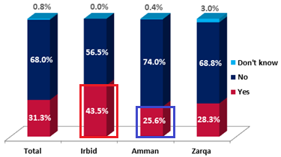

* Nearly one third of respondents have experienced a water supply problem during this year at **31.3%**, while the majority (**68%**) have not experienced that this year. Only **0.8%** of the overall sample stated that they “don’t know”.

**Geographical Location:**

* Respondents from **Irbid Governorate** were the most to experience water supply problems during the year at **43.5%** of its overall sample, especially in **Bani Kenanah** and **Irbid Districts**, at **53%** and **52.9%** respectively.
* Among **Amman governorate districts**; **Wadi Al Seer** was the most to experience water supply problems at **35%** of its overall sample.
* **43.3%** of respondents living in Rural areas face water shortage problems, compared with **30.5%** of respondents in Urban areas.

**Family size:** One of the interesting findings is regarding family size;

*the bigger it is, the more often it will face water supply problems, where;*

* Families with **10+ members** were the highest to experience water supply problems at **39.7%**.

**As per the qualitative approach:**

Several participants stated that they **did not believe their share** of water **was equal** to others, despite paying a similar amount on their water bills.

***“Water is not distributed equally to all areas as some areas receive water for 3 or 4 days while other areas only receive water for one day – and this is unfair” (FG3)***

***“My neighbor has 4 tanks on the roof and another 4 tanks on the ground floor, and I feel that he took my share” (FG4)***

***“My area is divided into 3 sub-areas; I live in Jordan street, close by is Nuzha and Qusoor; though we are in the same area but water share differs from one sub-area to the other” (FG2)***

***“Once the water arrives, my neighbors start their motors and use the water to bathe, clean and do their laundry and finally I receive water the next day” (FG6)***

Many of the participants have therefore added a **second** **water tank** to their home in order to conserve what water they are issued, but many stated that they did not receive enough water to sustain them until their next refill which push them sometimes to **order water tanks**. However, for **Syrians** specifically, they tend to fill extra water gallons to avoid the regular cut-offs or buy water bottles. Most Zarqa residents referred to their common need to have pumps and motors to increase the power of water received.

|  |  |
| --- | --- |
| **Q9.** | **For how long water was not available?** |

For those who experienced water supply problems during this year and counted **625 respondents**, the revealed duration of time water was not available is shown in the following figure:

Figure 22 Overall Sample distribution of duration for water unavailability

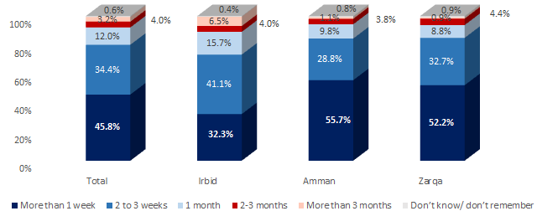

* **45.8%** of overall the respondents mentioned reported that water was unavailable for “more than 1 week”, followed by **34.4%** of respondents who were without water for “2 to 3 weeks”, **12%** for “1 month”, while **4%** were “without water for 2 to 3 months” and **3.2%** for “3 months or more”. Just **0.6%** of respondents stated that they “don’t know”.

**Governorate:**

It is evident from the above figure that in **Irbid Governorate** water was unavailable for the longest duration, as **67.3%** of those who have been cut-off from the water supply there have been without water for **two weeks or more**, especially at **Koura District** where **17.4%** of its overall sample got disconnected for “more than 3 months”, and **Bani Obaid District** where **51.2%** of its overall sample got disconnected for “2-3 weeks”.

* Whereas in **Amman Governorate** and **Zarqa Governorate**, the duration was less as **44.3%** and **47.8%** respectively of the two governorates have experienced water shortages for “two weeks or more”.

**As per the qualitative approach:**

**FGDs have shown similar finding to survey in that aspect where;** There was a real mix among the participants about **how often they receive water**, ranging between one day per week to six days per week, depending on the source of their water and the line their household is connected to. The majority of participants, however, receive water on **average two days per week**. Participants spoke of r**elatively regular water cut-offs (especially during summer)** and suggested the need for municipalities to take more control in terms of water management.

***“When we have visitors, water might not last the whole week and it might cut off prior to receiving the water” (FG3)***

***“Last month, we did not receive water for 2 consecutive weeks and so we had to order water tanks” (FG7)***

***“Two weeks ago, we did not receive water for 8 days and so we had to buy a tank for 12JD” (FG8)***

|  |  |
| --- | --- |
| **Q10.** | **Thinking about your water tanks, how many do you have?** |

Figure 23 Overall distribution of water tank numbers per Household

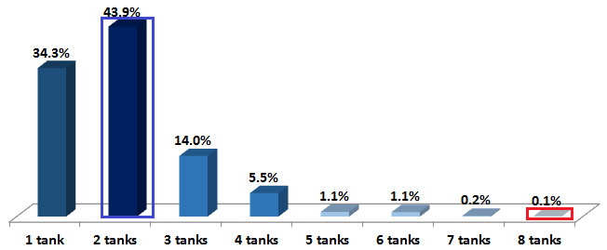

Where;

* **43.9%** of respondents have **2 water tanks**, followed by **34.3%** with only “1 tank”, while those with “3 -4 tanks” followed next at **14%** and **5.5%** of the overall sample respectively.
* **1.1%** of the overall sample had “5-6 tanks” and only 0.2% (4 respondents) have got “7 tanks” and 0.1% (1 respondent) have got “8 tanks”.

**Governorate:** The same results appeared a**cross the three Governorates** were the utmost had “2 tanks”.

* A **bigger number of tanks** was more familiar in **Zarqa Governorate** where around 24.3% of respondents have “3 tanks” and above.

**Nationality:** The utmost of **Syrians** has “**1 tank**” only at **54.7%** of their overall sample, compared to **29.4%** of corresponding **Jordanians**.

**House type:**A larger number of tanks tend to exist more in “**villas**” and “**houses/dars**” at **54.5%** and **31.8%** of their sample respectively.

**Cross tabulation: (Q8 Vs. Q10 Vs. Nationality):**

* As shown aside; the highest percentage of **Jordanians** having a problem in water supply (had times when home was not supplied with water) were the ones who **own 2 tanks at 44.2%**. While for **Syrians** the highest percentage of Jordanians having a problem in water supply were the ones with **1 tank at 46.1%**.

|  |  |
| --- | --- |
| **Q11.** | **Do you have ground level water tank(s), or a roof level water tank(s) only, or both?** |

The distribution of available water tanks per household is shown in the below figure:

Figure 24 Overall sample distribution of available water tank(s) per household

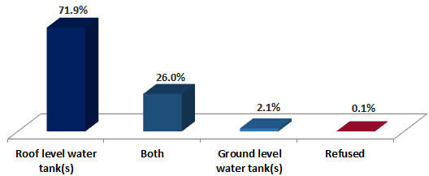

* The **utmost** of respondents has “**roof level water tanks**” **71.9%**, whilst **26%** have “both” (roof and ground level water tanks).
* And just **2.1%** of respondents have only “ground level water tanks” and **0.1%** refused to answer.

**Governorate:**

* Similar results appeared across the three Governorates, where the majority of respondents have “roof level water tank(s)”, especially in **Zarqa Governorate** where that proportion was the highest at **81.3%** of its sample, followed by **Amman Governorate** at **72.5%**.
* **Irbid Governorate** has the highest proportion of those having “both” (roof and ground) level water tank(s) at **33.2%** of its sample.

**Nationality:** Comparable results shown between **Jordanians** and **Syrians**;

* Where “roof level water tank(s)” were the most common among both samples at **81.3%** of Syrian respondents compared to **69.6%** of Jordanians.
* While **Jordanians** having “both” (ground and roof level water tank(s)) counted more than that that portion of **Syrians** at **28.3%** and **16.3%** respectively.

**Family Size:** For the correlation between family size and available tanks; Big families of **10+ members** were the most to have “both” (ground and roof level water tank(s)) among all families at **34.9%** of their sample.

|  |  |
| --- | --- |
| **Q12.** | **Thinking about your water tank(s), do you have water float valve(s) on your tank(s)?** |

Figure 25 Overall distribution of availability of water float valve(s) on water tank(s) at households

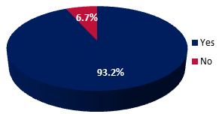

Where;

* The vast majority of respondents **do have water float valves** on their water tanks, at **93.2%**, while only **6.7%** do not have. And very few refused to answer at **0.1%**.

**Governorate:**

* **Zarqa Governorate** ranked the highest in availability of water valves on tanks at **96.5%** of its respondents, followed by **95%** of **Amman Governorate** and **87.5%** of **Irbid Governorate**.
* While **all of Sahab District** respondents turned out to be having water valves, only **79%** of **Ramtha District** respondents at **Irbid Governorate** are having water valves (the **lowest** among all Districts).

**Nationality:**

* **Syrians** having water valves are a bit more than **Jordanians** at **95.1%**, compared to **92.8%** of the latter.

|  |  |
| --- | --- |
| **Q13.** | **Why don’t you have a water float valve(s) on your water tank(s)?** |

For the **134 respondents** who do not have water float valves on their tanks, the reasons were:

Figure 26 Distribution of respondents reasons for not having water float valves on their water tanks

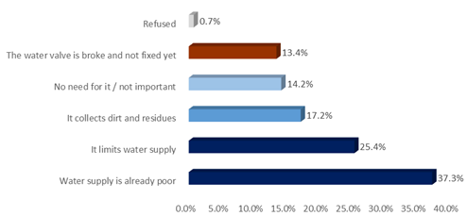

* “**Water supply is already poor**” came in the first place at **37.3%** of the responses. The second highest reason for not having water valves on tank(s) was “it limits water supply” at **25.4%** followed by believing that “it collects dirt and residues” at **17.2%**.
* While **14.2%** thought “no need for it/not important” and for **13.4%** “the water valve is broken and not fixed”.

**Governorate:**

* **50.7%** of respondents in **Irbid** relayed the reason for not having water valves on tank (s) to “water supply being already poor” compared to 24.5% of Amman sample and 14.3% of Zarqa.
* For **Amman Governorate** and **Zarqa Governorate** the reason that “valve limits water supply” was at first place at **28.6%** of both samples.
* While **Zarqa Governorate** was the most to have responses due to “the water valve is broken and not yet fixed” at **21.4%** of its sample.
* **Nationality:**
* The most prevalent reason for not having water valves on tank(s) for “**Jordanians and Syrians**” was **“Water supply is already poor**”. Where **52.9%** of Syrians citing this as their main reason compared to **32%** of Jordanians.

|  |  |
| --- | --- |
| **Q14.** | **In general, do you think that the quality of water arriving to your household tank(s) is drinkable/not drinkable/don’t know?** |

Figure 27 Overall perception of quality of water

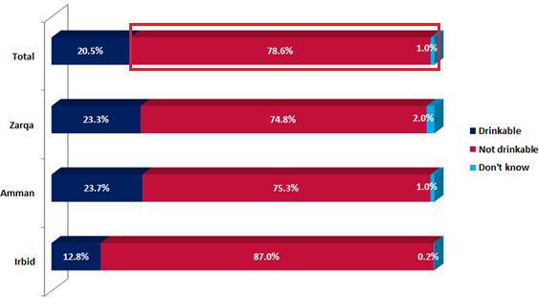

* The vast majority of survey respondents reported that the water they receive is **undrinkable**, at **78.6%** of the overall sample, while **20.5%** saying it is drinkable and **1%** don’t know.

**Governorate: Irbid** Governorate is the most to consider that the quality of water arriving to their household tanks is **not drinkable** at **87%** of its sample, and especially at **Bani Kenanah** and **Koura District** at **91%** and **89%** respectively. And **Kafer Yuba**, **Malka** and **Suhom** Localities at **100%** and **95%** serially.

**Nationality: Syrians** think that the quality of water arriving to their houses is “**not drinkable**” more than their **Jordanian** counterparts at **80.1%** compared to **78.2%** for the latter.

* **Gender; Males** have more considered the **water as drinkable** than females at **21.7%** compared to **19.4%** for the later.
* **Age groups; Elderly** have more considered the **water as drinkable** than the other groups at **24.9%** compared to **16.9%** for youth (the least) and 20% for middle aged group.

**As per the qualitative approach:**

The majority of participants stated that they felt there were significant issues with the **quality** of water they were issued, with it being not suitable for drinking or cooking, polluted, smelly, colourful, and with lots of residuals, chlorine and sand/soil:

***“Water in Jordan Valley and Irbid tastes like Sulphur, but in Amman it is much better. I even worked in Mafraq and water is bad there too” (FG2)***

***“I know some people who drank the tap water when they first came to Jordan and they got diarrhea and so we got scared ever since” (FG3)***

***“Sometimes I find red soil in the washing machine” (FG10)***

***“I rate the water quality to be zero since it is not suitable for anything – even taking showers” (FG10)***

***“Water comes out of the tap ‘Green’ in color” (FG2)***

***“Do you know that water in Zarqa cannot be used even to wash the cars! It spoils the polish!” (FG7)***

***“Water contains lot of Lime/Calcine which enforce me to re-install the pipes and faucets every month” (FG9)***

|  |  |
| --- | --- |
| **Q15.** | **What is your main source of drinking water? Do you drink from?** |

The figure below shows the overall distribution of main source of drinking water per overall sample:

Figure 28 Overall distribution of main source of drinking water per overall sample

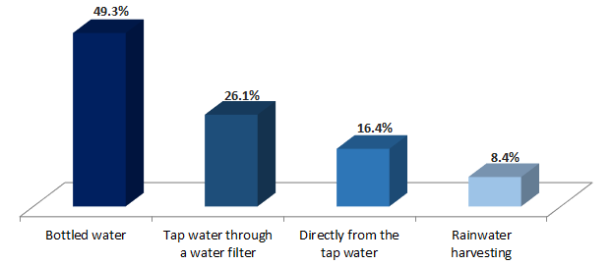

* **Bottled water** is the main source of drinking water among respondents, at **49.3%**, followed by tap water through a water filter at **26.1%**, then directly from the tap water at **16.4%** and lastly rainwater harvesting at **8.4%**.

**Governorate:**

* **“Bottled water**” is the main source of drinking water for **Irbid** and **Amman Governorates**, however, for **Zarqa** “tap water through a water filter” is their main source at **43.8%** followed by “bottled water”.
* **Irbid Governorate** use rainwater harvesting the most among the three Governorates at 27% of its sample, compared with **1%** at **Zarqa Governorate** and **0.9%** at **Amman Governorate**.

**Nationality:**

* “**Bottled wate**r” is the main source of drinking water for both **Jordanians** and **Syrians** and more by **Syrians** than **Jordanians** at **54.7%** compared to **48%** respectively.

**Education:**

* Depending on “**bottled water**” as a main source of drinking water is more common among the upper educated individuals (secondary level education and above).
* **As per the qualitative approach:**

Many participants stressed on the **importance of having water** with good **quality** and their readiness to pay more to get that water as they already spent money on buying filters and bottled water;

***“Water quality is more important than the service or maintenance – clean water is of utmost importance! We are willing to pay more if the water is drinkable” (FG9)***

|  |  |
| --- | --- |
| **Q16.** | **Why don’t you drink directly from the tap water?** |

For the (**1,506 respondent**s) who depended on other sources for drinking water besides drinking directly from the tap; the reasons given were as follows:

Figure 29 Distribution of reasons for not drinking directly from the tap water

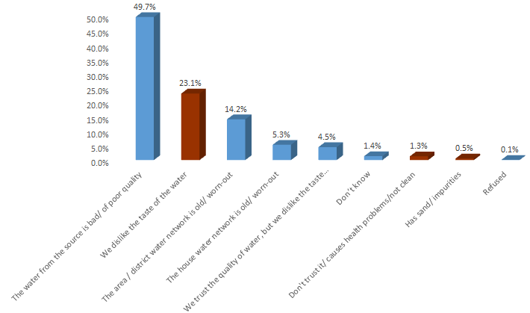

* As can be seen in the above figure, **49.7%** of mentioned respondents don’t drink directly from the tap water because “**the water from the source is bad/of poor quality**”, followed by the second reason “dislike the taste of the water” at **23.1%** and then the reason “the area/district water network is old/warn out” at **14.2%** of the sample.
* While, **5.3%** considered “having an old/warn out network” as a reason for not drinking tap water and **4.5%** for “disliking the taste though trust the quality”.
* Few respondents gave other reasons as “not trusting water/causing health problems/not clean” at **1.3%** or “having sand/impurities” at **0.5%**.

**Geographical Location:**

* Similar reasons appeared across the three Governorates where “**water from the source being bad/of poor quality**” was at the first ranked across **all Governorates** and was the highest at **Zarqa Governorate** **54.9%** compared to **Irbid Governorate** at **43.8%.**
* While **“disliking the taste of wate**r” rated the highest at **Irbid Governorate** at **30%** of its sample

**Nationality:**

* **Jordanians** considered the “water being of bad/poor quality” at a higher rate than Syrians at **50.5%** of Jordanians compared to **46.5%** of Syrians.
* While **Syrians** “disliked the taste of water” more than **Jordanians** at **27.5%** compared to **22%** for the latter.

|  |  |
| --- | --- |
| **Q17.** | **Is this house connected to the Sewage System/ sewer network?** |

Figure 30 Distribution of Households’ Connection to Sewer System per Overall Sample

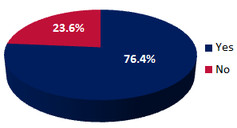

* The majority of respondents houses **are connected** to the sewer system at **76.4%,** while **23.6%** are not connected.

**Geographical Location:**

* **88%** of respondent’s households surveyed in **Zarqa Governorate** are connected to the sewer system, followed by **84.8%** in **Amman** and the lowest number in **Irbid Governorate** at **53.2%**. Specifically, in Bani Kenanah District where only **5%** of respondents stated that their house is connected to the sewer system. This was followed by Koura District, which is not far behind with only **11%** connected.
* In **Urban** areas **79.8%** are connected to the sewer system in comparison to only **22.5%** in **Rural** areas.

**House Type:**

* **81.5%** of respondents in apartments are connected to the sewer system, followed by **66.2%** of those in houses/dar and **54.5%** of those in villas.

|  |  |
| --- | --- |
| **Q18.** | **In which way do you get rid of wastewater in your house?** |

For those who are not connected to the sewage system/sewer network in their houses and counted 472 respondents **(23.6%)** of the overall sample based on question 17**;** this question has followed to know more about the used ways to get rid of wastewater. And results were as follows:

Figure 31 Distribution of Ways to get rid of Wastewater in Houses

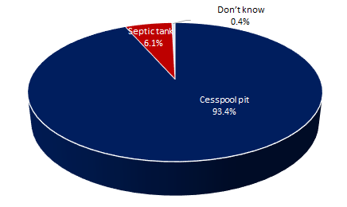

* “**Cesspool pit**” came first by the majority of those who are not connected to sewage system at **93.4%** of their overall sample
* “**Sceptic Tank**” followed next at **6.1%** of those who are not connected to sewage system. While just **.4%** expressed that they don’t know the way of getting rid of wastewater.
* Similar results appeared across the **three governorates** where “**Cesspool pit**” came first by the majority of those who are not connected to sewage system at **95.9%** of their overall sample at **Irbid** governorate, at **91.7%** of their overall sample at **Amman** governorate and at **85.4%** of their overall sample at **Zarqa** governorate.
* **Sceptic Tanks** seemed the most used at **Zarqa** governorate among governorates at **14.6%** of those who are not connected to sewage system and generally more in (**Rural**) areas than (**Urban**) areas; at **9.7%** compared to **5.3%** of those who are not connected to sewage system at the mentioned areas successively.

|  |  |
| --- | --- |
| **Q19.** | **And how often do you get rid of wastewater in your house?** |

Survey responses on the frequency to get rid of wastewater at their houses were distributed per **overall sample and governorate** as the chart below illustrates.

Figure 32 Overall Distribution of Frequency to get rid of Wastewater in Houses

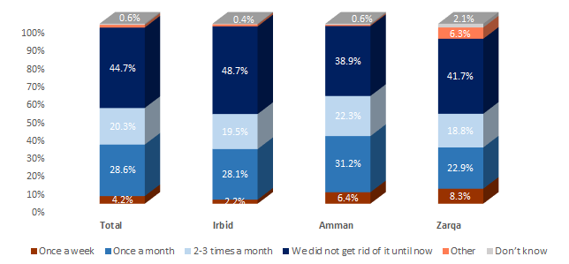

The figure reveals:

* **The utmost** of the overall sample of those who are not connected to sewage system did not get rid of wastewater at their houses until now at **44.7%** of their overall sample. Followed by **28.6%** who get rid of wastewater **once a moth** and then **20.3%** (**2-3 times a month**). While only 4.2% get rid of wastewater once a week and 1.5% declared other frequencies as (once every 3-4 months or every 6-12 months). And .6% expressed that they don’t know how frequent they do that.
* Very similar results appeared across the **three governorates** where “**Not getting rid of wastewater until now**” came first by the utmost of those who are not connected to sewage system at its **highest** of **48.7%** of overall sample at **Irbid** governorate, followed by **41.7%** of the overall sample at **Zarqa** governorate and lastly at **38.9%** of the overall sample at **Amman** governorate.
* **Amman** respondents are the **utmost frequent** among governorates in getting rid of wastewater; where around **59.9%** of those who are not connected to sewage system there get rid of their wastewater between once a week to several times a month.

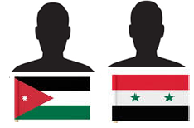

* **Syrians** who **did not get rid of wastewater until now** were the highest among Syrians who are not connected to sewage system and more than its compared percentage among Jordanians, percentages were **49.5%** and **43.5%** respectively.

**43.5% 49.5%**

|  |  |
| --- | --- |
| **Q20.** | **Do you conduct regular checks and maintenance on your house water network which includes (water pipes, tanks, faucets, and/or toilet tanks)?** |

The figure below shows the variation between respondents who conduct regular checks and maintenance on their household water network, disaggregated between Jordanians and Syrians in each of the three Governorates surveyed:

Figure 33 Sample Distribution of respondents who conduct regular checks and maintenance on their house water network per Nationality and Governorate

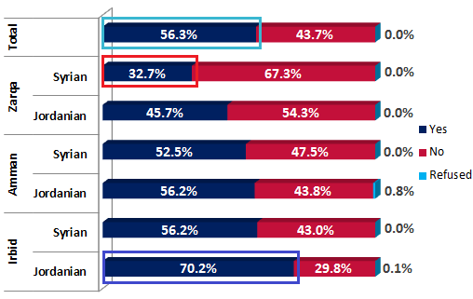

* Among the overall sample of respondents, **56.3%** conduct regular checks and maintenance on house water network. While **43.7%** declared the divergent stream of not conducting regular checks and maintenance and only **0.1%** refused to answer.
* Jordanian respondents in **Irbid Governorate** were by far the most active in terms of maintaining their network at **70.2%** of those surveyed, followed by Syrians in **Irbid Governorate** and Jordanians in Amman, both at **56.2%**.
* Syrians in **Amman Governorate** were less active, with respondents conducting regular checks of their water network at **52.5%**, followed by Jordanians in **Zarqa Governorate** at **45.7%**.
* The **least proactive** respondents in terms of carrying out regular maintenance checks were Syrians in **Zarqa Governorate** at **32.7%** of surveyed respondents.
* **Males** respondents confessed **conducting maintenance** to house networks more than the percentage given by females’ respondents in regard to their houses at **60.3%** compared to **52.6%** for the later.
* **Elderly** respondents confessed **conducting maintenance** to house networks more than the percentage given by middle aged and youth respondents at **60.4%** compared to **55.9% and 52.6%** for the other groups serially.

So in general, Survey showed that Jordanians conduct regular checks and maintenance more than Syrians

|  |  |
| --- | --- |
| **Q21.** | **And how often do you do that?** |

Survey responses on the **frequency** to conduct regular checks and maintenance for house water network for the 1125 respondents (**56.3%** of the overall sample) who reported conducting these regular checks and maintenance in question 20 were distributed per **overall sample and governorate** as the chart below illustrates;

Figure 34 Overall Distribution of Frequency to conduct regular checks/ maintenance for house water network

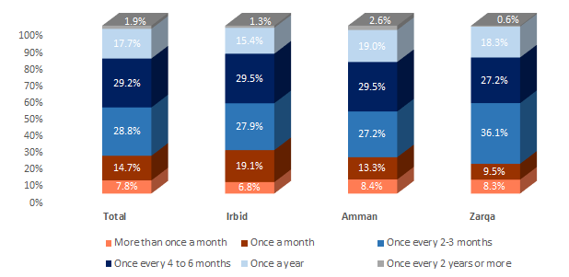

* **The utmost** of the overall sample of those who conduct regular checks and maintenance for house water network conduct checks/maintenance once every 4-6 months at **29.2%** of that sample. Followed by **28.8%** of those who conduct checks/maintenance once every 2-3 months. While **22.5%** conduct that maintenance **more** often**; 14.7% once a month** and **7.8%** **more than** **once a month**. And **19.6%** conduct that maintenance **less** often**; 17.7% once a year** and **1.9%** **once every 2 years or more.**
* **Per Governorates:** Maintenance over “**4-6 months**” came 1st by the utmost of those who conduct regular checks/ maintenance for house network at **Irbid** and **Amman** governorates at **29.5%** of overall sample in both governorates. Followed by those who conduct checks/maintenance once every 2-3 months at **27.9%** and **27.2%** consecutively. While in **Zarqa** those who conduct checks once every 2-3 months were the utmost at **36.1%.**
* **Per Nationality: 27.4% of Syrians** conduct that maintenance **more** often**; 19.4% once a month** and **8.1%** **more than** **once a month**. Compared to **21.5% of Jordanians** whoconduct that maintenance **more** often**; 13.7% once a month** and **7.8%** **more than** **once a month**.
* On the other hand **15.6% of Syrians** conduct that maintenance **less** often**; 15.1% once a year** and **.5%** **once every 2 years or more.** Compared to **20.3% of Jordanian** whoconduct that maintenance **less** often**; 18.2% once a year** and **2.1%** **once every 2 years or more.**
* **Per Gender: 29.3% of males** expressed that they conduct the maintenance every 2-3 months followed by **27.3%** who do it every 4-6 months. However, **31% of females** expressed that maintenance is conducted every 4-6 months in their houses followed by 28.3% who said that it is conducted every 2-3 months.
* **Per Age: 30.6% of youth** expressed that they conduct the maintenance every 2-3 months followed by **26.2%** who do it every 4-6 months. However, **31.2% of elderly** expressed that maintenance is conducted every 4-6 months in their houses followed by 27.3% who said that it is conducted every 2-3 months.

|  |  |
| --- | --- |
| **Q22.** | **After you find out that there is a water leak in your house, how long does it take to fix that leak or to do maintenance for your house water network?** |

Survey responses on the **duration** spent till conducting maintenance or fixing a water leak in house water network for the 1125 respondents (**56.3%** of the overall sample) who reported conducting these regular checks and maintenance in question 20 were distributed per **overall sample and governorate** as the chart below illustrates;

Figure 35 Overall Distribution of Duration spent till conducting maintenance or fixing a water leak in house network

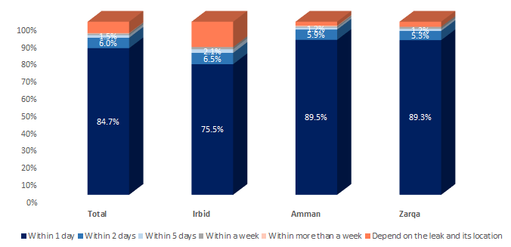

The figure reveals:

* **The utmost** conduct **maintenance or fixing** for a water leak in house water network within 1 day of its noticing at **84.7%** of that sample. Followed by **6%** of those who conduct the maintenance or fixing within 2 days, **1.5%** within **5 days**.
* While **.9%** within a week and **.3%** within more than a week.
* On the other hand, **6.6%** reported that it **depends on the leak and its location**.
* **Per Governorates:**

**The majority** conduct **maintenance or fixing** for a water leak in house water network within 1 day of its noticing at its **highest** of **89.5%** of overall sample at **Amman** governorate, followed by **89.3%** of the overall sample at **Zarqa** governorate and lastly at **75.5%** of the overall sample at **Irbid** governorate.



**85.8% 79%**

* **Per Nationality:**
* **Jordanians** conducting **maintenance or fixing** for a water leak in house water network within 1 day of its noticing were around **85.8%** of their overall sample compared to **79%** of **Syrians**
* **As per the qualitative approach:**
* Most of the **Jordanian** participants clean their water tanks in the **summer or once every year** and they mostly check the taps around the house for leakage and the pipes **from time to time (long period) and mostly just when a problem occurs**. If a problem occurs, it is usually fixed **within the same day** by the plumber.

***“If nothing got ruined why shall I search for the problem!” (FG1)***

***“We discovered we have a problem when we got a very high priced bill” (FG1)***

***“I go and check the tanks if I saw the water dropping” (FG2)***

***“I check the pipes for leakage every 10 years” (FG4)***

* **Jordanians** in **Irbid governorate** tend to do maintenance more regularly as they kept complaining of the water quality (high levels of Calcine).
* For **Syrians** participants; they depend more on themselves in solving water problems. Some of them were surprised to see how some Jordanians might leave a leaking tap unfixed in their houses.

***“When we used to look for a house to rent, we got shocked how the water faucets were all not functioning and dropping water… Some people here don’t care and don’t solve such problems” (FG3)***

***“Jordanians should be more cautious in water consumption since they are aware that there is a water shortage problem and water is a gift from God, they must use it more efficiently…. Jordanians are careless specially in maintenance” (FG3)***

|  |  |
| --- | --- |
| **Q23.** | **Do you have a garden?** |

Figure 36 Overall distribution of garden availability per households

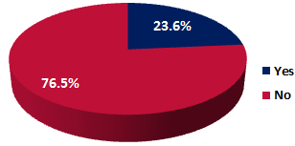

* Among the overall sample of surveyed respondents, only **23.6%** **have a garden**, while the majority do not have one at **76.5%**.
* Respondents from **Irbid Governorate** have gardens the most at **27.7%** followed by **Zarqa Governorate** at **27.5%**, while just **19.7%** in **Amman Governorate** have a garden.
* **Jordanian** respondents have more gardens than **Syrians**, at **26.9%** compared to **9.6%** for the latter.

|  |  |
| --- | --- |
| **Q24.** | **What is the source of water you use to irrigate your garden?** |

The **source of water** used to irrigate gardens, at the **471** respondents who stated the availability of gardens at their households, were categorized as per the following Pareto chart:

Figure 37 Sources of Water Used in Irrigating Gardens

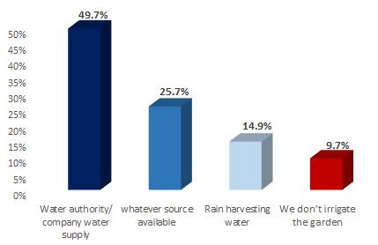

Where;

* **Water Authority/Company Water Supply** ranked the highest at **49.7%,** followed by whatever source available at **25.7%,** thenrain harvesting waterat **14.9%.** While **9.7%** declared that they “**don’t irrigate their gardens**”.

**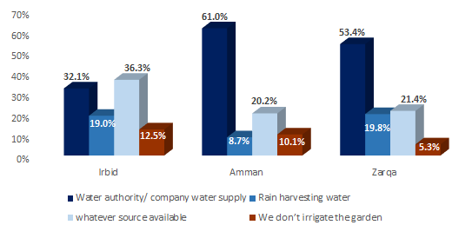Per Governorates;**

* **Water Authority/Company Water Supply** ranked the highest as well at **Amman and Zarqa** governorates **61%** and **53.4%** successively.
* While in **Irbid** governorate; “**whatever source available**” ranked the highest by **36.3%** of those having gardens there.
* The highest percentage of those who don’t irrigate their gardens appeared in **Irbid** governorate at **12.5%** of those having gardens there.

**Per Locality Description;**

* **Water Authority/Company Water Supply** ranked the highest as a source for **Urban localities**.
* While **whatever source available** ranked the highest as a source for **rural localities.**
* **Rain harvesting water** appeared to be used more as a source for irrigation by **rural localities** than **Urban localities**.

**Per Nationality;**

* **Water Authority/Company Water Supply** ranked the highest as a source as well for both **Jordanians and Syrians**. While **rain harvesting water** appeared to be used more as a source for irrigation by **Syrians** than Jordanians at **23.8%** compared to **14.1%** for the later.

**Per Gender;**

**Water Authority/Company Water Supply** ranked the highest as a source as well for both (males and females) but by **females** more than males at **53.5%** compared to **44.5%** for the later as per the table below then followed by **whatever source available** at comparable results between both then finally **rain harvesting** (which is used more as a source by **males** than **females**);

|  |  |  |
| --- | --- | --- |
| Using water authority as a source | *44.5%* | *53.5%* |
| Using whatever source available | *25.7%* | *25.8%* |
| Rain harvesting | *17.9%* | *12.7%* |

**Per Age Groups;**

**Water Authority/Company Water Supply** ranked the highest as a source as well for all groups but by **youth** more than others at **58.6%** compared to **48.8%** middle aged and **42.3%** for **elderly**. While **rain harvesting** (is used more as a source by **elderly and middle aged** than **youth** at 15.4%, 14.8% and 14.5% serially.

|  |  |
| --- | --- |
| **Q25.** | **Usually, how do you irrigate your garden?** |

The **method** used to irrigate gardens, for the **421** respondents who (stated the availability of gardens at their households and depended on a certain source of water to irrigate the garden as per question 24), were categorized as per the following Pareto chart:

Figure 38 Method Used in Irrigating Gardens

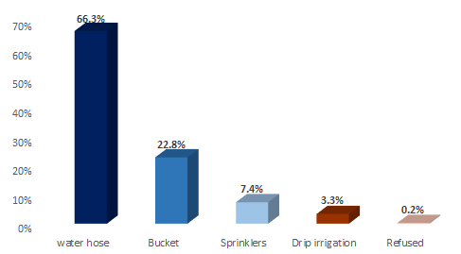

**Water Hose** ranked the highest at 66.3**%,** followed by bucket at **22.8%,** thensprinklesat **7.4%.** While **drip irrigation** is the least used method to irrigate gardens at **3.3%.** While .2% refused to answer.

**Per Geographical Location;** Similar results appeared across all **governorates**. Where, **Water Hose** ranked the highest**,** followed by bucket**,** thensprinkles**.** While **drip irrigation** turned to be the least used method at all governorates.  **Water hose** appeared to be used more as a method for irrigation by **rural localities** than **Urban localities**. While **drip irrigation** is never used at **rural localities.**

**Per Nationality;** Similar results appeared between **Jordanians and Syrians** in methods used to irrigate gardens. Where, **Water Hose** ranked the highest for both**,** followed by bucket**,** thensprinkles**.** While **drip irrigation** turned to be the least used method to irrigate gardens. However, when it comes to **bucket** use in irrigation, **Syrians** tend to be using that method more than **Jordanians** at **34.3%** compared to **21.8%** for the later.

**Per Gender; Water Hose** ranked the highest for both, followed by bucket which appeared to be more used by **females** than males at **27%** compared to 16.9% for the later, while sprinkles were more used by males than females as below;

|  |  |  |
| --- | --- | --- |
| Water Hose Usage | *66.7%* | *66.0%* |
| Bucket Usage | *16.9%* | *27.0%* |
| Sprinkles Usage | *12.4%* | *3.7%* |
| Drip Irrigation Usage | *3.4%* | *3.3%* |

**Per Age; Water Hose** ranked the highest for all, followed by bucket which appeared to be more used by **elderly** than the other ages as per the below percentage;

|  |  |  |  |
| --- | --- | --- | --- |
|  | **19-29** | **30-49** | **50+** |
| Water Hose Usage | *64.8%* | *69.8%* | *62.5%* |
| Bucket Usage | *23.0%* | *20.1%* | *26.7%* |
| Sprinkles Usage | *5.7%* | *7.8%* | *8.3%* |
| Drip Irrigation Usage | *6.6%* | *2.2%* | *1.7%* |

|  |  |
| --- | --- |
| **Q27.** | **Do you know how your water bill is calculated?** |

Figure 39 Overall sample knowledge of water bill calculation

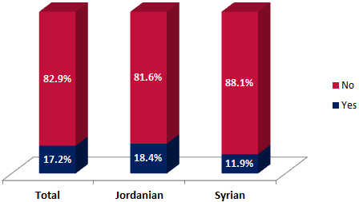

* Among the overall sample, only **17.2%** of respondents know how their water bill is calculated while the majority lack the knowledge of water bill calculation at **82.9%**.

**Governorate:**

* Knowledge of water bill calculation is limited across all Governorates, but especially at **Irbid Governorate** at **15.8% (lowest)**, followed by **Amman Governorate** at **17.4%** and then **Zarqa Governorate** at **18.5%**.

**Nationality:**

* **Jordanians** tend to know how to calculate their water bills more than **Syrians**; where **18.4%** of **Jordanians** know that compared to **11.9%** of **Syrians**.

**Age:**

* The most knowledgeable age group in water bill calculation is the **50+ range** at **23.3%** of their sample size, followed by the 30-49 range at **17.4%**, then the 19-29 range at **10.0%**.

**Gender:**

* **21.2%** of **male** respondents know how their water bill is calculated versus **13.6%** of **female** respondents from the overall sample.

**As per the qualitative approach:**

The majority of participants either had **little understanding or only a vague** knowledge **of how their** **water bill is calculated**, but few showed an in-depth understanding of the calculation.

***“The bill is based on consumption of cubic meters; but I don’t know how” (FG1)***

***“I know that they charge you 1JD per meter of water for the first 10 meters and then they start charging you 2JD per meter after that – it is accumulative” (FG4)***

***“Charging is per meters and they add waste and sewage fees” (FG7)***

***“I once calculated the cost; it is around 45 piasters per meter” (FG10)***

**Syrians** have no knowledge at all of how water bill is calculated since they pay directly to house lords. And many of **Syrians** gave some examples that showed they are exploited by house lords who charge them more than the required amounts.

The majority of participants think that they **are paying more than the water services** they are getting now. Many of the participants showed a **willingness to pay more for their bill** if there was an increase in the water quality and avoid of water cut-offs (even **Syrians**), as they stated that the water they receive at present is of very low quality; undrinkable, often white with chlorine, and regularly run out. If water became clean and drinkable, that would save them a significant amount on buying bottled water.

***“It would be feasible for me to pay more for the water I receive if it was safe for my children to drink from without getting sick, I will stop buying bottled water that costs me around 25JD a month” (FG1)***

***“If we get clean water like Disi, we are ready to pay even 10 JD more” (FG5)***

***“I am ready to pay more if I can drink from the water tap directly” (FG11)***

|  |  |
| --- | --- |
| **Q28.** | **Do you know the cost per cubic meter of water that the government pays to deliver water to your home?** |

Figure 40 Overall sample knowledge of the cost per cubic meter of water that the government pays to deliver water to homes

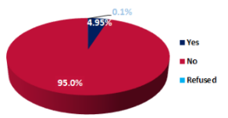

* Almost **95%** of respondents don’t know the cost per cubic meter of water that the Government pays to deliver water to their homes and very few respondents of **4.95%** do know that cost. And just **0.1%** refused to answer.

**Nationality: Syrian** respondents are less knowledgeable in the cost per cubic meter of water that the government pays to deliver water to their home at **3.1%** of knowledgeable respondents compared with **5.4%** of Jordanian respondents.

**Gender: 6.3%** of **male** respondents know the water cost per cubic meter versus **3.8%** of **female** respondents from the overall sample.

**Age:** The most knowledgeable age group in water cost is the **50+ range** at **6.5%** of their sample size, followed by the 30-49 range at **5.4%**, then the 19-29 range at **2.3%**.

|  |  |
| --- | --- |
| **Q29.** | **In your opinion, what are the main elements of this cost?** |

In relation to the above question, the figure below shows the distribution of the **knowledgeable 99 respondents** opinions of the main elements of the cost per cubic meter of water that the government pays to deliver water to their homes:

Figure 41 Distribution of perceptions of main elements of water cost per cubic meter

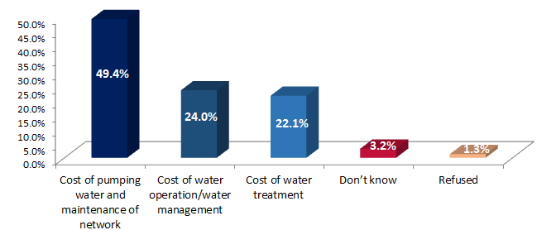

* As can be seen from the above figure, **49.4%** of the mentioned respondents are of the opinions that the main elements of this cost is the cost of pumping water and establishment and maintenance of the network, followed by **24%** stating it is the cost of water operation/water management, and **22.1%** stating it is the cost of water treatment.
* While **3.2%** don’t know and **1.3%** refused to answer.

**Geographical Location:**

* Similar results appeared across the three Governorates where “cost of pumping water the establishment and maintenance of network” was foreseen as the first main element of water cost per cubic meter and it was highest in **Irbid Governorate** at **53.4%** of its sample.
* While **Zarqa Governorate** respondents considered the “cost of water treatment” as an element more than other Governorate at **28.1%** compared to **21.9%** and **19%** for **Amman Governorate** and **Irbid Governorate** serially.

**Nationality:**

* “Cost of pumping and maintenance of network” is the main element of cost considered by **Jordanians** and **Syrians**.

|  |  |
| --- | --- |
| **Q30.** | **Now, thinking about your governorate, in general, how would you compare the water supply with other governorates?** |

The figure below shows overall sample distribution of how respondents would compare the water supply for their governorate with other governorates:

Figure 42 Overall Sample Distribution of how respondents would compare the water supply for their governorate with other governorates

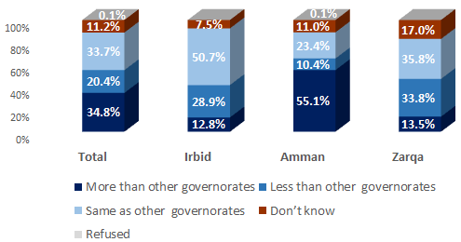

* As can be seen in the above figure at the overall sample level, **34.8%** of respondents say their **water supply is more than other Governorates**, followed by **33.7%** who find it is the same as other Governorates, while **20.4%** find it is less than other Governorates.
* On the other hand, **11.2%** of respondents don’t know how to compare their water supply to other governorates and just **0.1%** refused to answer.

**Governorate:**

* The utmost of **Amman Governorate** respondents say their water supply is **more than other Governorates** at **55.1%**, followed by **23.4%** who say it is the same as other Governorates, then lastly **10.4%** who say it is less than other Governorates.
* The utmost of respondents in **Irbid Governorate** say their water supply is the **same as other Governorates** at **50.7%**, followed by **28.9%** who say it is less than other Governorates, followed by **12.8%** who say it is more than other Governorates.
* **35.8%** of respondents in Zarqa say their water supply is the **same as other Governorates,** followed by **33.8%** who say it is less than other Governorates, then last by **13.5%** who say it is more than other Governorates.

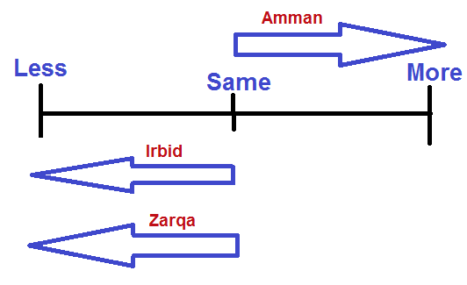

|  |  |
| --- | --- |
| **Q31.** | **Why do you think so?** |

In correlation with the above question, the below figure shows the reasons given by the **407 respondents** who said that their Governorate’s water supply is less than other Governorates:

Figure 43 Overall Distribution of reasons for considering water supply less than other governorates

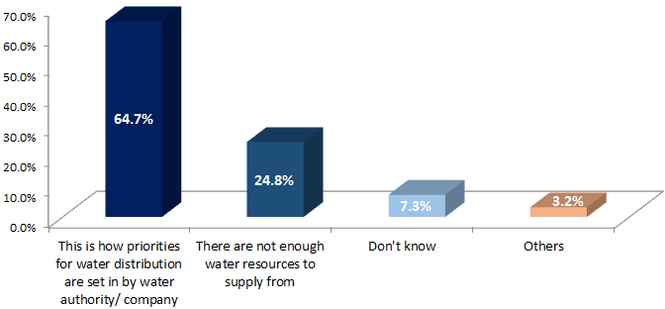

* **64.7%** of respondents considered water supply in their Governorate less than others due to “how priorities for water distribution are set by the water authority/company”, followed by **24.8%** who considered that due to the fact that “there are not enough water resources to supply from”.
* **3.2%** gave “other” options as (unjust water distribution among governorates at 1.4% or large number of people at **1.8%),** while **7.3%** of respondents don’t know.

**Governorate:**

* **73.2%** of respondents from **Zarqa Governorate** relay the reason for “how priorities for water distribution are set by the water authority/company”, compared to **62.4%** of **Irbid Governorate** and **57%** of **Amman Governorate** sample.
* **27.7%** of respondents from **Irbid Governorate** relay the reason for “not having enough water resources to supply from”, followed by **25.4%** from Amman and **20.8%** from Zarqa.

**Nationality:**

* Jordanians and Syrians agree that the reason is mostly related to “how priorities for water distribution are set in by water the authority/company” by **64.9%** of Jordanians compared to **63.6%** of Syrians.

|  |  |
| --- | --- |
| **Q32.** | **As you may know, the Government has made several efforts and investments to provide more water for residents. I will read to you a list of key water projects in Jordan that might have affected your area. For each one, please tell me to what extent have you heard about this project?** |

Surveyed sample ‘s **knowledge about key water projects** in Jordan came as follows:

Table 8 Knowledge about Key Water Projects in Jordan per overall sample and per Governorate

****

Where;

**A. Disi Water Project**

* The **utmost** of the overall sample **(58.3%)** had heard at **a great deal** about the arrival of **Disi water** to the North and to Amman. Followed by **25.4%** who had heard **a fair amount** about that project.
* **While (15.8%)** had expressed their **divergent** opinion towards that; totaled from those who had not heard that much at **6.3%** and those who heard nothing at all at **9.6%**. And just very few respondents stated that they do not know at .5% or refused to answer at .1%

**B. Projects to improve water supply in the North**

* The **utmost** of the overall sample **(71.3%)** had not that heardabout the projects to improve water supply in the North; totaled from those who had heard **nothing at all** at **55.8%** and those who **had not heard much** at **15.5%**.
* **While (27.6%)** had expressed their **divergent** opinion towards that; totaled from those who had heard a fair amount at **20.7%** and those who heard a great deal at **6.9%**. And just very few respondents stated that they do not know at 1.1% or refused to answer at .1%

**C. Projects for the Rehabitation of the water in general and sanitation network in particular**

* The **utmost** of the overall sample **(60.1%)** had not that heardabout the projects for re-habitation of water in general and sanitation network in particular; totaled from those who had heard **nothing at all** at **41.7%** and those who **had not heard much** at **18.4%**.
* **While (39.1%)** had expressed their **divergent** opinion towards that; totaled from those who had heard a fair amount at **27.7%** and those who heard a great deal at **11.4%**. And just very few respondents stated that they do not know at .8%

Surveyed Sample Knowledge about the three key projects were as per the following sequence:

**Disi Project ›** Re-habitation and Sanitation Projects **› Water Supply Projects in the North**

**Per Geographical Location;**

* Respondents from **Zarqa** governorate were the **most to know** about **Disi Water** Project at **89.5%** of its overall sample. However, they were **the least to know** about the other two projects (water supply project in the north and re-habitation/sanitation project); as **78.5%** and **62.5%** of **Zarqa** governorate overall sample have not heard that much of the two consecutive mentioned projects.
* Respondents from **Irbid** governorate were the **most to know** about **water supply project in the north** at **41.6%** of its overall sample. However, they were **the least to know** about **Disi Water** Project at **69.8%** of its overall sample. Specially at **Irbid** and **Koura** **district**.
* Respondents from **Sahab and Rusaifeh** **districts** were the **least to know** about **water supply project in the north** as **only 13% and 17%** of their overall sample consecutively have heard of the mentioned project. Respondents from **Sahab and Amman** **districts** were the **least to know** about **water re-habitation/sanitation** projects as **only 32% and 28.3%** of their overall sample consecutively have heard of the mentioned project.

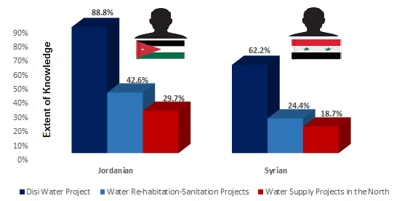**Per Other Characteristics;**

* **Jordanians** are in general **more knowledgeable** of the mentioned projects than **Syrians**
* **Syrians** have heard of Disi Water project more than the other two mentioned projects; where just **24.4%** and **18.7%** of Syrians have heard of water re-habitation/sanitation project and water supply projects in the north serially.
* **Middle aged** groups were more to know or have heard of the projects than **youth**
* **Males** are in general **more knowledgeable** of the mentioned projects than **Females**

|  |  |  |  |  |  |
| --- | --- | --- | --- | --- | --- |
|  |  | | **19-29** | **30-49** | **50+** |
| Knowledge about Disi | *86.8%* | *80.8%* | *83.5%* | *81.8%* | *87.5%* |
| Knowledge about Projects in the North | *29.3%* | *26.1%* | *22.8%* | *30.5%* | *26.5%* |
| Knowledge about Re-habitation Projects | *40.7%* | *37.6%* | *33.8%* | *41.4%* | *39.4%* |

**As per the qualitative approach:**

Many participants had, in some way, heard of the **Red-Dead water project** and the **Disi project. (Jordanians know about projects more than Syrians)**. Participants knowledge about mega projects were mainly through **relatives and friends** and very few heard about them through **TV/Radio news**. However, many participants were not that knowledgeable about the details of the projects (its source, operation, coverage etc.). And very few participants have heard of **Wadi Al-Arab project** in the North even those from Irbid governorate.

|  |  |
| --- | --- |
| **Q33.** | **Do you think that these projects have a positive effect on improving water supply in your (governorate)?** |

Figure 44 Overall sample perception on projects positive effect on improving water supply

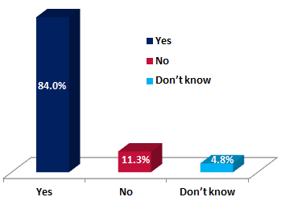

Of the overall sample, **84%** think that these projects have a **positive effect on improving water** supply in their governorate, with **11.3%** disagreeing and **4.8%** not knowing.

The figure below shows the variation between respondents across Governorates:

Figure 45 Overall distribution of perception on projects positive effect per Governorate

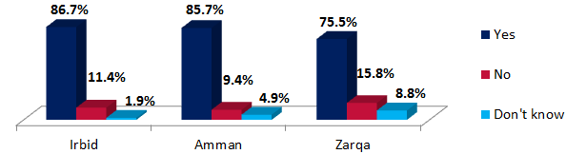

* The responses are notably **positive and optimistic** for each of the **3 Governorates**, with **86.7%** of respondents in Irbid believing the projects will be beneficial and having a positive on improving water supply , followed by **85.7%** in Amman and **75.5%** in Zarqa.

**Nationality:**

**85%** of Jordanian respondents believe the projects will have a positive effect in their Governorates, while **79.5%** of Syrian respondents believe the same.

**Gender:**

* **Females** are more to believe that the projects will have a positive effect in their Governorate than **males at 84.8%** compared to **83%** for the later.

**Age:**

* **Elderly** are more to believe that the projects will have a positive effect in their Governorate and **youth are the least** to believe that **at 88%** compared to **82.7%** for the later.

**As per the qualitative approach:**

The participants of all FGDs were almost all **in favour** of such projects, as they believed they would be crucial in helping to **address the water shortage** issue in Jordan and felt that these projects would go a long way in achieving that. Most participants were also very positive about the prospect of the water being considerably **better quality** than their current supply, some saying that the water would even be drinkable directly from the tap. However, **some** Jordanian participants from Irbid governorate were pessimistic regarding the water quality and don’t think it will improve.

***“It is unclean and it might even contain diseases, in addition to the Chlorine of course” (FG8)***

Most participants were also in favour of the supposed higher water pressure that these initiatives should bring, which would allow their **water tanks to be filled more regularly**.

***“We will then receive water 3 times a week instead of once a week or for 2 hours daily” (FG6)***

However, participants almost invariably believed that these water initiatives would significantly increase the **cost of water** per household. But surprisingly some expressed their willingness to pay more if they got better service and quality.

***“If the new projects will make water cleaner and will stop the problem of cut-off, then government can increase the bill by a reasonable percentage from 5 to 7 JD for example but not 12 JD!!” (FG1)***

***“If service and quality improved I can pay 5% more” (FG4)***

Many of the participants also felt that it **would only benefit certain areas**, as some municipalities would not be receiving water from the aforementioned mega projects and again cited the poor management and distribution of resources. Some participants in **Zarqa** felt that such projects could not even have an impact on water service in Zarqa.

 ***“The Disi project was originally made to serve Amman but after the Syrian influx they had to pump the water to the Za’tari- since the water there was not enough to serve the residents of Mafraq in addition to the Syrians” (FG1)***

And, many participants felt that the mega projects will **take a long time** to solve the water shortage problem in Jordan that could reach to 10 years or more depending on the project cost and size and the duration spent by government in projects implementation.

|  |  |
| --- | --- |
| **Q34.** | **Now, I’m going to read a list of actions that the Government has recently taken to improve water supply. For each one, please tell me to what extent do you agree or disagree with this government action to improve water supply?** |

Sample ‘s **perception towards government actions to improve water supply** came as follows:

Figure 46 Perception Distribution towards Government Actions to Improve Water Supply

**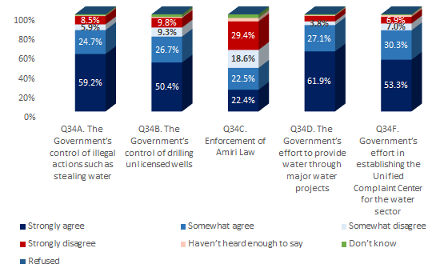**

Where;

**A. Government Control of Illegal Actions**

* The **utmost** of the overall sample **(83.8%)** had **positively** **agreed** with the government’s control of illegal actions to improve water supply. **While (14.4%)** had expressed their **divergent** opinion towards that; totaled from those who somewhat disagreed at **5.9%** and those who strongly disagreed at **8.5%**. And just very few respondents stated that they haven’t heard enough to day or do not know at .7% and 1.2% successively.

**B. Government Control of Drilling Unlicensed Wells**

* The **utmost** of the overall sample **(77.1%)** had **positively** **agreed** with the government’s control of drilling unlicensed wells to improve water supply. **While (19.1%)** had expressed their **divergent** opinion towards that; totaled from those who somewhat disagreed at **9.3%** and those who strongly disagreed at **9.8%**. And just very few respondents stated that they haven’t heard enough to day or do not know at 1.2% and 2.7% successively.

**C. Enforcement of Amiri Law**

* The **utmost** of the overall sample **(47.9%)** were in **disagreement** with the government’s enforcement of Amiri Law to improve water supply. **While (44.9%)** had expressed their **divergent** opinion towards that; totaled from those who somewhat agreed at **22.5%** and those who strongly agreed at **22.4%**. And just very few respondents stated that they haven’t heard enough to day or do not know or refused to answer at 3.5%, 3.7% and .1% successively.

**D. Government Efforts to Provide water through major water Projects**

* The **utmost** of the overall sample **(88.9%)** had **positively** **agreed** with the government’s efforts to provide water through major water projects. **While (9.5%)** had expressed their **divergent** opinion towards that; totaled from those who somewhat disagreed at **3.8%** and those who strongly disagreed at **5.7%**. And just very few respondents stated that they haven’t heard enough to day or do not know at .9% and .8% successively.

**E. Government Effort in Establishing the Unified Complaint Center for the Water Sector**

* The **utmost** of the overall sample **(83.6%)** had **positively** **agreed** with the government’s effort in establishing the unified complaint center for the water sector. **While (13.9%)** had expressed their **divergent** opinion towards that; totaled from those who somewhat disagreed at **7%** and those who strongly disagreed at **6.9%**. And just very few respondents stated that they haven’t heard enough to day or do not know at 1.8% and .8% successively.

Surveyed Sample **Perception towards government actions to improve water supply** were as per the following sequence:

**Agreement Disagreement**

**Action D ›** Action A **›** ActionE**›** ActionB **›Action C**

**Major Water Projects ›** Control of Illegal Actions **›** Establishing Unified Complaint Center**›** Control of Drilling Unlicensed Wells **›Enforcement of Amiri Law**

**Per Geographical Location;**

* For **Irbid** Governorate, respondents’ agreement was as per the following sequence:

**Major Water Projects ›** Control of Illegal Actions **›** Control of Drilling Unlicensed Wells **›** Establishing Unified Complaint Center **›Enforcement of Amiri Law**

* For **Amman** Governorate:

**Major Water Projects ›** Establishing Unified Complaint Center **›** Control of Illegal Actions **›** Control of Drilling Unlicensed Wells **› Enforcement of Amiri Law**

* For **Zarqa** Governorate:

**Establishing Unified Complaint Center ›** Major Water Projects **›** Control of Illegal Actions **›** Control of Drilling Unlicensed Wells **› Enforcement of Amiri Law**

**Per Other Characteristics;**

* **Jordanians** and **Syrians** perceptions towards government actions to improve water supply **came very similar** and approximately for all the listed actions A, B, C, D and E.
* While per **gender**; **females** appeared to be more in agreement with the government actions than males as per the table. And **Middle aged and elderly** appeared to be more in agreement with the government actions than **youth**.

|  |  |  |  |  |  |
| --- | --- | --- | --- | --- | --- |
|  |  | | **19-29** | **30-49** | **50+** |
| Agreement with gov. control of illegal use | *83.0%* | *84.5%* | *82.0%* | *83.9%* | *85.3%* |
| Agreement with gov. control of drilling wells | *75.9%* | *78.2%* | *73.1%* | *78.9%* | *77.3%* |
| Agreement with enforcement of Amiri Law | *46.8%* | *43.1%* | *49.9%* | *41.8%* | *46.1%* |
| Agreement with gov. efforts in mega projects | *87.8%* | *89.9%* | *88.3%* | *89.0%* | *89.2%* |
| Agreement with gov. efforts in complaint center | *82.6%* | *84.4%* | *84.1%* | *83.2%* | *83.7%* |

**As per the qualitative approach:**

Many of the participants felt that the **water authority** (presented by the MWI and Water Companies) should take more initiative in solving the issue and increase efficiency through improved management of water resources, performing regular maintenance and check-ups and better distribution mechanisms. While, participants in several of the FGDs blamed a lack of investment and action from the **government** for the situation. Some participants suggested that **Municipalities** should enforce hose-pipe bans and have greater punishments for illegal or reckless water wastage by individuals or companies.

***“Monitor the pipes and the water resources in Amman, Zeezya and Al-Jeezah since a lot of people steal in those areas”. (FG 2)***

A number of **possible infrastructure initiatives** were suggested in the FGDs, including:

* Building high-quality dams in a way that will reduce water evaporation;
* Better methods of gathering and storing rainwater;
* Digging wells for all new apartments and buildings;
* Sea water desalination;
* Enforcing manufacturers/big industries to have private water desalination facility;
* Brokering deals with other countries in order to increase Jordan’s water wealth and resources

Participants in several of the FGDs again mentioned the need for the **government to be more proactive** in addressing the water shortage. They also reaffirmed the need for greater enforcement and regulation to c**ontrol illegal and wasteful** water usage;

***“I have really suffered with the water authority as I have complained about someone who was stealing water right in front of my eyes, and the employee there told me to go and steal as well” (FG4)***

***“I also know some people who dug wells and started selling the water and they also got away with it due to their connections – and now they sell an entire tank for no less than 12Jd” (FG8)***

Many of the participants believed that if water resources were better monitored and controlled to prevent wastage, then many of Jordan’s water shortage issues could be solved relatively quickly. Many participants were **unfamiliar** with the **Amiri Law,** but once explained to them the majority of participants agreed with the concept; and some gave examples on its application:

***“If I steal water for example then the government can withhold the Amiri money and I will have to pay 3 times more than the original bill – so if the bill was 100, I will have to pay 300”. (FG 4)***

However, many of the **Syrian** participants were familiar with the law, as it is also applied in Syria, supposedly with relative success. Many of the Syrian participants also felt that **Jordanians are somewhat spoiled** in terms of water resources, as they are allowed to waste water significantly more than what used to be allowed in Syria and **very little punishment** is actually enforced for illegal usage.

***“One of our neighbors dug a well and started distributing water to everyone and when the government found out they only destroyed the well- but they should have imposed stricter punishments” (FG3)***

Regarding **water companies**;

* For **Miyahuna**, many participants believed that the company was strong once it started and it even gave out free devices for water taps/showers then its performance deteriorated. Also, they believed that the company should have a role in limiting the water shortage problem by fixing broken pipes, controlling illegal actions as stealing and solving complaints.
* For **Yarmouk Company**, most Irbid participants believed that Yarmouk company is not responsible for solving the water shortage problem, while others feel that they should have a grass root solution and not solve individual cases but rather have a macro perspective on the water shortage problem.

***“If I went to complain they will only solve my problem without considering my neighbours who might have the similar problem” (FG8)***

Additionally, many of participants felt that individuals are accountable as there is a **lack of awareness for water usage** among **individuals** which needs to be addressed.

***“The citizens and the government are both responsible for solving this problem” (FG7)***

They felt that **education and guidance** needs to be provided across all levels and sectors of society in order to achieve this, by targeting schools, mothers, children, old and young men, households and companies through advertising campaigns on radio, television and social media outlets and **government** should have a role in this.

***“Usually children keep the tap open as they brush their teeth and that is why there should be awareness” (FG10)***

***“The awareness programs here in Jordan are very limited; you can’t see Ads in streets or even at TV channels not even at Roya TV” (FG11)***

Many participants felt that the **government** does relatively little to advocate water saving methods and encourage its importing. Except one of the participants who expressed a divergent opinion in that regard based on his experience in washing machines maintenance where he stated the following;

***“Based on my experience as a maintenance employee, you can say that 70-80% of the newly imported washing machines in Jordan are saving machines (Have an inverter System: Water and Electricity” (FG11)***

However, many participants also felt that even if they were encouraged to buy more efficient washing machines and dishwashers, they would not be able to afford them anyway.

***“The officials have the biggest role and the people have a 25% responsibility” (FG 2)***

|  |  |
| --- | --- |
| **Q35.** | **I will read a list of practices, and for each, please tell me if you think it is an illegal use of water or no?** |

Surveyed sample ‘s **perception towards illegal practices of water use** came as follows:

Figure 47 Perception Distribution towards Illegal Practices of Water Use

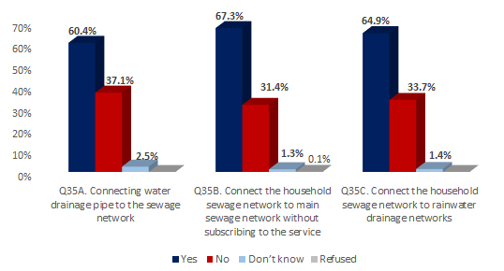

Where;

**A. Connecting Water Drainage Pipe to the Sewage Network**

* The **utmost** of the overall sample **(60.4%)** had **considered** the practice of connecting water drainage pipe to the sewage network **as illegal practice of water use**. **While (37.1%)** had expressed their **divergent** opinion towards that. And very few respondents stated that they do not know at 2.5%.

**B. Connecting the Household Sewage Network to Main Sewage Network without Subscribing to the Service**

* The **utmost** of the overall sample **(67.3%)** had **considered** the practice of connecting the household sewage network to main sewage network without subscription **as illegal practice of water use**. **While (31.4%)** had expressed their **divergent** opinion towards that. And very few respondents stated that they do not know or refused to answer at 1.3% and .1% consecutively.

**A. Connecting the Household Sewage Network to Rainwater Drainage Networks**

* The **utmost** of the overall sample **(64.9%)** had **considered** the practice of connecting the household sewage network to rainwater drainage network **as illegal practice of water use**. **While (33.7%)** had expressed their **divergent** opinion towards that. And very few respondents stated that they do not know at 1.4%.

**Per Geographical Location;**

* Respondents from **Amman** governorate were the **most to consider** all listed actions as illegal practices of water use. Followed by those from **Zarqa** governorate.
* While Respondents from **Irbid** governorate were the **least to consider** all listed actions as illegal practices of water use. Specially at **Koura** and **Bani Kenanah** **districts**.
* Respondents from **Urban** localities were the **most to consider** listed actions as illegal practices of water use than **rural localities**.

**Per Other Characteristics;**

* **Jordanians** are **more to consider** the listed actions as illegal practices of water use than **Syrians** for actions A, B and C.
* **Syrians** considered connecting the household sewage network to main sewage network without subscribing to the service as the most illegal action among listed actions by **63.2%** of Syrians sample.
* **Males** have more considered the listed actions as **illegal practices** of water use than **Females** for actions A, B and C.

**Action A 63.4% 57.7%**

**Action B 69.7% 65.1%**

**Action C 67.2% 62.8%**

* **Youth** have more considered the listed actions as **illegal practices** of water use than **middle aged and elderly as shown;**

|  |  |  |  |
| --- | --- | --- | --- |
|  | **19-29** | **30-49** | **50+** |
| water drainage pipe to sewage network | *62.8%* | *58.0%* | *62.9%* |
| sewage network to main network without subscription | *70.1%* | *65.7%* | *67.6%* |
| sewage network to rainwater drainage network | *66.8%* | *63.1%* | *66.7%* |

|  |  |
| --- | --- |
| **Q36.** | **And do you know what are the penalties of illegal water usage?** |

Figure 48 Overall sample knowledge of penalties for illegal water usage

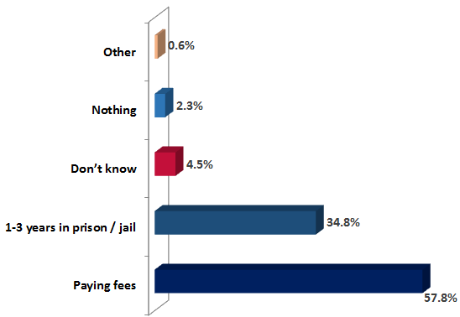

* As seen in the above figure, **57.8%** of respondents perceive the penalties for illegal water usage to be “**paying fees**”, followed by **34.8%** who perceived that the penalty could be “1-3 years in prison”, **4.5%** “don’t know” and **2.3%** think it is “nothing”.
* While 0.6% gave “other” options for penalties as “receiving warning” or “getting disconnected”.

**Governorate:**

* **68.6%** of respondents from Irbid believe paying fees is the penalty for illegal water usage, compared with **55.9%** of respondents from Amman and **48.1%** of respondents from Zarqa.
* **43.5%** of respondents from Zarqa believe the penalties are for illegal water usage are 1-3 years in prison, compared with **35.1%** of respondents from Amman and **28.1%** of respondents from Irbid.
* **Zarqa Governorate** respondents were the most to consider that “**no penalties**” are there at **4%** of its sample compared to **2.6%** of those in **Amman** and **0.6%** of **Irbid Governorate**.

**Nationality:**

* The **Jordanians** who believe the penalties are for illegal water usage are “**1-3 years in prison**” are **35.8%**, compared with **30.5%** of **Syrian** respondents.
* While **Syrians** who “**don’t know”** what the penalties are for illegal water usage are more than Jordanians at **8.1%**, compared with **3.6%** of the latter.

**Gender:**

* **60.4%** of **female** respondents believe “paying fees” is the penalty for illegal water usage, compared with **54.9%** of **male** respondents, while **37.4%** of **males** believe “1-3 years in prison/jail” is the penalty compared to **32.4%** of **females**.

**Age:**

* **59.2%** of **middle aged** respondents believe “paying fees” is the penalty for illegal water usage, compared with **55.9%** of **youth** respondents, while **37.4%** of **youth** believe “1-3 years in prison/jail” is the penalty compared to **33.1% and 35.7%%** of **middle aged and elderly serially**.

|  |  |
| --- | --- |
| **Q37.** | **And do you know how much you should pay?** |

For those who know that paying fees are the penalty for illegal water usage and counted **57.8%** of the overall sample as shown in Q36 before; this question has followed to investigate if they know how much should be paid. The results are as follows:

Figure 49 Sample distribution of respondents knowledge of amount of money/fees subjected as penalty for illegal use

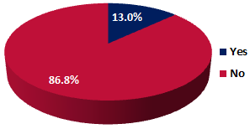

* **86.8%** of respondents **do not know how much** they should be paying as a penalty for illegal water usage and only **13%** expressed the contrary opinion of **knowing how much** they should be paying.
* **Nationality:**

**14.4%** of **Jordanian** respondents are knowledgeable of the amount to be paid compared to **7.5%** of **Syrians**.

Table 9 Sample distribution of respondents’ knowledge of amount of money/fees subjected as penalty for illegal use per Nationality and Governorate

**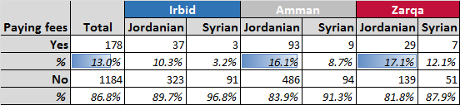**

* **Zarqa Governorate** are the most to know to know how much should be paid as a penalty at **15.9%** of its overall sample, while **Irbid Governorate** are the least to know at **8.8%** of its sample, especially in **Koura District** where nobody knows (**0%**) of its sample.
* Under **Irbid Governorate** many localities appeared **not to know at all the amount to be paid**, as: **Huwara**, **Al Thaneeba**, **Kettem**, **Deir Abi Saeed**, **Jdeeta**, **Suhom**, **Sama** **Al Rousan**, **Kafr al ‘Ma’a**, **Janeen al Safa** (**0%** responses)

**Current Occupation:**

* **17.6%** of respondents currently in a **Professional** (doctor, lawyer, engineer) **occupation** know how much they should be paying for their water bill, while just **10%** of those currently in a Semi-skilled/unskilled labor position know.
* **Per Gender:**

While **13.2% Females** know how much they should be paying for their water bill, 12.9% of males know that.

* **Per Age:**

While **18.8% of youth** know how much they should be paying for their water bill, 11.6% and 11.3% of middle aged and elderly know that.

|  |  |
| --- | --- |
| **Q38.** | **How much is the amount?** |

The table below shows the penalty amounts given by the **178 respondents** who declared their knowledge of the amount of money/fees that should be paid:

Table 10 Respondents perception of the amount of money/fees to be paid as a penalty



* As can be seen in the above table, almost half of the respondents believe the fine amount is **between 401-500 JOD** at **50.6%**, followed by **16.9%** who believed that it is between at 901-1,000 JOD and then **6.7%** who believed that it is between 10-100 JOD.
* While the remaining 25.8% of respondents gave several amounts scattered between 101-5,000 JOD.

**Nationality:**

* Similar findings appeared between **Jordanians** and **Syrians** where almost half of each sample believed that the fine amount is **401-500 JOD.**

**Governorate:**

* **55%** of mentioned respondents in Irbid believe the fine amount is **401-500 JOD**, compared with **52.9%** in Amman and **38.9%** in Zarqa.
* **30.6%** of mentioned respondents in Zarqa believe the fine amount is **901-1,000 JOD**, compared with **17.5%** in Irbid and **11.8%** in Amman.

|  |  |
| --- | --- |
| **Q39.** | **In your opinion, what penalties may be incurred if you do not pay your water bill?** |

Figure 50 Overall sample perception of penalties incurred for not paying water bill

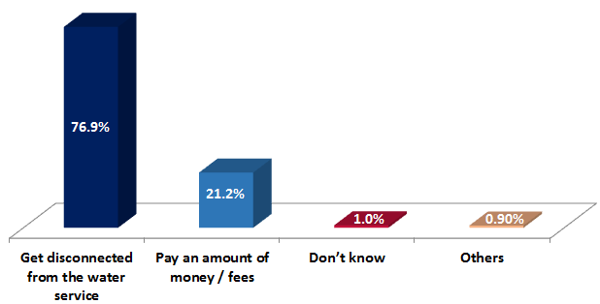

* As can be seen from the above figure, **76.9%** of the overall sample respondents think of “getting disconnected from the water service” as penalties incurred for not paying water bills, followed by **21.2%** believing they will “pay an amount of money/fees”. **While 1%** of respondents “don’t know” what type of penalties are incurred and **0.9%** gave “other” reasons as “no penalty” or “paying installments” or “imprison”.

**Governorate: Zarqa Governorate** respondents are the most to think of “**getting disconnected from water service**” as incurred penalties at **82.8%** of its sample.

**Nationality: Syrian** and **Jordanian** perceptions were very matched with each other and with the overall sample percentages.

**Gender: Females** and **males’** perceptions were very close to each other; where **77.4% of females** are aware of being disconnected of water service as a penalty for non-payment and **76.4%** of males are aware of that as penalty. Similar results appeared **among age groups**.

|  |  |
| --- | --- |
| **Q40.** | **Do you pay your water bill regularly?** |

Figure 51 Overall Distribution of respondents who pay their water bill regularly

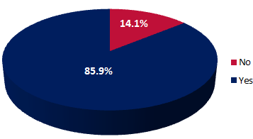

* **85.9%** of respondents do pay their water bill regularly, whilst **14.1%** do not.

**Per Geographical Location:**

* **88.3%** of respondents in **Amman Governorate** pay their water bill regularly (the highest), followed by **87.8%** in **Zarqa Governorate** and **80.2%** in **Irbid Governorate**.
* **94%** of respondents in Sahab pay their bill regularly, followed by **91.5%** in Rusaifeh and Marka and **91%** in Wadi Al Seer.
* Only **70%** of respondents in Bani Kenanah District in **Irbid Governorate** pay their water bill regularly.
* **86.6%** of respondents in Urban areas pay their bill regularly compared with **75%** of respondents in Rural areas.

**Nationality: 86.7%** of Jordanian pay their water bill regularly compared with **82.4%** of Syrians.

* Syrians in **Irbid Governorate** are the lowest group of respondents paying water bills regularly at **68.6%** of their sample compared to **91.8%** of Syrians in **Amman Governorate**. Jordanians in **Zarqa Governorate** pay their water bill regularly the most among Jordanian respondents at **89.1%**, followed by **87.7%** in **Amman Governorate** and **83.3%** in **Irbid Governorate**.

**Current Occupation:** Unemployed are the lowest group of respondents to pay their bills regularly at **80.6%** of their sample while Housewives are the highest in paying regularly at **97.4%** of their sample.

**Gender: 87%** of **females** pay their water bill more regularly than males, who pay it regularly by **84.7%** of its overall sample.

**Gender: 86.8%** of **youth** pay their water bill more regularly than others (middle aged and elderly), who pay it regularly by **86.2%** and **84.5%**of its overall sample serially.

**As per the qualitative approach:**

Most participants prefer the payments of bills **regularly** every quarter rather than monthly and most are aware that what they incur if bills were not paid is the **disconnection** from water service.

|  |  |
| --- | --- |
| **Q41.** | **Regardless whether you pay your water bill regularly or not, where or how do you usually pay your water bill?** |

Figure 52 Overall sample distribution of where or how respondents usually pay their water bill

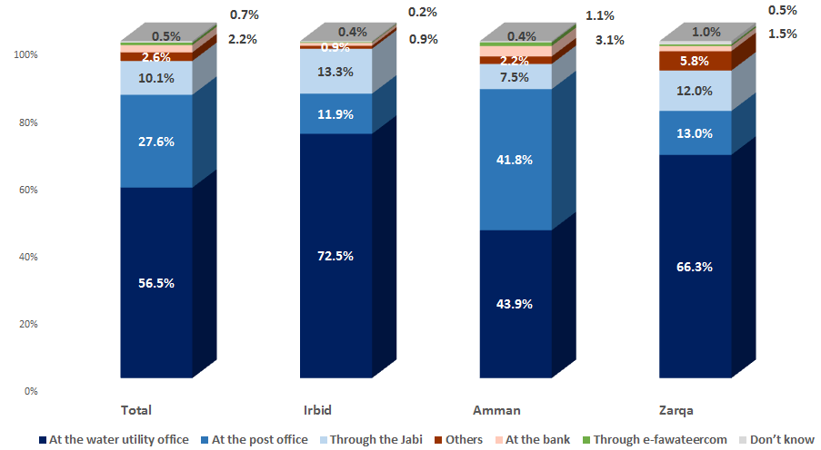

* The **utmost** of overall respondents pays their water bill “at the **water utility office**” by **56.5%**, followed by **27.6%** who “pay at the post office”, then **10.1%** through the Jabi.
* **2.6%** of respondents gave **other** options as “pay to the house owner”, while only **2.2%** pay at the bank and **0.7%** “through e-fawateercom”.
* Just **0.5%** of respondents don’t know.

**Governorate:**

* The majority of **Irbid Governorate** respondents pay their water bill “at the utility office” at **72.5%** of its overall sample, followed by **66.3%** of respondents from **Zarqa Governorate** who pay the same way.
* **Amman Governorate** respondents are the most to pay “at the post office” at **41.8%** and “at the bank” at **3.1%** and “through e-fawateercom” at **1.1%**.

**Nationality:**

* **57.2%** of Jordanian respondents pay their water bill “at the utility office”, compared with **53.6%** of Syrian respondents.
* **28.5%** of Jordanian respondents pay their water bill “at the post office”, compared with **23.6%** of Syrian respondents.
* **9.3%** of Syrian respondents pay their bill “to the house owner”, compared with **0.9%** of Jordanian respondents.

**Current Occupation:** The utmost of respondents who pay their water bill “at the post office” and “at the bank” are **professionals** at **34.2%** and **4.7%** of their sample respectively.

**Gender:** Paying at the water utility office is the most preferred method by both (males and females). **Males** pay more at the **post office,** to the **Jabi** and at **Banks** than **females** as per the table below;

**Age:** Paying at the water utility office is the most preferred method by all. **Elderly** pay the least through e-fawateercomas per the table below;

|  |  |  |  |  |  |
| --- | --- | --- | --- | --- | --- |
|  |  | | **19-29** | **30-49** | **50+** |
| Paying at water utility office | *56.0%* | *57.0%* | *56.6%* | *56.0%* | *57.5%* |
| Paying at the post office | *28.0%* | *27.2%* | *27.8%* | *27.4%* | *27.6%* |
| Paying to the Jabi | *10.2%* | *9.9%* | *10.0%* | *9.9%* | *10.4%* |
| Paying at Banks | *2.6%* | *1.8%* | *1.3%* | *2.4%* | *2.5%* |
| Paying through e-fawateercom | *0.6%* | *0.8%* | *0.6%* | *1.0%* | *0.2%* |

**As per the qualitative approach:**

The FGDs showed there are several different methods of payment used by the participants, including:

* Directly to the water authority/company; (**majority**)/ Through the post office;/Directly to landlord; **(most Syrians)/** Online;/ Jabi

There were, however, some discrepancies among the FDGs, in that some would not use online payments, as they did not feel it was secure, preferring to go personally to the post or company instead though that takes more time and usually slow, whilst some participants felt the exact opposite. **Just 2-3 participants** declared their use of online payment methods (as e-fawateercom and “Mahfathati-My Wallet”);

***“Either my husband pays the bill at the company office or I go to the post office or pay it directly to Al-Jabi” (FG8)***

***“Paying directly to water company is better, as sometimes through the post office some delays occur” (FG9)***

***“There is a system called ‘my wallet’ whereby you need to have money in your wallet (through Umniah or the bank) to pay the water or electricity bills” (FG7)***

|  |  |
| --- | --- |
| **Q42.** | **Do you report about a water leakage if noticed in the streets or in public places?** |

The table below shows the variation between respondents per nationality and per governorate in reporting water leakage in the street or public places as and when they come across it:

Table 11 Sample Distribution of respondents who would report water leakage when encountered per overall sample, governorate and nationality

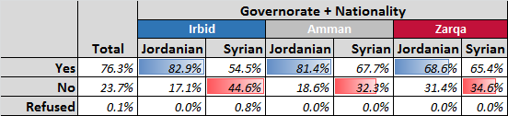

* The overall sample shows that 76.3% of respondents would report water leakage when they encounter it compared with 23.7% who would not.

**Location and Nationality:**

* It is interesting to note that in Irbid the disparity between Jordanian and Syrian respondents is quite significant. **82.9%** of Jordanians said they would report a water leakage, which is the highest of off those groups surveyed, whereas only **54.5%** of Syrian respondents in Irbid would do the same, which is the lowest of all respondent groups.
* Amman also saw a relatively significant disparity between Jordanian and Syrian respondents, with **81.4%** of Jordanians saying they would report a leakage, whilst only **67.7%** of Syrians saying they would.
* In Zarqa respondents were on average the least likely to report a leakage, however, the disparity between Jordanians and Syrians was very slim with **68.6%** and **65.4%** of Jordanians and Syrians respectively.
* **Ramtha District** in **Irbid Governorate** has the highest proportion of respondents who would report water leakage when they encounter it at **91%**, while **Zarqa District** in **Zarqa Governorate** has the lowest at **66.5%**.
* **Sama al Rousan** and **Al Thaneeba** Localities in **Irbid Governorate** are the least to report water leakage at **10%** and **30%** respectively. While in **Al Sareeh** and **Al Hoson** are the most at **94.3%** and **95%** respectively.
* In Urban areas **77%** of respondents would report water leakage when they encounter it compared with **65%** in Rural areas.

**Age:**

* Respondents willingness to report water leakage if they notice it in the streets or in public places **increases with age**, where **84.3%** of respondents **aged 50+** would report water leakage when they encounter it, followed by **75.6%** of respondents aged 30-49 and **69.3%** of respondents aged 19-29.

**Gender:**

* **Male** Respondents showed more willingness to report water leakage if they notice it in the streets or in public places **than females at 80.6%** compared to **72.5%** to the later.

**Age:**

* **Elderly** Respondents showed more willingness to report water leakage if they notice it in the streets or in public places **than youth at 84.3%** compared to **69.3%** to the later.

|  |  |
| --- | --- |
| **Q43.** | **Do you report about any wasted water if noticed at your neighbors or other places?** |

The figure below shows the variation between respondents who would report water wastage by their neighbours or any other place:

Table 12 Distribution of respondents who would report water wastage per Overall Sample, Governorate and Nationality

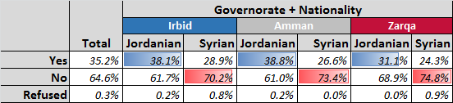

While;

* **64.6%** of respondents do not report about any wasted water if they noticed it at their neighbors or any other place, **35.2%** do and just **0.3%** refused to answer.

**Nationality:**

* There is some **disparity between Syrian and Jordanian** respondents in terms of who would be willing to report water wastage among their neighbors or elsewhere.
* **Jordanians** respondents are on average more willing to report wastage, with **38.8%** of their sample in **Amman**, **38.1%** in **Irbid** and **31.1%** in **Zarqa**.
* Syrians respondents stated that they would be willing to report water wastage by **28.9%** of their sample in **Irbid Governorate**, **26.6%** in **Amman** and **24.3%** in **Zarqa**.
* **Ramtha District** in **Irbid Governorate** are the most to report about any wasted water if they noticed it at their neighbors or any other place at **52%** of their sample.
* While **Koura District** in **Irbid Governorate** are the least to report about any wasted water if they noticed it at their neighbors or any other place at **16%** of its sample.
* **36.2%** of respondents living in an Urban area would report about any wasted water if they noticed it at their neighbors or any other place, versus **19.2%** of respondents living in a Rural area.

**Gender:**

* **Male** Respondents showed more willingness to report about water stealing **than females at 36%** compared to **34.4%** to the later.

**Age:**

* **Elderly** Respondents showed more willingness to report water stealing **than youth at 42%** compared to **29%** to the later.

|  |  |
| --- | --- |
| **Q44.** | **Do you report about any water stealing incidents, or illegal usage of water incidents if you found out or knew about it?** |

The figure below shows overall distribution of respondents who would report any water stealing incidents or illegal usage of water incidents if they found out or knew about it.

Figure 53 Overall distribution of respondents who would report any water stealing incidents or illegal usage of water incidents if they found out or knew about it

**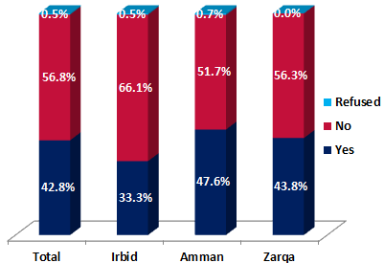**

* As can be seen in the above figure, only **42.8%** of respondents from the overall sample would report any water stealing incidents or illegal usage of water incidents if they found out or knew about it, while **56.8%** would not report that and **0.5%** refused to answer.

**Geographical Location:**

* **Amman** Governorate got the highest score where **47.6%** of respondents in Amman would report any water stealing incidents or illegal usage of water incidents if they found out or knew about it, followed by **43.8%** in Zarqa and **33.3%** in Irbid.
* **Al-Jam’aa District** in **Amman Governorate** are the most to report any water stealing incidents or illegal usage of water incidents if they found out or knew about it at **53%**. While **Koura District** in **Irbid Governorate** are the least at **19%**.
* **Kafer Yuba Locality** in **Irbid Governorate** are the most to report any water stealing incidents or illegal usage of water incidents if they found out or knew about it at **85.7%**. While **Sama Al Rousan Locality** also in **Irbid Governorate** are the least at **0%**.
* **43.6%** of respondents who live in an Urban area would report any water stealing incidents or illegal usage of water compared with **30%** of respondents who live in Rural areas.

**Nationality: 45.2%** of Jordanians would report any water stealing incidents or illegal usage of water incidents if they found out or knew about it, compared with **32.4%** of Syrian respondents.

**Current Occupation: 70%** of those currently in the **Armed Forces** would report any water stealing incidents or illegal usage of water incidents if they found out or knew about it. **(The most to report).** While **Housewives** are the least to report at **33.3%**.

**Gender: Male** Respondents showed more willingness to report about water illegal usage **than females at 47%** compared to **39%** to the later.

**Age: Elderly** Respondents showed more willingness to report about water illegal usage **than middle aged (the least willing) at 51%** compared to **39%** to the later.

|  |  |
| --- | --- |
| **Q45.** | **Do you trust your water meter?** |

The figure below shows the overall respondents level of trust in their water meter:

Figure 54 Overall respondents level of trust in water meter

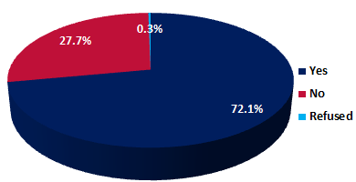

* It is clear from the overall sample that the majority of respondents **do trust their water meter** at **72.1%** versus **27.7%** who do not.

**Governorate:**

* **78.1%** of respondents from **Irbid** do trust their water meter the most, followed by **72.9%** of respondents from **Amman** and **61.3%** of respondents from **Zarqa**.

**Nationality:**

* **76.2%** of **Syrians** do trust their water meter, compared with **71.1%** of **Jordanians**.

**Gender:**

* **Female** Respondents showed more trust in the water meters **than males at 74.3%** compared to **69.5%** to the later.

**Age:**

* **Elderly** Respondents showed more trust in the water meters **than youth at 74.7%** compared to **70.1%** to the later.

|  |  |
| --- | --- |
| **Q46A.** | **Do you think that changing your water meter to an electronic type is better in terms of reading?** |

The figure below shows respondents perception distribution toward meter reading improvement if changed to an electric type per overall sample and Governorate:

Figure 55 Perceptions towards meter reading improvement if changed to an electronic type per Overall Sample and Governorate

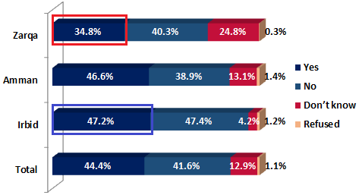

* From the overall sample of respondents, **44.4%** that changing their water meter to an electronic type is **better**, **41.6%** think it is **worse** while **12.9%** don’t know either way and **1.1%** refused to answer.

**Geographical Location:**

* The highest proportion of respondents who think that changing their water meter to an electronic type is better were those from **Irbid Governorate** at **47.2%**, followed by respondents from **Amman Governorate** at **46.6%** and only **34.8%** from **Zarqa Governorate**.
* **24.8%** of respondents from Zarqa did not know either way, followed by **13.1%** from Amman and only **4.2%** from Irbid did not know.
* **44.6%** of respondents who live in an Urban area think that changing their water meter to an electronic type is better, compared with **40.8%** who share the same thinking in Rural areas.

**Nationality:**

* **44.9%** of Jordanian respondents think that changing their water meter to an electronic type is better, versus **42.5%** of Syrian respondents who think similarly.

**Gender:**

* **Female** Respondents showed more trust that changing their water meter to an electronic type is better **than males at 47.5%** compared to **40.9%** to the later.

**Age:**

* **Youth** Respondents showed more trust that changing their water meter to an electronic type is better **than elderly at 50.5%** compared to **36.7%** to the later.

|  |  |
| --- | --- |
| **Q46B.** | **Do you think that changing your water meter to an electronic type is better in terms of life span?** |

Figure 56 Perceptions towards meter life span improvement if changed to an electronic type per Overall Sample and Governorate

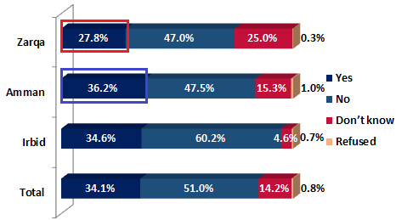

* **51%** of the overall sample do not think that changing their water meter to an electronic type is better in terms of life span, while **34.1%** think it would be better.
* **14.2%** do not know and **0.8%** of respondents refused to answer.

**Governorate:**

* The majority of respondents do not feel that changing to electronic water meters would be better in terms of life span, with **60.2%** in **Irbid Governorate**, **47.5%** in **Amman Governorate** and **47%** in **Zarqa Governorate** being skeptical of how much longer they might last.

**Current Occupation**

* Respondents in a **professional** occupation are the most to think that changing their water meter to an electronic type is better in terms of life span at **40.9%** of their sample.

**Gender:**

* **Female** Respondents showed more trust that changing their water meter to an electronic type will be better in terms of meter life span **than males at 36.7%** compared to **31.1%** to the later.

**Age:**

* **Youth** Respondents showed more trust that changing their water meter to an electronic type will be better in terms of meter life span **than elderly at 38.8%** compared to **29%** to the later.

|  |  |
| --- | --- |
| **Q47.** | **If the Water Authority/water companies developed a mobile application that can help you report about wasted water incidents (such as leaks, illegal use…etc), would you be willing to download it and use it to report about such incidents?** |

Figure 57 Overall sample distribution of respondents who would be willing to download mobile application on their mobile and use it to report about such incidents

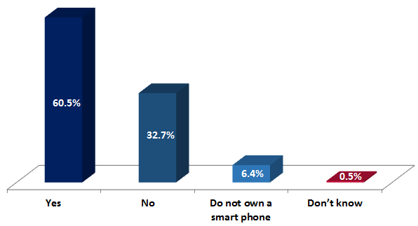

* **60.5%** of respondents from the overall sample said **they would download** a mobile application on their mobile and use it to report about such incidents, with **32.7%** saying they **would no**t. While **6.4%** of respondents said they do not own a smart phone and **0.5%** said they don’t know.

**Governorate:**

* **65.3%** of respondents from **Zarqa Governorate** said they would download a mobile application on their mobile and use it to report about such incidents, compared to **63.8%** from **Amman Governorate** and **51.1%** from **Irbid Governorate**.
* **61.6%** of respondents in Urban areas would download a mobile application on their mobile and use it to report about such incidents, compared to **41.7%** of respondents in Rural areas.

**Age Range:**

* **67.4%** of respondents aged 19-29 said they would download a mobile application on their mobile and use it to report about such incidents, compared to **60.7%** aged between 30-49 and **53.3%** aged 50+, **so willingness reduces with age.**

**Nationality:**

* **63%** of Jordanian respondents said they would download a mobile application on their mobile and use it to report about such incidents, compared to **49.7%** of Syrian respondents.
* **9.3%** of Syrian respondents said they do not own a smartphone, compared to **5.6%** of Jordanian respondents.

**Gender:**

* **64.6%** of male respondents said they would download a mobile application on their mobile and use it to report about such incidents, compared to **56.8%** of female respondents.

**Education:**

* **78.9%** of respondents who have completed higher education/Masters/PhD said they would download a mobile application on their mobile and use it to report about such incidents, compared to **33.3%** of respondents with no formal education.
* **31.4%** of respondents with no formal education said they don’t own a smartphone, compared to **0%** of respondents who have completed higher education/Masters/PhD.

|  |  |
| --- | --- |
| **Q48.** | **Do you know that there are female plumbers?** |

Figure 58 Sample Distribution in awareness of female plumbers

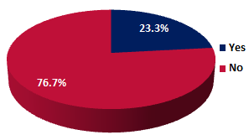

* As seen in the above figure, a relatively low proportion of respondents are aware of the existence of female plumbers at **23.3%**. While **76.7%** of respondents are not aware of that.

**Nationality: 25.8%** of **Jordanians** know that there are female plumbers, compared with **13.3%** of Syrians.

**Governorate: 25.3%** of respondents in **Amman Governorate** know that there are female plumbers (**the most to know**), followed by **24%** in **Irbid Governorate**, then **17%** in **Zarqa Governorate**.

**Age Range: 28.0%** of respondents aged 50+ know that there are female plumbers (the most), followed by **23.2%** of respondents aged 30-49, followed by **18.4%** of respondents aged 19-29, so we can see that **awareness increases with aging**.

**Gender: Female** Respondents are more knowledgeable that there are female plumbers **than males at 24.4%** compared to **22%** to the later.

|  |  |
| --- | --- |
| **Q49.** | **Have you ever dealt with a female plumber?** |

This question has followed for those who expressed their knowledge of the availability of female plumbers and counted **466 respondents (23.3% of the overall sample)** and results were as follows:

Figure 59 Overall Sample Distribution of respondents experience of dealing with a female plumber

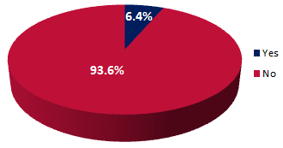

* As can be seen in the figure, very few (**6.4%**) of the mentioned respondents have ever dealt with a female plumber, while the majority, **93.6%**, **never have**.

**Governorate:**

* In **Zarqa Governorate**, **20.6%** of mentioned respondents have dealt with a female plumber (the **most**), followed by **5.7%** in **Amman Governorate** and **0.7%** in **Irbid Governorate**.
* In **Al Zarqa Locality** in **Zarqa Governorate**, **31.6%** of respondents have dealt with a female plumber, the **highest** among all localities.

**Nationality** The level of mentioned respondents experience of dealing with a female plumber per nationality are relatively similar at **6.5%** of Jordanians versus **6%** of Syrians.

* However, in both Irbid and Amman, **0%** of Syrian respondents have dealt with female plumbers, compared with **18.8%** in Zarqa.

**Gender: 8.5%** of female mentioned respondents have dealt with a female plumber, compared with **3.9%** of male mentioned respondents.

**Age: 12.5%** of youth mentioned respondents have dealt with a female plumber, compared with **2.8%** of elderly mentioned respondents.

|  |  |
| --- | --- |
| **Q50.** | **Regardless of whether you know about females plumbers or not, are you willing to call one of them to repair a plumbing problem at your house?** |

The figure below shows the total survey respondents who are willing to call a female plumber to repair a plumbing problem at their house:

Figure 60 Distribution of respondents who are willing to call a female plumber to repair a plumbing problem at their house per Overall Sample and Governorate

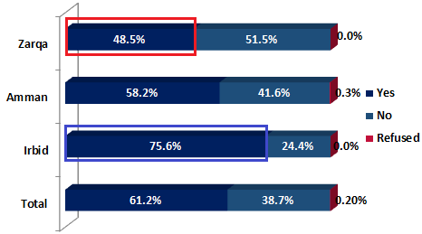

* **61.2%** of respondents from the overall sample **are willing to call a female plumber** to repair a plumbing problem at their house, compared with **36%** who **are not** and **0.2%** who refused to answer.

**Governorate:**

* In **Irbid Governorate** **75.6%** of those surveyed would be happy to use a female plumber if one was available, followed by **58.2%** in **Amman** and less than half of the respondents at **48.5%**, in **Zarqa**.

**Nationality:** There is very little variation between Syrian and Jordanian respondents answer to the question at **61%** of Jordanian respondents willing to call a female plumber to repair a plumbing problem at their house, versus only **61.9%** of Syrian respondents.

**Gender: 67.5%** of females surveyed are willing to call a female plumber to repair a plumbing problem at their house, versus **54%** of males.

**Age: 64%** of middle aged surveyed are willing to call a female plumber to repair a plumbing problem at their house, versus **57.3%** of elderly and 59.5% of youth.

|  |  |
| --- | --- |
| **Q51.** | **There is a new mobile application called (3oun) in which you can use to locate the nearest plumber to your house and book an appointment with to come and deduct /repair any water related problems in your house. Have you heard about this application before?** |

Figure 61 Distribution of total survey respondents who have heard of the 3oun mobile application:

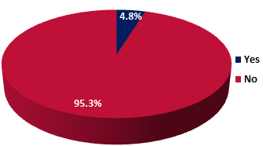

* As is evident from the above figure, the vast majority of respondents **(95.3%)** **have not heard** of the 3oun mobile application, with only **4.8%** of those surveyed knowing of its existence.

**Governorate:**

* In **Zarqa Governorate** **5.5%** of respondents have heard of the application, followed by **5.2%** in **Amman Governorate**, then **3.3%** in **Irbid Governorate**.
* **9.5%** of respondents in **Zarqa District** have heard of the application (the highest), compared with only **1.5%** of respondents in **Rusaifeh District** (the lowest among Districts).

**Nationality:**

* **5.1%** of Jordanian respondents have heard of the application, versus **3.4%** of Syrian respondents.

**Age Range:**

* **6.1%** of respondents between the ages of 19-29 have heard of the application, followed by **4.7%** of respondents aged 50+, then **4.2%** of respondents aged 30-49, so we can see that **awareness of mobile application decreases with ageing**.

**Gender: Female** Respondents are somehow a bit more knowledgeable about 3oun application **than males at 4.8%** compared to **4.7%** to the later.

|  |  |
| --- | --- |
| **Q52.** | **Have you ever used this application?** |

For those who have heard of the mobile application (3oun) and counted 95 respondents **(4.8%)** of the overall sample based on question 51**;** this question has followed to know more if they have ever used it. And results were as follows:

Table 13 Distribution of Usage of Application (3oun)



Where:

* **85.3%** turned out to **not** **have ever used** the application (3oun) while **13.7%** (13 respondents) **have ever used** that application. Only 1.1% stated that they do not own a smart phone.
* **(Zarqa) governorate** was the most likely to have people who **ever used that application** by **22.7%** of those who reported having heard of the application of its overall sample.
* On the other hand, **(Irbid governorate)** was the least to have people who ever used that application, where **just 5.3%** (1 respondent) of those who reported having heard of the application of its overall sample have ever used that application.
* **Syrians** who have ever used the application were more than Jordanians whoever did, percentages were **23.1%** and **12.2%** respectively (of those who ever heard of the application).

**12.2% 23.1%**

* **Middle aged** groups and **elderly** have used the application more than **youth at 16.7% compared to 6.9% for the later.**

****

* **Males** who have ever used the application were more than Females whoever did, percentages were **15.9%** and **11.8%** respectively (of those who ever heard of the application).

**15.9% 11.8%**

|  |  |
| --- | --- |
| **Q53.** | **Why not?** |

For those who have never used the mobile application (3oun) and counted 81 respondents **(85.3%)** of the sample of those who ever heard of the application based on previous questions**;** this question has followed to investigate further the reasons behind not using the application. And results were as follows:

Figure 62 Distribution of Reasons for not Using Application (3oun)

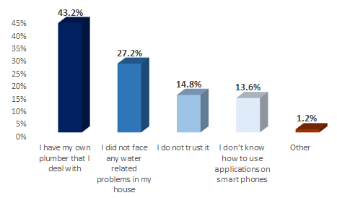

* “**Having own plumber to deal with**” came first as a reason for not using (3oun) application by **43.2%** of the overall sample of those who have never used the application.
* “**Not facing any water related problems in house**” followed next at **27.2%** and then “Not trusting the application” at **14.8%**.
* While around **13.6%** expressed that they don’t know how to use applications on smart phones and just 1.2% gave other reason.

**Per Geographical Location;**

* “**Having own plumber to deal with**” came first as a reason for not using (3oun) application across all **governorates**.
* Other reasons as: **“Not trusting the application”** and **“Not knowing how to use applications on smart phones”** counted the highest at **Zarqa** governorate compared to the other two governorates.

**Per Other Characteristics;**

* For **Jordanians**: “**Having own plumber to deal with**” came first as a reason for not using (3oun) application by **45.1%** of the overall sample of those who have never used the application compared to **30%** of **Syrians** who considered that as a reason for not using the application.

* Other reasons as: **“Not trusting the application”** and **“Not knowing how to use applications on smart phones”** counted higher among **Syrians** than **Jordanians** at (30% and 20% serially per reason) compared to (12.7% and 12.7%).

|  |  |
| --- | --- |
| **Q54.** | **Which source do you trust the most to get water related information?** |

The **trusted sources to get water related information** were ranked as per the following Pareto chart per overall sample:

Figure 63 Distribution of Trusted Sources to get Water Related Information

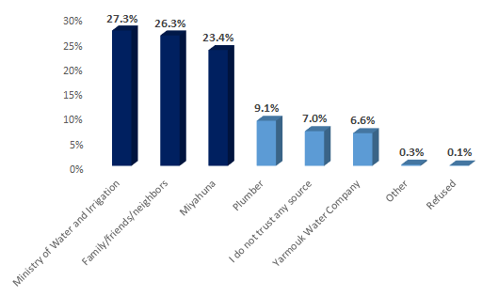

* “**Ministry of Water and Irrigation**” came first as the most trusted sources to get water related information by **27.3%** of the overall sample. “**Family/Friends/Neighbors**” followed next at **26.3%** and then “Miyahuna” at **23.4%**.
* The **“Plumber”**, “**Yarmouk Water Company**” followed later at **9.1%** and **6.6%** serially. While **7%** stated that they don’t trust any source and .3% gave other reason (no source).

**Per Geographical Location;**

* “**MWI**” came first as the most trusted sources to get water related information at **Irbid** governorate followed by “**Family/Friends/Neighbors**”. While **“Yarmouk Water Company**” came in the 3rd rank. While for **Amman** governorate; “**Mihayna**” came first as the most trusted sources to get water related information followed by “**Family/Friends/Neighbors**”.
* And for **Zarqa** governorate; “**Mihayna**” came first as the most trusted sources to get water related information followed by “**MWI**”. **Zarqa** governorate ranked the highest of **those whom do not trust any source** at 13.8% of its overall sample.

**Per Other Characteristics;**

* For **Jordanians**: “**MWI**” came first as the most trusted sources to get water related information at followed by “**Miyahuna**”. For **Syrians**: “**Family/Friends/Neighbors**” came first as the most trusted sources to get water related information at followed by “**MWI**”.
* **Gender and age: Female** Respondents are somehow trusting official authorities’ sources more **than males at** the following percentages, same as to **elderly**.

|  |  |  |  |  |  |
| --- | --- | --- | --- | --- | --- |
|  |  | | **19-29** | **30-49** | **50+** |
| Trusting Ministry of Water as a source | *27.1%* | *27.5%* | *25.5%* | *27.3%* | *29.0%* |
| Trusting Miyahuna as a source | *21.5%* | *25.0%* | *24.8%* | *21.4%* | *25.9%* |
| Trusting Yarmouk Water Company as a source | *5.9%* | *7.3%* | *5.0%* | *8.1%* | *5.1%* |

|  |  |
| --- | --- |
| **Q55.** | **And what about media sources? Which source do you follow the most to get news and information about water in Jordan?** |

Figure 64 Distribution of Followed Media Sources to get Water Related News and Information

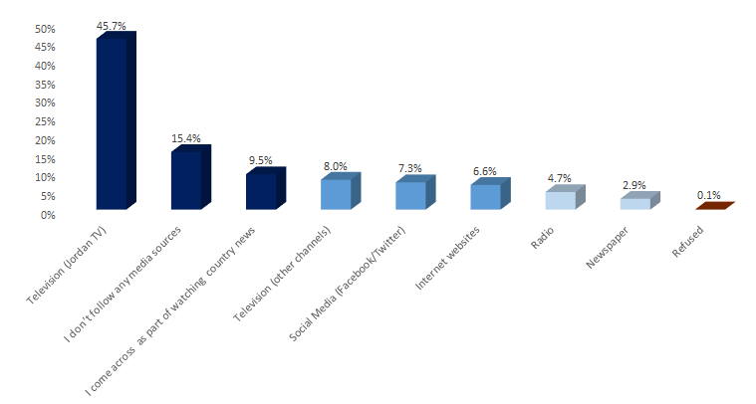

* “**(Jordan TV)**” came first as the most followed media source to get water related news and information by **45.7%** of the overall sample. While, in the second rank came those who stated that “they don’t follow any media sources” at **15.4%** of the overall sample followed by **9.5%** who come across water related news as part of watching the country news.
* “**Other TV channels**” followed at **8%** and then “Social Media Channels as Facebook and twitter” at **7.3%**. The **“Internet Websites”** and “**Radio**” followed later at **6.6%** and **4.7%** serially. While **2.7%** stated that they depend on “**Newspaper**” and 0.1% refused to answer.

**Per Geographical Location;**

* “**Jordan TV**” came **first** as the most followed media source to get water related news and information across the **three** **governorates**. And mostly at **Amman** by 49.8% of its sample.
* Survey Responses of “those who don’t follow any media sources” ranked the second across the **three** **governorates**. And mostly at **Zarqa** by 19.8% of its overall sample.
* As for the second most followed media source; “Internet Websites” followed next at **Amman** governorate, Other TV Channels at **Zarqa** governorate and “coming across that as part of watching country News” at **Irbid** governorate.
* **Koura** and **Zarqa** **districts** ranked the highest in survey responses of “those who don’t follow any media sources” at 22% and 21% serially.

**Per Nationality;**

* Very comparable results appeared between **Jordanians** and **Syrians**. Where for **both** “**(Jordan TV)**” came first as the most followed media source to get water related news and information followed by survey responses of those who stated that “they don’t follow any media sources” and then those who come across water related news as part of watching the country news.
* While **Syrians** who “don’t follow any media sources” are higher than that percentage for **Jordanians** at **27.7%** compared to **12.5%** for the later.

**Per Age Group;**

* “**Jordan TV**” came **first** as the most followed media source to get water related news and information across all **age groups**. And mostly by **elderly** by 51.6% of responses who are above 50 years old.
* It was noticed that; **Social Media** is more used by **youth** than middle aged groups and elderly at **11.1%** for youth (between 19-29 years old) compared to **8.4%** for middle aged (30-49 years old) and **1.6%** for elderly (above 50 years old). Same as to **internet websites**; where it is used by **10%** for youth compared to **6.9%** for middle aged and **2.7%** for elderly. On the other hand; “**Radio”** and **“Newspaper”** appeared to be more followed as media sources by elderly than other age groups.

**Per Gender;** The followed media sources were as shown below per gender; where males follow more than females (social media, newspaper) than females. And those **males** who don’t follow any sources at all are more than **females**.

|  |  |  |
| --- | --- | --- |
| Following Jordan TV | *44.5%* | *46.7%* |
| Not following any media sources | *16.2%* | *14.7%* |
| Following as part of country news | *9.3%* | *9.6%* |
| Following other TV channels | *7.6%* | *8.4%* |
| Following social media | *7.4%* | *7.2%* |
| Following Internet websites | *6.5%* | *6.6%* |
| Following radio | *4.5%* | *4.9%* |
| Following newspaper | *4.1%* | *1.8%* |

|  |  |
| --- | --- |
| **Q56.** | **I will read a list of some sources available on the internet. For each one, please tell me whether you access this source to get news and information about water in Jordan on not?** |

For those who listed “**Internet Websites**” and “**Social Media**” as the most followed media sources to get water related news and information in question 55 previously and counted **277** respondents **(13.9%)** of the overall sample**;** this question has followed to investigate further the exact sources they check. And results were as follows:

Figure 65 Access Level of Main Authorities Websites and Social Media Pages

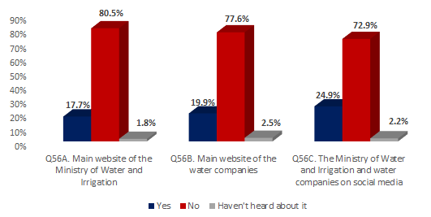

Where;

**A. Main Website of the Ministry of Water and Irrigation**

* It appeared that the **utmost** of the overall sample **(80.5%) does not access** the main website of MWI. **While (17.7%)** had confirmed their **accessing of that website**. And very few respondents stated that they haven’t heard about it at 1.8%.

**B. Main Website of Water Companies**

* It appeared that the **utmost** of the overall sample **(77.6%) does not access** the main website of water companies. **While (19.9%)** had confirmed their **accessing of water companies’ websites**. And very few respondents stated that they haven’t heard about it at 2.5%.

**C. The Ministry of Water and Irrigation and Water Companies on Social Media**

* It appeared that the **utmost** of the overall sample **(72.9%) does not access** the MWI and water companies on social media. **While (24.9%)** had confirmed their **accessing of social media pages of water related bodies**. And very few respondents stated that they haven’t heard about it at 2.2%.

**Per Source;**

* Based on the above;

“**Social Media Pages** of MWI and Water Companies” are **more** accessed than its **internet websites**

**Per Geographical Location;**

* Respondents from **Amman and Zarqa** governorates accessed ““**Social Media Pages** of MWI and Water Companies” **more** than its **internet websites**.
* While, respondents from **Irbid** governorate accessed the “**Main Website of Water Companies**” more than the MWI website or social media pages.

**Per Other Characteristics;**

* **Jordanians** are **more to access internet websites of** MWI and Water Companies than **Syrians**.
* For **Social Media** accessing; **Jordanians and Syrians** showed very comparable results. But still for both **“Social Media**” is the most accessed source.

**Males** access media sources in general more than **Females** except for “MWI Website” where both shown approximately similar results.

**Access to Ministry Website 17.6% 17.8%**

**Access to Company Website 20.6% 19.2%**

**Access to Social Media Pages 26.7% 23.3%**

* It was noticed that; **Social Media Pages** are more accessed by **youth** than middle aged and elderly at **30.7%** for youth (between 19-29 years old) compared to **21.4%** for middle aged (30-49 years old) and **22.7%** for elderly (above 50 years old).
* While **middle aged groups and elderly** are more to access “MWI and Water Companies **Websites**”.

**As per the qualitative approach:**

It appears from the FGDs that sources of information **vary between age groups**;

* With the younger participants placing much more reliance on the **internet and social media** (in particular the Miyahuna water company Facebook page),
* Whilst older participants would instead trust in more traditional sources of information, such as **television (specially Jordan channel)** and communication with **family, friends and neighbors’**. (And they usually depend on more than one source).

The majority of participants would, however, trust in the **water authority** as a reliable source of information for water related issues and usually return to the authority as an information source just when a problem occurs.

Participants invariably stated that **placing complaints** was a difficult procedure which often went unsolved, or issues took several days to fix.

***“I used to call the authority to complain but no action is taken, they never came; now I changed the way, whenever there is a problem, I call and pretend I am a parliament deputy and they come immediately and solve the matter” (FG4)***

***“I try as much as I can to reach someone I know at the authority to solve the problem otherwise it will take ages” (FG9)***

***“Our neighbor filed the same complaint three times and nobody showed up to check the matter; this has been for more than 1 year” (FG10)***

And for high priced bills, many expressed that they are forced to pay the amount even after complaining but they got offered to pay in instalments.

And for placing complaints, most participants usually **return to the authority** or **call the specified number** within the bill “Water complaints department”, but for **Syrians**, they usually return to the house lord to solve the issue since most of them own rented houses or to some of the Jordanian neighbours as most **Syrians** felt unaware of the entities they should direct their complaints for if a problem occurs.

The majority of participants **had not heard** of the **unified complaints service**, but once it was explained to them many seemed to be very willing to use this service as an alternative, except for:

* Males group in Zarqa and Irbid governorates, they were not that excited to know about such a service or even to use it.
* And also the Syrian Males in Amman who stated that there could be other fast and productive methods for solving complaints as “Mobile Maintenance Fleet”.

**Only one participant** in Amman stated that he once used the unified complaints service and its service was fast and satisfying.

Some participants also suggested calling 911 for issues related to stealing water as they highly consider “Civil Defence” as trustworthy and always react and some have used it;

***“The armed forces and civil Defense should start supervising the process since they have military discipline and national belonging and they are the fastest” (FG4)***

|  |  |
| --- | --- |
| **Q57.** | **Have you recently heard or seen any initiatives or activities related to water usage?** |

Table 14 Overall Sample knowledge about water related initiatives and activities

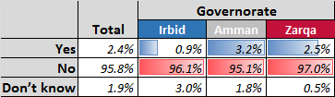

* Overall respondents’ knowledge about water related initiatives and activities is very limited where only **2.4%** of overall sample respondents have recently heard or seen any initiatives or activities related to water usage, while the majority of respondents have not at **95.74%** and only **1.85%** of respondents don’t know.
* The above table shows how the significant majority of respondents from all Governorates surveyed have very limited knowledge of current water initiatives, especially in **Irbid Governorate** where only 0.88% of its sample have heard of or seen any water related initiatives or activities.

**Nationality:**

* **2.9%** of **Jordanian** respondents have recently heard or seen any initiatives or activities related to water usage, compared with just **0.3%** of Syrian respondents and in **Irbid** and **Amman**, **none of the Syrians** surveyed had have awareness of any water initiatives.

**Age Range:**

* **2.9%** of respondents between the ages of 19-29 have heard of water initiatives, followed by **2.8%** of respondents aged 30-49, then **1.2%** of respondents aged 50+, so **knowledge about water related initiatives or activities decrease with ageing**.

**Education:** Those who have completed **secondary education and above** tend to know more.

**Gender:** Females usually know more about water initiatives than males at **2.5%** compared to **2.3%**.

|  |  |
| --- | --- |
| **Q58.** | **Can you recall one or more of these initiatives/ activities?** |

The Figure below shows the initiatives/activities recalled by the **48 respondents** who have ever seen or heard of any water related initiatives/activities:

Figure 66 Respondents Recalled initiatives/activates

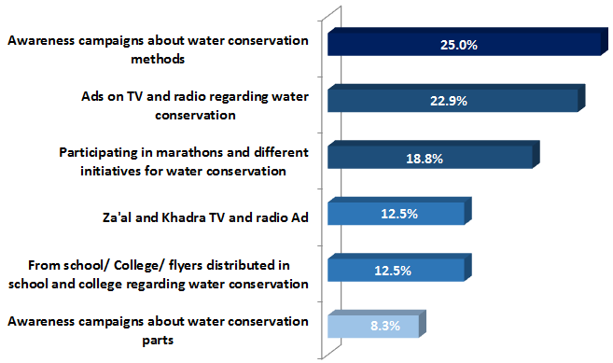

* “**Awareness campaigns about water conservation methods**” were the most recalled initiatives/activities by **25**% of respondents, followed by “ads on TV and radio regarding water conservation” at **22.9%**, then “participating in marathons and different initiatives for water conservation” at **18.8%**. These are followed by recollection of “Za’al and Khandra TV and radio ads” and recollection “from school/college/flyers distributed in school and college regarding water conservation”, both at **12.5%**, and finally “recalling awareness campaigns about water conservation parts” at **8.3%**.

**Governorate:** The utmost of **Irbid Governorate** “recall ads on TV and radio” regarding water conservation at **40%** of its sample, compared with **27.3%** of **Amman Governorate** respondents while **0%** of **Zarqa Governorate** respondents “recall any ads on TV or radio”.

* The utmost of **Zarqa Governorate** respondents “recall awareness campaigns about water conservation methods” at **40%** of its sample. Compared to 24.2% at Amman and 0% at Irbid.
* **20%** of respondents from Zarqa recall initiatives/activities from **school/ College/ flyers distributed in school and college** regarding water conservation, followed by **12.1%** from Amman and **0%** from Irbid.
* **Awareness about** campaigns about water conservation parts was the highest at Zarqa at 10% followed by 9.1% at Amman and 0% at Irbid.

**Gender: 40.9%** of male respondents have “recalled awareness campaigns about water conservation” methods the most, versus **11.5%** of female respondents.

* **30.8%** of female respondents “recall participating in marathons and different initiatives for water conservation” the most, compared with **4.5%** of male respondents.

**Age: Youth** are the least aware of water related initiatives;

|  |  |  |  |
| --- | --- | --- | --- |
|  | **19-29** | **30-49** | **50+** |
| Awareness of campaigns about conservation methods | | *21.4%* | *25.0%* | *33.3%* |
| Awareness of Ads on TV and radio | | *14.3%* | *25.0%* | *33.3%* |
| Awareness through participating in marathons/ others | | *42.9%* | *10.7%* | *0.0%* |
| Awareness of Za'al and Khadra TV and radio Ad | | *7.1%* | *14.3%* | *16.7%* |
| Awareness through flyers/ college/ schools | | *14.3%* | *14.3%* | *0.0%* |
| Awareness of campaigns about conservation parts | | *0.0%* | *10.7%* | *16.7%* |

|  |  |
| --- | --- |
| **Q59.** | **To what extent have you heard about initiatives designed for the youth and that are focused on water topics in local communities such as summer activities, awareness programs, advocacy campaigns, youth engagement programs, …etc?** |

The figure below shows the extent level of hearing about initiatives designed for the youth and focused on water topics in local communities such as summer activities, awareness programs, advocacy campaigns, youth engagement programs, …etc.

Figure 67 Extent level of hearing about initiatives designed for the youth and focused on water topics in local communities

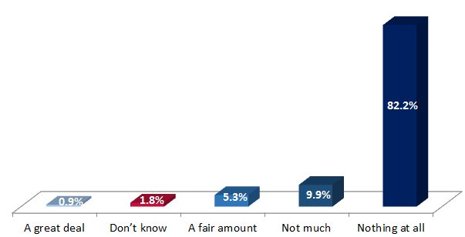

* **82.2%** of respondents have heard “nothing at all”, followed by **9.9%** of respondents who have heard “not much”, then **5.3%** of respondents who have heard “a fair amount”, then **0.9%** who have heard a “great deal”.
* **1.8%** of respondents “don’t know”.

**Governorate:**

* **89%** of respondents from **Zarqa** have heard nothing at all (the **highest**), versus **82.1%** from Irbid and **79.6%** from **Amman**.
* **1.5%** of respondents from **Amman** have heard a great deal (the **highest**), followed by **0.4%** from **Irbid** and **0.3%** from **Zarqa**.
* **Koura** and **Rusaifeh Districts** were the highest in not hearing “anything at all” at **91%** of its sample.
* **5.4%** of respondents from Urban areas have heard a fair amount, versus **2.5%** of respondents from Rural areas.

**Nationality 86%** of Syrian respondents have heard nothing at all, compared to **81.3%** of Jordanian respondents. **5.8%** of Jordanian respondents have heard a fair amount, compared to **2.8%** of Syrian respondents.

**Age Range:**

* **85.3%** of respondents aged 50+ have heard nothing at all, compared with **82.9%** of respondents aged 20-49, then **77.5%** aged 19-29.
* **1.7%** of respondents aged 19-29 have heard a great deal, followed by **0.7%** of respondents aged 30-49, then **0.6%** of respondents aged 50+, so **youth tend to have heard the mos**t.

**Gender;** **females** appeared more aware of youth water related initiatives than **males** at 6.9% compared to **5.3**% for the later.

|  |  |
| --- | --- |
| **Q60.** | **What kind of activities or initiatives would you personally like to participate in?** |

This question has followed for the youth group who counted **479 respondents**; where the figure below shows the kind of activities or initiatives that youth would personally like to participate in.

Figure 68 Kind of activities or initiatives youth would personally like to participate in

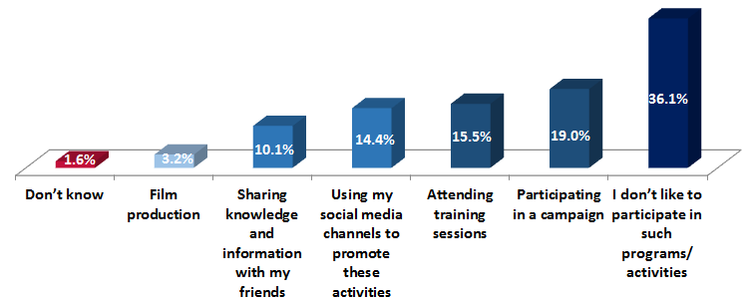

* **36.1%** of respondents said they “don’t like to participate in such programs/activities”, followed by **19%** of participants who said they would like “**participating in a campaign**”, then **15.5%** of participants who would “attend training sessions”.
* **14.4%** of respondents said they would “use their social media channels to promote these activities”, followed by **10.1%** of respondents who are happy “sharing knowledge and information with their friends”, while **3.2%** who would be interested in “film production”.
* And only **1.6%** of respondents “don’t know”.

**Governorate:**

* **participating in a campaign**” is the activity of most interest across all governorates.
* **51.7%** of respondents from Zarqa said they don’t like to participate in such programs/activities, compared with **33.3%** from Amman and **29.4%** Irbid.
* **44.4%** of respondents who live in Rural areas said they don’t like to participate in such programs/activities, compared with **35.7%** of respondents who live in Urban areas.

**Nationality:**

* **42.3%** of Syrian respondents said they don’t like to participate in such programs/activities, compared with **34.8%** of Jordanian respondents.
* **Jordanians** were more interested to “participate in campaigns”, “training sessions” or “film production” than Syrians. Where **Syrians** were more interested in “social media channels” or “sharing with friends”.

**Education**

* **69.6%** of respondents who completed primary education said they don’t like to participate in such programs/activities, compared with more interest by other educated groups.

**Gender:**

* **40.1%** of female respondents said they don’t like to participate in such programs/activities, compared with **29.6%** of male respondents which can highlight some of the cultural constraints regarding females participation.
* **15.5%** of female respondents said they would use their social media channels to promote these activities, compared with **12.7%** of male respondents. While males were more interested in all other activities more than females.
* **Further comparisons between genders are shown aside;**

|  |  |  |
| --- | --- | --- |
|  |  | |
| Youth Not liking any participations | *29.6%* | *40.1%* |
| Youth liking participation in a campaign | *23.5%* | *16.3%* |
| Youth liking training sessions attendance | *17.8%* | *14.0%* |
| Youth liking using social media for promotion | *12.7%* | *15.5%* |
| Youth liking sharing knowledge with friends | *11.7%* | *9.2%* |
| Youth liking film Production | *3.3%* | *3.2%* |

**As per the qualitative approach:**

The vast majority of participants from all the FGDs **had not heard** of any youth programmes or activities related to water, beyond the **odd visit by water companies to schools** to hand out **leaflets** which were largely unused.

***“Once Miyahuna visited my son’s school, gave him a notebook to give out tickets (for water violation actions) and a bag filled with pamphlets and brochures about water conservation. My son came back home and started giving out tickets to the people who used water in a wrong manner – like our neighbor who used the hose to wash his car” (FG1)***

**Very few participants** referred to:

* Their own participation once in some awareness sessions at universities to educate people on how to use water efficiently
* Watching some TV episodes of “Za’al and Khadra” program about water conservation

However, a significant number of participants felt that targeting youth would be a **hugely beneficial exercise**, given that they are the future, and particular attention should be paid to **university** students, who are the most proactive and resourceful members of society when it comes to advocating such initiatives.

Several participants also suggested the **use of social media and SMS messages** for such initiatives, as other media sources (particularly flyers) don’t get utilised and it is a waste of time and resources, when a bigger audience can be reached in a more effective way.

Although many of participants stated that they would themselves **be happy to participate in such initiatives**, as they felt a responsibility to raise awareness for water saving, especially when they know how much water they receive and when they receive it, as this will help them to save water and use it more efficiently. **But**, they have declared that their participation could be hard as **they have jobs** or for **some mothers they are committed** to their families and homes, unlike young people who will probably reach more people.

***“It is hard to participate due to time constraint (limited time)” (FG8)***

|  |  |
| --- | --- |
| **Q61.** | **Last question, how do you see the water situation in Jordan in 10 years’ time? Do you see it as becoming (read out)?** |

Figure 69 Overall sample respondents perceptions of how they see the water situation in Jordan in 10 years’ time

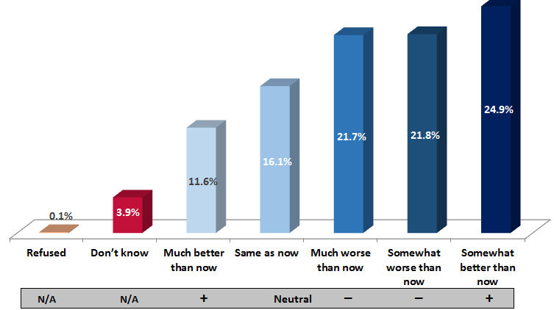

* **24.9%** of respondents see the water situation in Jordan in 10 years’ time as being “**somewhat better than now**”, followed by **21.8%** seeing it as being “**somewhat worse than now**”, then **21.7%** see it as at being “**much worse than now**”.
* **16.1%** of respondents are **neutral** and see it as being the “**same as now”**, whilst **11.6%** of respondents are very positive and see it as being “much better than now”.
* **3.9%** of respondents don’t know and **0.1%** refused to answer.

So, **43.5%** of the surveyed sample feel **negative** about the water situation versus **36.4%** of the sample who feel positive.

**Governorate:**

* **Amman Governorate** are the most **optimistic** about the situation where **41%** of its sample believe that the situation will be “somewhat **better**” or “much **better**”.

While **Irbid Governorate** are the most pessimistic about the situation, where **52.5%** of its sample believe that the situation will become “somewhat worse” or “much worse”, especially in **Koura District** and **Bani Kenaneh** where **70%** and **63%** serially are pessimistic about the situation.

* **30.8%** of respondents in rural areas see the water situation in Jordan in 10 years’ time as being **somewhat worse** than now, compared with **21.2%** of respondents in Urban areas.

**Nationality:**

* **23.7%** of Jordanian respondents see the water situation in Jordan in 10 years’ time as being much worse than now, compared with **13.5%** of Syrian respondents.
* **13.7%** of Syrian respondents see the water situation in Jordan in 10 years’ time as being much better than now, compared to **11%** of Jordanian respondents.
* So generally, **Syrians** feel more **positive** than Jordanians about the water situation (**42.7%** of Syrians believe that it will be “somewhat better” or “much better” than now compared to **34.9%** of Jordanians who share the same thinking).

**Education:**

* Respondents of **Secondary education level and above** are more **negative** about the situation than those of lower education levels.

**Age range:**

* **24.1%** of respondents aged 50+ see the see the water situation in Jordan in 10 years’ time as being much worse than now, followed by **21.1%** aged 30-49, then **20.5%** aged 19-29.
* **Youth are the most positive** about the water situation among age groups.

**Gender:**

* **Males are the most positive** about the water situation than **females** at **37.6%** of males feeling positive compared to **35.4%** of females.

**As per the qualitative approach:**

Participants’ perception towards water shortage in Jordan and how the situation will evolve over the coming decade shows **a genuine concern** for the issue. Many of the participants stated that they **were fearful** that increased water shortage could lead to illness and immigration, and possibly even conflict if left unaddressed.

***“ I don’t think there will be enough water here” (FG7)***

***“If we got good amounts of rain; then there will be water” (FG5)***

***“We always have a water shortage problem, no improvement” (FG9)***

***“I don’t see any optimistic change; every summer is like the preceding one” (FG9)***

***“We don’t have lots of water resources in Jordan and rainfall is low and our population is increasing so we will have a problem” (FG8)***

***“Maybe the situation will be better since many Syrians are leaving to Germany!” (FG6)***

***“Maybe people will start immigrating if there was no water” (FG10)***

Participants were, however, **optimistic** about the initiatives such as the Mega projects, and felt that these could **alleviate a lot of the issues** that Jordan faces in terms of water resources.

***“We hope it is going to be better” (FG4)***

***“If big projects are implemented then situation will get better otherwise we will face a water shortage problem” (FG1)***

Many participants again **expressed the need to raise awareness** for such issues and a requirement for **education** in water **conservation**. They also **predicted a raise in water prices** in the coming years, but hope for increased **quality**.

***“The water price will increase definitely in the coming future” (FG1)***

# conclusions

## Conclusions Related to Study Objectives

1. **Population knowledge and Awareness about Water Resources and Supply Issues**

Study results pointed out that around 61% of the overall sample are aware about the **existence of a water shortage problem** in Jordan from whom almost the majority (**96.5%**) have rated that problem between high to medium **criticality levels**. However, a considerable variation appeared among governorates regarding problem awareness ranging from 75.8% in Irbid to 47% in Zarqa.

Furthermore, rain water, was found to be the most known **water resource** in Jordan followed by underground water and dams.

In terms of the **reasons** for the existing problem of shortage in water; **population** related reasons were the most dominant explanations by **Jordanians** and specifically those related to the existence of other nationalities in Jordan (including Syrian refugees) in the 1st place and then the rapidly expanding population. While for **Syrians**; for whom Jordan water shortage problem has been foreknown since decades, it was mainly found allied to **resources** related reasons as per Jordan’s little rainfall and scarcity of existing water resources.

Population knowledge about existing **water saving methods** was consistent among governorates and was mainly concentrated by half of the sample in **indoor** methods as “closing water faucets”, “using water saving devices in the bathroom and kitchen”, “testing water networks for any leaks” and “taking shorter showers”. While, less knowledge seemed to exist about **outdoor** methods specially “efficient irrigation methods” and “planting low consuming plants” that turned to be the lowest recognized saving methods. **Syrians** tend to be more aware than **Jordanians** of certain saving methods as “water re-use” and “water tanks regular fixing and proper closing”.

Interestingly, the majority of respondents lack the knowledge of **water bill calculation** or the **cost per cubic meter that government pays to deliver water** at(82.9%) and (95%) of the overall sample serially. And this cognition reached the minimum at Irbid governorate where only 15.8% of its sample knows how to calculate their water bills. **Syrians** were even less of aware of that than their Jordanian counterparts specially that they pay directly to house lords. However, most of the targeted respondents were aware that “disconnection from water service” is what they incur if **bills were not paid**.

While in regard to familiarity of **illegal water usage practices** and **penalties**, over half of the sample were aware of the illegality of the suggested water usage practices of: connecting water drainage pipe to the sewage network or connecting the household sewage network to main sewage network without subscription or connecting the household sewage network to rainwater drainage network. And with more recognition perceived by **Jordanians** than **Syrians** and by **males** than **females**.

“Paying a fee” was the most acquainted **penalty for illegal water usage** by almost **57.8**% of overall surveyed sample. And with more recognition perceived by **Jordanians** than **Syrians.** Yet the majority were ignorant of the **amount** of that fee to be paid. While only 2.3% of the surveyed sample considered “no penalties” to be incurred for illegal water usage and mostly were from Zarqa governorate.

In terms of **water supply**; over three quarters of Amman respondents compared their governorate supply as same or more than other governorates. While around three quarters of Irbid and Zarqa respondents compared their governorates supply as same or less than other governorates which they considered mainly due to “how priorities for water distribution are set in by water authority/company”.

Surveyed and interviewed participants had heard the most about “**Disi Water Project**” among key **water projects** in Jordan especially those from Zarqa governorate and that was mainly through relatives and friends rather than TV/Radio news.While the sample information about “Re-habitation/Sanitation Network Projects” and “North Water Supply Projects” looked very narrow and hardly existed. And in general, (Jordanians, middle aged groups and males) seemed to be more aware about mega projects than others.

Remarkably, the vast majority of respondents were unaware of the existence of **female plumbers** in Jordan nor of the **mobile application** (3oun) at (77% and 95% respectively).

Furthermore, in respect to **water related initiatives/activities**, very similar results revolved up where almost 96% of the respondents were unaware of any related initiatives/activities especially those from Irbid governorate or **Syrians**. Likewise, for **youth related initiatives/** activities where only 6.3% had ever heard about.

1. **Population Attitudes towards Water Related Issues**

Study results indicated that there were significant issues perceived in regard to the **quality of wate**r, mainly as being not suitable for drinking (**undrinkable**) by **over three quarter** of the overall sample, reaching the maximum at Irbid governorate where **87%** considered the quality of water arriving to their household tanks as undrinkable, especially those at (Bani Kenanah and Koura District) and (Kafer Yuba, Malka and Suhom Localities).

This issue got confirmed as well throughout the FGDs along with water inappropriateness due its poor quality (smelly, colorful, and with lots of residuals such as chlorine/calcine/ sand/soil). Furthermore, it looked like Syrians think the water is “undrinkable” more than their Jordanian counterparts, the matter that pushed them to depend heavily on bottled water as a main source for drinking. Interestingly, many participants stressed on their readiness to pay more to get water of good quality as they are already spending over bottled water and filters.

While in regard to the prospected **impact/effect of “Water Mega Project”** on improving water supply; the majority were notably **positive** and **optimistic** trusting that the projects will be helpful in addressing the water shortage issue in Jordan ranging from 87% of the sample in Irbid to 76% of that in Zarqa. Positive effects derived through FGDs were in terms of enhancements in water quality and supply. However, worries appeared in regard to the long **duration** needed for achieving these projects and the expected **increase** in water cost per household. Nevertheless, some expressed their willingness to pay more if they got better service and quality based on these projects.

The **government’s effort** to provide water through major **water projects** was perceived as the most agreed with action to improve water supply by almost 89% of respondents, followed by government control of illegal actions and establishing the unified water complaint Center. While almost half of the sample was in **disagreement** with the government’s enforcement of Amiri law to improve water supply.

A high level of trust was professed by respondents in their current **water meters**, however the sample seemed split very closely between expected improvements in meter reading if changed into an electronic type. While almost half of the sample believed that changing into an electronic type would be better in terms of life span.

Remarkably, **60%** of respondents expressed their keen in downloading and using a new water sector related **mobile application** if developed ranging from interest levels of 65% by Zarqa responses to 51% of Irbid responses. Willingness was foreseen decreasing with aging and with lower education levels. Furthermore, similar results appeared for respondents’ willingness to **deal with female plumbers**, reaching its maximum level in Irbid at 76% of its sample compared to only 48.5% of the sample in Zarqa. And was encouraged more by females than males.

Lack of youth interest in personally participation in any **water related activities or initiatives** was admitted by one third of the sample and reached its extreme by half of the sample at Zarqa and was apparent among **Syrians** more than **Jordanians** and among females more than males. This was relayed in FGDs to time constraints and jobs commitments. While for the interested Jordanian youth, the kind of **activities or initiatives** that they would be attracted to partake in were mostly related to participating in a campaign or attending training sessions. While “social media channels” or “sharing with friends” were the more desirable kinds by **Syrians**.

**Amman** population were the most optimistic in regard to the **water situation in Jordan in 10 years** where 40% of its sample have confidence that the situation will be “somewhat better” or “much better” specially with the upcoming water mega projects that could alleviate lots of issues. While **Irbid** population were the most pessimistic, as around half of its sample are certain that the situation will become “somewhat worse” or “much worse”, especially those from Koura and Bani Kenaneh Districts. And, generally speaking, **Syrians** were more optimistic than **Jordanians** about the water situation. And it worth citing that many participants predicted a **raise in water prices** in the coming years.

1. **Population Practices in Water Usage and Consumption**

Research results brought up that the followed practices in **water saving methods** was somehow consistent among governorates and was mainly focused about **indoor** methods as “closing water faucets”, “testing water networks for any leaks”, “using water saving devices in the bathroom and kitchen” and “taking shorter showers”. While, the least used approaches in saving were those related to “efficient irrigation” or “planting low consuming plants”.

**Syrians** tend to be following certain saving methods more than **Jordanians** as “water re-use”, “water tanks regular fixing and proper closing”, “taking shorter showers”, “testing water networks for any leaks” and “placing a brick or bottle in the toilet tank”.

The minimal consumption of water and poor supply were found to be the key motivations behind not doing anything for saving by overall residents, while ignorance and lack of convince of water saving methods were affirmed mostly by Zarqa and Irbid residents respectively.

**Water efficient washing machines** turned to be the most used water saving technique while water efficient **dish washers** were used the least. FDGs reflected that residents use of water saving technologies is mainly presented in certain appliance for taps; while other technologies are very rarely used since many consider them as expensive and in need for regular maintenance. However, some participants expressed their willingness to inves**t** in water saving technologies if provided at reasonable prices since they are aware of its saving advantage. Furthermore, several **social behaviours/norms** were foreseen as reasons for limiting the efficient use of water, as: family size, ignorance, wealth boasting/showing off, social occasions and dependency on domestic servants.

In regard to **Syrians** **usage and consumption behaviours** of water resources; **Jordanian** participants considered that the situation was much worse during the initial influx of Syrians as they were not used to having a water shortage problem and thus tend to use water inefficiently, but afterwards many of them started to adapt their behaviours and became much more resource-conscious. The matter that got **reconfirmed** by Syrians themselves.

As a **main source for drinking**, population counted on bottled water the most followed by **filtered** tap water. While less than quarter of the sample drink directly from the tap.

While in regard to practices in **getting rid of wastewater** by the very few who are not connected to sewage system; “Cesspool pit” turned out to be the main way, but surprisingly, the utmost of them did not get rid of wastewater accumulated till now.

For **maintenance**, Irbid residents seemed the most active in maintaining water network due to their conveyed reason of poor water quality and its containing of high levels of Calcine, while those in Zarqa were the least proactive. And, though survey findings reflected that **Jordanians** do conduct maintenance and regular check-ups more than **Syrians** but those implementing Syrians conduct that maintaining more frequently.

Whereas, for **garden irrigation** practices, water authority water was the main source of that water used in irrigation by almost half of the overall sample; despite the fact of Irbid governorate dependence on rain harvesting as its main water source for irrigation followed by water company water. Furthermore, when observing the followed **methods in irrigation**, water hose tended to be the extremely used method by almost 66% of the overall sample followed by utilizing the buckets (which turned to be more by **Syrians** than **Jordanians**), while drip irrigation was almost not used (less than 3.3%) and especially at rural localities due to its high perceived cost.

**Regular bills payment** was the most common practice among the majority, ranging from a rate of 88% for Amman residents to 80.2% for those in Irbid. Besides, water utility office was the main **destination** for **water bills payment** by almost 57% of the sample followed by post office for another quarter of the sample. However, payment through banks or e-fawateerkom was hardly carried out and tend to be more by professionals than others.

**Reporting about water leakage** in the streets or public places was agreed upon by more than three quarters of the sample, which turned out to be more practiced and accepted than reporting about (water stealing incidents/illegal usages or water wastage by individuals) that did not exceed an implementation level of 35-42% of the overall sample. Additionally, reporting in general about such incidents seemed to be more approached by **Jordanians** than **Syrians**, and by elderly than middle aged or youth.

Concerning experiences in **dealing** with **female plumbers**; the majority have never dealt with any at almost 94% of the sample and those who ever did were mostly from Zarqa governorate. Very equivalent results appeared for **experiencing** the **usage of mobile application** (3oun) where only 13.7% of those who ever heard of that application have ever used it, and these were more **Syrians** than **Jordanians**. This very limited usage of the application was justified the most by having usually a personal plumber to deal with.

As for **sources of water related information**; some discrepancies appeared across governorates where “Miyahuna” was the most trusted source at Amman and Zarqa while for Irbid; the “Ministry” came first followed by “Family/Friends/Neighbors”, while “Yarmouk Water Company” came in the 3rd rank. On the other hand, lack of trust in any sources was remarkably apparent at Zarqa.

As for the case for **Syrians**, “Family/Friends/Neighbors” was the most trusted source to refer to for information, the matter that could be due to their unawareness of available information sources.

By means of **media sources** followed to get news and information about water in Jordan; Jordan TV was the most followed source by almost half of the sample followed by other TV channels. While follow-up rate for water news through social Media and internet websites was not very notable (reaching a maximum of 14% of the sample) but still more than radio and newspaper. However, turnout on media sources tend to vary across age groups; where youth preferred mostly (social media and internet websites) while for middle aged and elderly (TV has conquered as a source).

# Annexes

# Annex 1: Focus Group Discussion Guide

**Introduction**

**(Introduce yourself, the company, and the group discussion purpose)**

***“Thank you for taking the time to participate in this group discussion. My name is \_\_\_\_\_\_I work as a group moderator with the Market Research Organization (MRO) which is a private company that conducts many surveys about different topics”. Today, we are seeking your views on issues related to water. The information we gather will be used to better understand your requirements and expectations. We are interested in your honest opinion; there is no right or wrong answers. “The session will be audio recorded because I will not be able to remember what each of you has to say.” “All the relevant materials of this study will be treated confidentially. Please speak up, and only one person speaks at a time.”***

***“The discussion would take around two hours”***

**Before we begin, I’ll like to know more about you. I’d like you first to introduce yourselves to me and to the group participants.**

* Name?
* Age?

***Now let’s start with the water situation Jordan***

**M. In general, do you think that there is a water shortage problem in Jordan?**

**Probe**

* And how critical do you think this problem is?
* What are the reasons?
* What about the Syrian influx**?**

**M. How can this problem be solved?**

**Probe**

* Who is responsible to solve the problem? The government, companies, individuals? Why?
* What can be done?
* Do you think that the government is taking real actions towards overcoming the water shortage problem in Jordan?
* What actions are you aware of?

**Example of some government measures:**

* *The government’s action to control illegal use of water*
* *Enforcement of Amiri Law*
* *To import only water efficient appliances*

**Probe**

* Do you trust this action to solve the problem? Do you think this action would improve the water supply service? Why would you say that?
* What about water companies? Such as Miyahuna, and Yarmouk company?
* What can they do? Did they take any actions to try to solve this problem? What? How? Can these measures solve the problem?
* Do you trust the abilities of the water companies to solve the water shortage problem?
* What about you as an individual? Do you think you have a role in solving this problem? What can you do? How can it help

**M*.* There are mega water projects in Jordan such the Disi project,**

**Red-Dead project and Wadi Al Arab project in the north. Have you heard about these projects?**

**Probe**

* If yes, how did you know about these projects?
* What do you know about these projects?
* Would they help in solving the problem? How?
* And how long would it take to solve this problem?
* How would these projects help solve the water shortage problem?
* Do you trust that these projects will improve the water services, water quality, increase the supply of water? Why would you say that?
* Do you think that the implementation of these projects would affect the cost of water? How would you feel about it?

***I’d like now to ask about programs or activities related to water***

**M. Have you heard about or seen any** **programs or activities designed for the youth related to water usage in local communities? For example youth initiatives, we are all Jordan, Juhod….etc?**

**Probe**

* If yes, where did you hear about it? (organizations, mosques, schools, local community gatherings, lectures…etc)
* What was it about? What were the messages?
* Have you personally seen or participated in these programs?
* Did you learn anything new? What?
* Did it affect your habits regarding water use? How?
* Did you share the information with anyone?
* What was their reaction?
* Do you know if they did anything after learning about it?
* Do you trust such programs/activities to provide useful information and influence people’s behavior regarding water usage? How?

**M. Do you think that the youth are willing to participate in these programs to promote water efficiency?**

**Probe** If no, why not?

**M. What about you personally? Are you willing to participate and be part of such programs to promote water efficiency?**

**Probe**

* If yes, what kind of programs related to water are you willing to participate in?
* How would you like to receive information about these programs/activities?
* If no, why not?

***I’d like now to ask about sources of information related to water***

**M. If you want to get information about any water related issue, from where** **would you get this information? Check for**

* *Ministry of Water and Irrigation, Miyahuna, Water Authority of Jordan, Yarmouk Water Company, Plumber, Family/friends/neighbors…etc*

**Probe**

* Do you trust this / these sources?
* And how regular you reach this / these sources for information?
* How would you like to receive the information? (in person, telephone, email, brochure, leaflet, mobile messages….etc)

**M. What about media sources, which source does you follow the most to get information about water related topics? Check for** *Television, radio, newspapers, internet websites, social media…etc)*

**Probe**

* Do you trust this / these sources?
* And how regular you reach this / these sources for information?

**M. If you have a complaint, what do you usually do?**

**Probe**

* Do you know where to go or what to do?
* Have you ever made a complaint?
* If yes, to whom? And How? Tell us about your experience?
* Was it solved? How long did it take to solve the problem/ to reply to your complaint?
* If no, why not? What stops you?

**M. Have you heard about “unified complaints service” in Jordan?** *Explain: Miyahuna company manages it , you call the number 117116 to make any complaint, and the reports goes directly to the Minister*

**Probe**

* Have you used it before? If yes, tell us about your experience?
* If no, are you willing to use it? Would you trust it to address your complaint? Do you think that your complaints would be heard?? If no, why not?

**M. How do you usually pay your water bills?**

**Probe**

* Do you pay your water bills on regular bases (quarterly)? If no, why not?
* How do you pay these bills? (bank, online, direct to the water utility, Jabi…etc)
* Is this paying method effective? Would you prefer another method?

**M. Do you know how the water bills are calculated?**

**M. Do you think you are paying more or less than the water services you’re getting now? Or is the money you pay equals the services you’re getting?**

**Probe**

* Why do you say that?
* Are you willing to pay more for better water services, such as improving water network, improve maintenance, increase number of repair team, fast response to complaints…etc If no, why not?

***Now, let’s talk about the water you receive to your house.***

**M. How frequently do you receive water?**

**Probe**

* Is it enough? If not, why not?
* Do you suffer from water shortages? How often? For how long?
* What do you do during this period?

**M.** **How do you rate the water quality** **you receive to your house?**

**Probe**

* Why do you say that?

**M. What are you currently doing in order to use water efficiently?**

**Probe**

* If not doing anything– why not? What stops you?
* Do you feel that you are doing as much as you can to save water?
* Would you be willing to invest in technologies that save water? Such water saving devices, water efficient appliances…etc?

**M. Do you conduct regular checks and maintenance on your household water network including water pipes, tanks, fixtures, and/or toilet tanks?**

**Probe**

* If yes, how often?
* What do you do if there’s a problem?
* Who repairs it?
* How long does it take to be repaired?
* If they do not conduct regular checks and maintenance - Why don’t you conduct regular checks and maintenance?

**M. When you receive water, what do usually do?**

**Probe**

* And what do you think other people do?

**M. Do you think that people in Jordan use water efficiently?**

**Probe:** At home, how?

At workplace and other places, how?

**M. What about Syrians? Do you think that Syrians in Jordan use water efficiently?**

**Probe**

* If no, why not?
  + Do you think that Syrians changed their water usage and behavior after coming to Jordan?
  + *(If Syrian)* – did you change your water usage behavior when you came to Jordan?
* If yes, how and If no, why not?

**M.** **Do you** **think there are reasons that might affect people’s behavior not to use water efficiently?**

**Probe**

* Social norms/ financial

**M. Last question, how do you see the water situation in Jordan in 10 years’ time?**

**Thank you**

# Annex 2: Household KAP Questionnaire

**Household KAP Questionnaire**

***Serial Number:* \_\_\_\_**

***Introduction:***

**“Hello, my name is \_\_\_\_\_\_\_\_\_\_\_\_\_; I am an interviewer working with the Market Research Organization (MRO) which is a private research company that conducts various surveys on different topics. Today, we are conducting a survey, to examine current knowledge, attitudes and practices about water in Jordan. The goal of this survey is to help Mubadara project which is funded by USAID to increase the efficiency of the water sector through understanding the current situation of the water sector.**

**Please note that your participation in this survey is voluntary and you can leave questions unanswered or end the interview at any moment. The answers you give will be kept in complete confidence and anonymity. The interview will take around 35 to 40 minutes. We would really appreciate taking the time to answer our questions. Thank you in advance.**

|  |  |  |  |  |
| --- | --- | --- | --- | --- |
|  | **Interview Date** | **Day**  **\_\_\_\_\_\_\_\_\_\_** | **Month**  **\_\_\_\_\_\_\_\_\_\_** | **Year**  2017 |
| **I.** | **Interviewer Code** | **-------------------** | | |
| **S.** | **Supervisor Code** | **-------------------** | | |

|  |  |  |
| --- | --- | --- |
| **Interview start time (24 hours)** | **Hour** | **Minute** |

|  |  |  |  |  |
| --- | --- | --- | --- | --- |
| **S1.** | **Governorate** | Irbid | Amman | Zarqa |
| 1 | 2 | 3 |

**Before we start, I’d like to ask some general information for our survey purposes**

**D1. How old are you?**

**(If the respondent is younger than 19 years old, thank the respondent and end interview)**

**Record exact age:** \_\_\_\_\_\_\_\_\_\_\_\_\_\_\_\_\_\_\_\_\_\_\_\_\_\_\_\_\_\_\_\_\_\_\_\_\_\_\_\_\_\_\_\_\_\_

Refused 99

**D2. (Record age range and continue)**

|  |  |
| --- | --- |
| 19-29 | 1 |
| 30-49 | 2 |
| 50+ | 3 |

**D3. Could you please tell me what is the nationality of head of household?**

|  |  |  |
| --- | --- | --- |
| Jordanian | 1 | **Skip to D5** |
| Syrian | 2 | **Continue** |
| Other | 3 | **Thank the respondent and end interview** |
| Refused | 9 |

**If Syrian in D3, ask:**

**D4. How long have your family been in Jordan?**

|  |  |  |
| --- | --- | --- |
| Days/ weeks | 1 | **Continue** |
| Less than 6 Months | 2 |
| 6 months – to 1 year | 3 |
| 1-2 years | 4 |
| 3 years | 5 |
| 4 years | 6 |
| 5 years | 7 |
| 6 years | 8 |
| More than 6 years | 9 | **Thank the respondent and end interview** |
| Refused | 99 |

**Ask all**

**D5. Are you the one responsible for managing your household and meeting its needs? (Not necessarily to be the one who runs the financials)**

|  |  |  |
| --- | --- | --- |
| Yes | 1 | **Continue** |
| No | 2 | **Thank the respondent and end interview** |
| Refused | 9 |

**D6. Is this house currently subscribed with the water authority?**

|  |  |  |
| --- | --- | --- |
| Yes | 1 | **Skip to D9 – record respondent gender, and continue** |
| The service is currently unavailable | 2 | **Ask D7, then Thank the respondent and end interview** |
| No, never been subscribed to the service | 3 | **Ask D8, then Thank the respondent and end interview** |
| Refused | 9 | **Thank the respondent and end interview** |

**If answered “2” (The service is currently unavailable) in D6, ask:**

**D7 Why is the service currently unavailable? (Multiple response)**

|  |  |
| --- | --- |
| We don’t receive water at all, that’s why we asked to unsubscribe from the service | 01 |
| The water authority disconnected the service because of accumulated water bills | 02 |
| We have a water well that is enough for our needs | 03 |
| Other (Specify) \_\_\_\_\_\_\_\_\_\_\_\_\_\_\_\_\_\_ | 97 |
| Don’t know | 98 |
| Refused | 99 |

**If answered “3” (never been subscribed to the service) in D6, ask:**

**D8. Why have you never subscribed to the water service? (Multiple response)**

|  |  |
| --- | --- |
| We never received water to this area | 01 |
| We have a water well that collects rain water and is enough for our needs | 02 |
| We buy water tankers | 03 |
| A new building / house | 04 |
| The cost of installing a water meter for the first time is high | 05 |
| Other (Specify) \_\_\_\_\_\_\_\_\_\_\_\_\_\_\_\_\_\_ | 97 |
| Don’t know | 98 |
| Refused | 99 |

**D9. Record respondent’s gender, and continue**

|  |  |
| --- | --- |
| Male | 1 |
| Female | 2 |

**D10. What is your relationship with the head of your household?**

|  |  |
| --- | --- |
| The respondent is the head of household | 1 |
| Son/daughter | 2 |
| Husband/wife | 3 |
| Grandfather/grandmother | 4 |
| Other relative (Uncle/aunt/cousins…etc) | 5 |
| Other **(specify)** | 97 |
| Refused | 99 |

**D11. What is the current occupation of the head of household?**

|  |  |
| --- | --- |
| Business owner | 1 |
| Professional (doctor, lawyer, engineer) | 2 |
| Managerial | 3 |
| Clerical, other office worker | 4 |
| Skilled labour | 5 |
| Semi-skilled/unskilled labour | 6 |
| Unemployed | 7 |
| Housewife | 8 |
| Student | 9 |
| Retired | 10 |
| Other **(specify)** | 97 |
| Refused | 99 |

**D12. What is your level of education?**

|  |  |
| --- | --- |
| No formal education | 1 |
| Completed primary | 2 |
| Completed Elementary | 3 |
| Competed Secondary | 4 |
| Completed diploma | 5 |
| Completed university | 6 |
| Completed higher education / Masters/ PHD | 7 |
| Refused | 9 |

**D13. How many live with you in this house? (Including yourself, family members, relatives, and servants)**

**Record exact number: \_\_\_\_\_\_\_\_\_\_\_\_\_\_\_\_\_\_\_\_\_\_\_\_\_\_\_\_\_\_\_\_\_\_\_\_\_\_\_\_\_\_\_\_\_**

Refused 99

**D14. House type**

|  |  |
| --- | --- |
| Apartment | 1 |
| House / Dar | 2 |
| Villa | 3 |
| Other (Specify) | 7 |

**D15.** **Is this house owned or rented?**

|  |  |
| --- | --- |
| Owned | 1 |
| Rented | 2 |
| Refused | 9 |

**Ask all**

**Q1. In general, do you think that there is a shortage problem in water resources in Jordan?**

|  |  |
| --- | --- |
| Yes | 1 |
| No | 2 |
| Don’t know | 8 |
| Refused | 9 |

**If answered “1” (yes) in Q1, ask:**

**Q2. How would you rate the problem of shortage in water resources in Jordan? Would you say that it’s a very critical problem, somewhat critical, or not critical at all?**

|  |  |
| --- | --- |
| A very critical problem | 1 |
| Somewhat critical | 2 |
| Not critical at all | 3 |
| Don’t know | 8 |
| Refused | 9 |

**If answered “1” (yes) in Q1, ask:**

**Q3. In your opinion, what are the reasons for the existing problem of shortage in water resources in Jordan? (Multiple response)**

|  |  |  |
| --- | --- | --- |
| **Population** | Fast growing population | 01 |
| Expansion of cities and demand for water services | 02 |
| Existence of other nationalities in Jordan/ Syrian refugees | 03 |
| Welcoming other Arab nationalities to stay in Jordan | 04 |
| **Resources** | Existing water resources are scarce | 05 |
| Little rainfall | 06 |
| Evaporation | 07 |
| Lack of dams | 08 |
| Climate change | 09 |
| **Government** | Mismanagement by the government/water companies | 10 |
| Urban planning | 11 |
| Sharing of water resources with neighboring countries / poor water supply agreements with neighboring countries | 12 |
| Worn-out networks/broken pipes in streets | 13 |
| **Households** | Mismanagement/misuse by individuals | 14 |
| Illegal use of water / water stealing | 15 |
| Inefficient use of water by individuals in their own house | 16 |
|  | Other ( specify)\_\_\_\_\_\_\_\_\_\_\_\_\_\_\_\_\_\_\_\_\_\_\_\_\_\_\_\_\_\_\_\_\_\_ | 97 |
| Don’t know | 98 |
| Refused | 99 |

**Ask all**

**Q4. What are the water resources in Jordan that you’re aware of? (Multiple response)**

|  |  |
| --- | --- |
| Rain water | 01 |
| Underground water | 02 |
| Dams water | 03 |
| Treated wastewater | 04 |
| River water/ Yarmouk river/Jordan river | 05 |
| Desalination | 06 |
| Other (Specify)\_\_\_\_\_\_\_\_\_\_\_\_\_\_\_\_\_\_\_\_\_\_\_\_\_\_\_\_\_\_\_\_\_\_\_ | 07 |
| Don’t know | 08 |
| Refused | 09 |

**Q5. In regards to water saving methods, what methods are you aware of?**

**(Show card - Multiple response)**

**Q6. And which of these methods are you currently using in order to save water in your house?(Show card - Multiple response)**

|  |  |  |  |
| --- | --- | --- | --- |
|  | | Q5 | Q6 |
| **Indoor water Saving methods** | Use water saving devices on bathroom and kitchen/ Use of water efficient showerheads | 01 | 01 |
| Purchase/ use only water efficient appliances | 02 | 02 |
| Regularly clean faucets/water saving devices as sediments may accumulate and reduce the flow | 03 | 03 |
| Close water faucets during hands washing, shaving, teeth brushing, ablution, or washing the dishes…etc | 04 | 04 |
| Use toilets with flushing water tank size 4-6 L/ use double flushing system toilets | 05 | 05 |
| Test water network for any leaks and make necessary repairs promptly | 06 | 06 |
| Placing a brick or a bottle in the toilet tank | 07 | 07 |
| Take shorter showers | 08 | 08 |
| Replace with dry cleaning instead of normal washing of curtains, carpets, bed covers…etc | 09 | 09 |
| Water Tanks regular fixing and repair | 10 | 10 |
| Reuse of water | 11 | 11 |
| **Outdoor water Saving methods** | Make sure that the water tanks are well closed | 12 | 12 |
| Replacing metal water tanks with plastic ones | 13 | 13 |
| Using a water valve on all water tanks and do regular maintenance | 14 | 14 |
| Planting plants that need low water irrigation/ consume less water | 15 | 15 |
| Use water efficient irrigating methods (such as drip irrigation, automated irrigation systems, sprinkler systems) | 16 | 16 |
| Rain water harvesting/ use of rain water | 17 | 17 |
|  | Currently, I’m not doing anything to save water | 96 | 96 |
| Other (Specify)\_\_\_\_\_\_\_\_\_\_\_\_\_\_\_\_\_\_\_\_\_\_\_\_\_\_\_\_ | 97 | 97 |
| Don’t know (Don’t read) | 98 | 98 |
| Refused (Don’t read) | 99 | 99 |

**If answered “96” (Currently, not doing anything to save water) in Q6, ask:**

**Q7. Why are you currently not doing anything to save water?**

**(Don’t read - Multiple responses)**

|  |  |
| --- | --- |
| I'm not convinced of water saving methods | 01 |
| Water consumption is already minimal | 02 |
| Water supply is already poor to save/don’t receive enough water to save | 03 |
| Water efficient products/ appliances are more expensive than others | 04 |
| Changing old pipes/renewal of water pipes is expensive | 05 |
| water saving appliances are expensive | 06 |
| I don’t think that using water efficient methods will make any difference | 07 |
| I don’t know about any water saving solutions available in the market | 08 |
| I don’t know how to save water | 09 |
| I do not know where the biggest consumption of water in my house is and therefore it is difficult to determine which saving method to use | 10 |
| Other (specify)\_\_\_\_\_\_\_\_\_\_\_\_\_\_\_\_\_\_\_\_\_\_\_\_\_\_\_\_\_\_\_\_\_\_\_\_\_\_\_\_\_\_ | 97 |
| Refused | 99 |

**Ask all**

**Q7A. For each of the following, please tell me whether you currently use it in your house or not?**

|  |  |  |  |  |  |
| --- | --- | --- | --- | --- | --- |
|  | | **Yes** | **No** | **Don’t know** | **refused** |
| **A** | Water efficient automatic washing machine | 1 | 2 | 8 | 9 |
| **B** | Water efficient dish washer | 1 | 2 | 8 | 9 |
| **C** | Dual flush toilets | 1 | 2 | 8 | 9 |
| **D** | Faucets with water saving devices (aerators) installed | 1 | 2 | 8 | 9 |
| **E** | Water efficient showerheads | 1 | 2 | 8 | 9 |
| **F** | Reuse of water | 1 | 2 | 8 | 9 |

**Q8. Now thinking about water supply at your house. During this year, have there been times when your house has not been supplied with water?**

|  |  |
| --- | --- |
| Yes | 1 |
| No | 2 |
| Don’t know/ don’t remember | 8 |
| Refused | 9 |

**If answered “1” (yes) in Q8, ask:**

**Q9. For how long water was not available?**

|  |  |
| --- | --- |
| More than 1 week | 1 |
| 2 to 3 weeks | 2 |
| 1 month | 3 |
| 2-3 months | 4 |
| More than 3 months | 5 |
| Don’t know/ don’t remember | 8 |
| Refused | 9 |

**Q10. Thinking about your water tanks, how many do you have?**

**Record number \_\_\_\_\_\_\_\_\_\_\_\_\_\_\_\_\_\_\_\_\_\_**

Refused 99

**Q11. Do you have ground level water tank(s) only, or a roof level water tank(s) only, or both?**

|  |  |
| --- | --- |
| Ground level water tank(s) | 1 |
| Roof level water tank(s) | 2 |
| Both | 3 |
| Refused | 9 |

**Q12. Thinking about your water tank(s), do you have water float valve(s) on your water tank(s)?**

|  |  |
| --- | --- |
| Yes | 1 |
| No | 2 |
| Refused | 9 |

**If answered “2” (no) in Q12, ask:**

**Q13. Why don’t you have a water float valve(s) on your water tank(s)?**

**(Multiple responses)**

|  |  |
| --- | --- |
| It limits water supply | 01 |
| It collects dirt and residues | 02 |
| No need for it / not important | 03 |
| Water supply is already poor | 04 |
| The water valve is broke and not fixed yet | 05 |
| Other (specify) | 07 |
| Refused | 09 |

**Ask all**

**Q14. In general, do you think that the quality of water arriving to your household tank(s) is: (read out)?**

|  |  |
| --- | --- |
| Drinkable | 1 |
| Not Drinkable | 2 |
| Don’t know (Don’t read) | 8 |
| Refused (Don’t read) | 9 |

**Q15. What is your main source of drinking water? Do you drink from \_\_\_\_?**

**(Read out) (Single response)**

|  |  |
| --- | --- |
| Directly from the tap water | 1 |
| Tap water through a water filter | 2 |
| Rainwater harvesting | 3 |
| Bottled water | 4 |
| Refused (Don’t read) | 9 |

**If answered “2” (Tap water through a water filter) or “4” (Bottled water) in Q15, ask:**

**Q16. Why don’t you drink directly from the tap water? (Multiple response)**

|  |  |
| --- | --- |
| The house water network is old/ worn-out | 01 |
| The area / district water network is old/ worn-out | 02 |
| The water from the source is bad/ of poor quality | 03 |
| We trust the quality of water, but we dislike the taste of the water | 04 |
| Other (Specify)\_\_\_\_\_\_\_\_\_\_\_\_\_\_\_\_\_\_\_\_\_\_\_\_\_\_\_\_\_\_\_\_\_\_\_ | 97 |
| Don’t know | 98 |
| Refused | 99 |

**Ask all**

**Q17. Is this house connected to the Sewage System/ sewer network?**

|  |  |
| --- | --- |
| Yes | 1 |
| No | 2 |
| Refused | 9 |

**If answered “2” (no) in Q17, ask:**

**Q18. In which way is do you get rid of wastewater in your house?**

|  |  |
| --- | --- |
| Cesspool pit | 1 |
| Septic tank | 2 |
| Don’t know | 8 |
| Refused | 9 |

**If answered “2” (no) in Q17, ask:**

**Q19. And how often do you get rid of wastewater in your house?**

|  |  |
| --- | --- |
| Once a week | 1 |
| Once a month | 2 |
| 2-3 times a month | 3 |
| We did not get rid of it until now | 4 |
| Other (specify) | 7 |
| Don’t know | 8 |
| Refused | 9 |

**Ask all**

**Q20. Do you conduct regular checks and maintenance on your house water network which includes (water pipes, tanks, faucets, and/or toilet tanks)?**

|  |  |
| --- | --- |
| Yes | 1 |
| No | 2 |
| Refused | 9 |

**If answered “1” (yes) in Q20, ask:**

**Q21. And how often do you do that?**

|  |  |
| --- | --- |
| More than once a month | 1 |
| Once a month | 2 |
| Once every 2-3 months | 3 |
| Once every 4 to 6 months | 4 |
| Once a year | 5 |
| Once every 2 years or more | 6 |
| Refused | 9 |

**If answered “1” (yes) in Q20, ask:**

**Q22. After you find out that there’s a water leak in your house, how long does it take to fix that leak or to do maintenance for your house’s water network?**

|  |  |
| --- | --- |
| Within 1 day | 1 |
| Within 2 days | 2 |
| Within 5 days | 3 |
| Within a week | 4 |
| Within more than a week | 5 |
| Depend on the leak and its location | 6 |
| Refused | 9 |

**Q23. Do you have a garden?**

|  |  |
| --- | --- |
| Yes | 1 |
| No | 2 |
| Refused | 9 |

**If answered “1” (yes) in Q23, ask**

**Q24. What is the source of water you use to irrigate your garden?**

|  |  |
| --- | --- |
| Water authority/ company water supply | 1 |
| Rain harvesting water | 2 |
| whatever source available | 3 |
| We don’t irrigate the garden | 7 |
| Don’t know | 8 |
| Refused | 9 |

**If answered “1” (yes) in Q23, ask**

**Q25. Usually, how do you irrigate your garden?**

|  |  |
| --- | --- |
| Sprinklers | 1 |
| Bucket | 2 |
| water hose | 3 |
| Drip irrigation | 4 |
| Refused | 9 |

**Ask all**

**Q27. Do you know how your water bill is calculated?**

|  |  |
| --- | --- |
| Yes | 1 |
| No | 2 |
| Refused | 9 |

**Q28. Do you know the cost per cubic meter of water that the government pays to deliver water to your home?**

|  |  |
| --- | --- |
| Yes | 1 |
| No | 2 |
| Refused | 9 |

**If answered “1” (yes) in Q28, ask:**

**Q29. In your opinion, what are the main elements of this cost? (Multiple response)**

|  |  |
| --- | --- |
| Cost of water treatment | 01 |
| Cost of pumping water and the establishment and maintenance of network | 02 |
| Cost of water operation / water management | 03 |
| Other **(Specify)\_\_\_\_\_\_\_\_\_\_\_\_\_\_\_\_\_\_\_\_\_\_\_\_\_\_\_\_\_\_\_\_\_\_\_** | 97 |
| Don’t know | 98 |
| Refused | 99 |

**Ask all**

**Q30. Now, thinking about your governorate, in general, how would you compare the water supply for this \_\_\_\_\_ (mention governorate) with other governorates? Do you think that the water supply is \_\_\_ (read out)?**

|  |  |
| --- | --- |
| More than other governorates | 1 |
| Less than other governorates | 2 |
| Same as other governorates | 3 |
| Don’t know | 8 |
| refused | 9 |

**If answered “2” (Less than other governorates) in Q30, ask:**

**Q31. Why do you think so? (Multiple response)**

|  |  |
| --- | --- |
| There are no enough water resources to supply from | 01 |
| This is how priorities for water distribution are set in by water authority/ company | 02 |
| Other (specify) \_\_\_\_\_\_\_\_\_\_\_\_\_\_\_\_\_\_\_\_\_ | 07 |
| Don’t know | 08 |
| Refused | 09 |

**Ask all**

**Q32. As you may now, the Government of Jordan has made several efforts and investments to provide more water for residents.  
 I will read to you a list of key water projects in Jordan that might have affected your area such as Disi water and improving water supply in the north.**

**For each one, please tell me to what extent have you heard about this project?**

|  |  |  |  |  |  |  |  |
| --- | --- | --- | --- | --- | --- | --- | --- |
|  | | **A great deal** | **A fair amount** | **Not much** | **Nothing at all** | **Don’t know** | **Refused** |
| **A** | Arrival of Disi water to the North and to Amman | 1 | 2 | 3 | 4 | 8 | 9 |
| **B** | Projects to improve the water supply in the north to face the increase number in population | 1 | 2 | 3 | 4 | 8 | 9 |
| **C** | Projects for the rehabilitation of the water in general and sanitation network in particular | 1 | 2 | 3 | 4 | 8 | 9 |

**Q33. In general, do you think that these projects have a positive effect on improving water supply in your\_\_\_\_\_\_\_ (mention governorate)?**

|  |  |
| --- | --- |
| Yes | 1 |
| No | 2 |
| Don’t know | 8 |
| Refused | 9 |

**Q34. Now, I’m going to read a list of actions that the Government has recently taken to improve water supply. For each one, please tell me to what extent do you agree or disagree with this government action to improve water supply?**

|  |  |  |  |  |  |  |  |  |
| --- | --- | --- | --- | --- | --- | --- | --- | --- |
|  | | **Strongly agree** | **Somewhat agree** | **Somewhat disagree** | **Strongly disagree** | **Haven’t heard enough to say**  **(Don’t read)** | **Don’t know**  **(Don’t read)** | **Refused** |
| **A** | The Government’s control of illegal actions such as stealing water | 1 | 2 | 3 | 4 | 7 | 8 | 9 |
| **B** | The Government’s control of drilling unlicensed wells | 1 | 2 | 3 | 4 | 7 | 8 | 9 |
| **C** | Enforcement of Amiri Law | 1 | 2 | 3 | 4 | 7 | 8 | 9 |
| **D** | The Government’s effort to provide water through major water projects | 1 | 2 | 3 | 4 | 7 | 8 | 9 |
| **E** | Government’s effort in establishing the Unified Complaint Center for the water sector | 1 | 2 | 3 | 4 | 7 | 8 | 9 |

**Q35. I will read a list of practices, and for each, please tell me if you think it is an illegal use of water or no? (Read each one)**

|  |  |  |  |  |  |
| --- | --- | --- | --- | --- | --- |
| **Refused** | **Don’t know** | **No** | **Yes** |  | |
| 9 | 8 | 2 | 1 | Connecting water drainage pipe to the sewage network | **A** |
| 9 | 8 | 2 | 1 | Connect the household sewage network to main sewage network without subscribing to the service | **B** |
| 9 | 8 | 2 | 1 | Connect the household sewage network to rainwater drainage networks | **C** |

**Q36. And do you know what are the penalties of illegal water usage?**

**(Multiple response)**

|  |  |
| --- | --- |
| 1-3 years in prison / jail | 01 |
| Paying fees | 02 |
| Nothing | 03 |
| Other (specify) | 07 |
| Don’t know | 08 |
| Refused | 09 |

**If answered “2” (Pay an amount of money / fees) in Q36, ask:**

**Q37. And do you know how much you should pay?**

|  |  |
| --- | --- |
| Yes | 1 |
| No | 2 |
| Refused | 9 |

**If answered “1” (yes) in Q37, ask:**

**Q38. How much is the amount?**

**Record amount: \_\_\_\_\_\_\_\_\_\_\_\_ (Jordanian dinars)**

Refused 99

**Ask all**

**Q39. In your opinion, what penalties may be incurred if you do not pay your water bill? (Multiple response)**

|  |  |
| --- | --- |
| Get disconnected from the water service | 01 |
| Pay an amount of money / fees | 02 |
| Other (specify) | 07 |
| Don’t know | 08 |
| Refused | 09 |

**Ask all**

**Q40. Do you pay your water bill regularly?**

|  |  |
| --- | --- |
| Yes | 1 |
| No | 2 |
| Refused | 9 |

**Q41. Regardless whether you pay your water bill regularly or not, where or how do you usually pay your water bill? (Single response)**

|  |  |
| --- | --- |
| At the water utility office | 1 |
| At the post office | 2 |
| At the bank | 3 |
| Through e-fawateercom | 4 |
| Through the Jabi | 5 |
| Other (Specify)\_\_\_\_\_\_\_\_\_\_\_\_\_\_\_\_\_\_\_\_\_\_ | 7 |
| Don’t know | 8 |
| Refused | 9 |

**Q42. Do you report about a water leakage if you noticed it in the streets or in public places?**

|  |  |
| --- | --- |
| Yes | 1 |
| No | 2 |
| Refused | 9 |

**Q43. Do you report about any wasted water if you noticed it at your neighbors or any other place?**

|  |  |
| --- | --- |
| Yes | 1 |
| No | 2 |
| Refused | 9 |

**Q44. Do you report about any water stealing incidents, or illegal usage of water incidents if you found out or knew about it?**

|  |  |
| --- | --- |
| Yes | 1 |
| No | 2 |
| Refused | 9 |

**Q45. Do you trust your water meter?**

|  |  |
| --- | --- |
| Yes | 1 |
| No | 2 |
| Refused | 9 |

**Q46A. Do you think that changing your water meter to an electronic type is better in terms of reading?**

|  |  |
| --- | --- |
| Yes | 1 |
| No | 2 |
| Refused | 9 |

**Q46B. Do you think that changing your water meter to an electronic type is better in terms of life span?**

|  |  |
| --- | --- |
| Yes | 1 |
| No | 2 |
| Refused | 9 |

**Q47. If the Water Authority/water companies developed a mobile application that can help you report about wasted water incidents (such as leaks, illegal use…etc), would you be willing to download it on your mobile and use it to report about such incidents?**

|  |  |
| --- | --- |
| Yes | 1 |
| No | 2 |
| Do not own a smart phone | 3 |
| Don’t know | 8 |
| Refused | 9 |

**Q48. Do you know that there are female plumbers?**

|  |  |
| --- | --- |
| Yes | 1 |
| No | 2 |
| Refused | 9 |

**If answered “1” (yes) in Q48, ask:**

**Q49. Have you ever dealt with a female plumber?**

|  |  |
| --- | --- |
| Yes | 1 |
| No | 2 |
| Refused | 9 |

**Ask all**

**Q50. Regardless of whether you know about females plumbers or not, are you willing to call one of them to repair a plumbing problem at your house?**

|  |  |
| --- | --- |
| Yes | 1 |
| No | 2 |
| Refused | 9 |

**Q51. There is a new mobile application called (3oun) in which you can use to locate the nearest plumber to your house and book an appointment with to come and deduct /repair any water related problems in your house. Have you heard about this application before?**

|  |  |
| --- | --- |
| Yes | 1 |
| No | 2 |
| Refused | 9 |

**If answered “1” (yes) in Q51, ask:**

**Q52. Have you ever used this application?**

|  |  |
| --- | --- |
| Yes | 1 |
| No | 2 |
| Do not own a smart phone | 3 |
| Refused | 9 |

**If answered “2” (no) in Q52, ask:**

**Q53. Why not? (Multiple responses)**

|  |  |
| --- | --- |
| I did not face any water related problems in my house | 01 |
| I do not trust it | 02 |
| I have my own plumber that I deal with | 03 |
| I don’t know how to use applications on smart phones | 04 |
| Other (specify) \_\_\_\_\_\_\_\_\_\_\_\_\_\_\_\_\_\_\_\_\_\_\_\_\_\_\_\_\_\_\_\_\_ | 07 |
| Refused | 09 |

**Ask all**

**Q54. Now, I’d like to ask you about your sources of which you get information from regarding water. Which source do you trust the most to get water related information? (Single response)**

|  |  |
| --- | --- |
| Ministry of Water and Irrigation | 01 |
| Miyahuna | 02 |
| Yarmouk Water Company | 03 |
| Plumber | 04 |
| Family/friends/neighbors | 05 |
| Other (Specify)\_\_\_\_\_\_\_\_\_\_\_\_\_\_\_\_\_\_\_\_\_\_ | 97 |
| I do not trust any source | 98 |
| Refused | 99 |

**Q55. And what about media sources? Which source do you follow the most to get news and information about water in Jordan? (Single response)**

|  |  |
| --- | --- |
| Television (Jordan TV) | 1 |
| Television (other channels) | 2 |
| Radio | 3 |
| Newspaper | 4 |
| Internet websites | 5 |
| Social Media (such as Facebook/Twitter…etc) | 6 |
| I come across water related news as part of watching the country news | 7 |
| Other (specify) | 97 |
| I don’t follow any media sources to get news and information about water in Jordan | 98 |
| Refused | 99 |

**If answered “5” (Internet websites) or “6” (Social Media such as Facebook/Twitter…etc) in Q55, ask:**

**Q56. I will read a list of some sources available on the internet. For each one, please tell me whether you access this source to get news and information about water in Jordan on not?**

|  |  |  |  |  |  |
| --- | --- | --- | --- | --- | --- |
|  | | **Yes** | **No** | **Haven’t heard about it**  **(Don’t read)** | **Refused**  **(Don’t read)** |
| **A** | Main website of the Ministry of Water and Irrigation | 1 | 2 | 3 | 9 |
| **B** | Main website of the water companies | 1 | 2 | 3 | 9 |
| **C** | The Ministry of Water and Irrigation and water companies on social media | 1 | 2 | 3 | 9 |

**Ask all**

**Q57. Now, let’s talk more about water related initiatives and activities. Have you recently heard or seen any initiatives or activities related to water usage?**

|  |  |
| --- | --- |
| Yes | 1 |
| No | 2 |
| Don’t know/ don’t remember | 8 |
| Refused | 9 |

**If answered “1” (yes) in Q57, ask:**

**Q58. Can you recall one or more of these initiatives/ activities?**

**Record exact response: \_\_\_\_\_\_\_\_\_\_\_\_\_\_\_\_\_\_\_\_\_\_\_\_\_\_\_\_\_\_\_\_\_\_\_\_\_\_\_\_\_\_\_\_\_\_**

Refused99

**Q59. To what extent have you heard about initiatives designed for the youth and that are focused on water topics in local communities such as summer activities, awareness programs, advocacy campaigns, youth engagement programs, …etc?**

|  |  |
| --- | --- |
| A great deal | 1 |
| A fair amount | 2 |
| Not much | 3 |
| Nothing at all | 4 |
| Don’t know | 8 |
| Refused | 9 |

**If the respondent aged between 19 and 29 ask:**

**Q60. What kind of activities or initiatives would you personally like to participate in?**

**(Multiple response)**

|  |  |
| --- | --- |
| Attending training sessions | 01 |
| Participating in a campaign | 02 |
| Film production | 03 |
| Sharing knowledge and information with my friends | 04 |
| Using my social media channels to promote these activities | 05 |
| I don’t like to participate in such programs/ activities | 07 |
| Don’t know (don’t read) | 08 |
| Refused (don’t read) | 09 |

**Ask all**

**Q61. Last question, how do you see the water situation in Jordan in 10 years’ time? Do you see it as becoming \_\_\_ (read out)?**

|  |  |
| --- | --- |
| Much better than now | 1 |
| Somewhat better than now | 2 |
| Same as now | 3 |
| Somewhat worse than now | 4 |
| Much worse than now | 5 |
| Don’t know (don’t read) | 8 |
| Refused (don’t read) | 9 |

**Thank the respondent and end the interview**

***Supervisor/interviewer: Please record the following sample information***

**S2. District \_\_\_\_\_\_\_\_\_\_\_\_\_\_\_\_\_\_\_**

**S3. Locality \_\_\_\_\_\_\_\_\_\_\_\_\_\_\_\_\_\_\_**

**D4. Locality description**

|  |  |
| --- | --- |
| Urban | 1 |
| Rural | 2 |

# Annex 3: FGDs Sample Details

**Table 1: FDG 1 with Jordanian females targeted aged 18-30, held in Amman**

|  |  |  |  |  |
| --- | --- | --- | --- | --- |
| **Participant No.** | **Age** | **Education Level** | **Housing Type** | **Own / Rent** |
| 1 | 30 | BA | Apartment | Own |
| 2 | 28 | Secondary | Apartment | Rent |
| 3 | 29 | Diploma | Apartment | Own |
| 4 | 30 | Secondary | Apartment | Own |
| 5 | 30 | Secondary | Apartment | Rent |
| 6 | 30 | BA | Apartment | Rent |
| 7 | 25 | Secondary | Apartment | Rent |

**Table 2: FDG 2 with Jordanian males targeted aged 18-30, held in Amman**

|  |  |  |  |  |
| --- | --- | --- | --- | --- |
| **Participant No.** | **Age** | **Education Level** | **Housing Type** | **Own / Rent** |
| 1 | 30 | Secondary | Apartment | Rent |
| 2 | 29 | BA | Apartment | Own |
| 3 | 30 | Secondary | Apartment | Rent |
| 4 | 29 | Secondary | Apartment | Rent |
| 5 | 21 | Primary | Apartment | Own |
| 6 | 30 | Secondary | Apartment | Rent |
| 7 | 31 | Elementary | Apartment | Rent |

**Table 3: FDG 3 with Syrian females targeted aged 31+, held in Amman**

|  |  |  |  |  |  |
| --- | --- | --- | --- | --- | --- |
| **Participant No.** | **Age** | **Education Level** | **Housing Type** | **Own / Rent** | **(If Syrian)**  **When they came to Jordan** |
| 1 | 30 | Elementary | Apartment | Rent | 5 years ago |
| 2 | 60 | Primary | Apartment | Rent | 5 years ago |
| 3 | 53 | Primary | Apartment | Rent | 6-12 months ago |
| 4 | 58 | Diploma | Apartment | Rent | 6 years ago |
| 5 | 52 | Elementary | Apartment | Rent | 4 years ago |
| 6 | 48 | Secondary | Apartment | Rent | 3 years ago |
| 7 | 33 | Secondary | Apartment | Rent | 6 years ago |
| 8 | 30 | BA | Apartment | Rent | 5 years ago |

**Table 4: FDG 4 with Jordanian males targeted aged 31+, held in Amman**

|  |  |  |  |  |
| --- | --- | --- | --- | --- |
| **Participant No.** | **Age** | **Education Level** | **Housing Type** | **Own / Rent** |
| 1 | 36 | BA | Apartment | Own |
| 2 | 47 | Diploma | Apartment | Own |
| 3 | 46 | Secondary | Apartment | Own |
| 4 | 52 | Secondary | Apartment | Own |
| 5 | 32 | BA | Independent House | Rent |
| 6 | 63 | BA | Independent House | Own |
| 7 | 32 | BA | Independent House | Own |
| 8 | 38 | BA | Apartment | Own |
| 9 | 28 | BA | Apartment | Own |

**Table 5: FDG 5 with Jordanian females targeted aged 30+, held in Zarqa’**

|  |  |  |  |  |
| --- | --- | --- | --- | --- |
| **Participant No.** | **Age** | **Education Level** | **Housing Type** | **Own / Rent** |
| 1 | 30 | Secondary | Apartment | Rent |
| 2 | 30 | Secondary | Apartment | Own |
| 3 | 45 | BA | Apartment | Rent |
| 4 | 34 | BA | Apartment | Own |
| 5 | 45 | Elementary | Apartment | Rent |
| 6 | 45 | Elementary | Apartment | Rent |
| 7 | 30 | Secondary | Apartment | Own |
| 8 | 39 | Secondary | Apartment | Own |

**Table 6: FDG 6 with Syrian females targeted aged 18-30, held in Zarqa’**

|  |  |  |  |  |  |
| --- | --- | --- | --- | --- | --- |
| **Participant No.** | **Age** | **Education Level** | **Housing Type** | **Own / Rent** | **(If Syrian)**  **When they came to Jordan** |
| 1 | 19 | Secondary | Apartment | Rent | 5 years ago |
| 2 | 20 | Secondary | Apartment | Rent | 5 years ago |
| 3 | 30 | Primary | Apartment | Rent | 5 years ago |
| 4 | 35 | Secondary | Apartment | Rent | 5 years ago |
| 5 | 26 | Secondary | Apartment | Rent | 5 years ago |
| 6 | 27 | Diploma | Apartment | Rent | 5 years ago |
| 7 | 30 | Secondary | Apartment | Rent | 5 years ago |
| 8 | 30 | Diploma | Apartment | Own | 5 years ago |

**Table 7: FDG 7 with Jordanian males targeted aged 18-30, held in Zarqa’**

|  |  |  |  |  |
| --- | --- | --- | --- | --- |
| **Participant No.** | **Age** | **Education Level** | **Housing Type** | **Own / Rent** |
| 1 | 28 | BA | Apartment | Rent |
| 2 | 25 | BA | Apartment | Own |
| 3 | 20 | Secondary | Apartment | Rent |
| 4 | 20 | Diploma | Apartment | Own |
| 5 | 23 | BA | Apartment | Own |
| 6 | 22 | Diploma | Apartment | Rent |
| 7 | 26 | Higher Education | Apartment | Own |
| 8 | 20 | Diploma | Apartment | Rent |

**Table 8: FDG 8 with Jordanian females targeted aged 18-30, held in Irbid**

|  |  |  |  |  |
| --- | --- | --- | --- | --- |
| **Participant No.** | **Age** | **Education Level** | **Housing Type** | **Own / Rent** |
| 1 | 29 | BA | Independent House | Rent |
| 2 | 22 | Secondary | Independent House | Own |
| 3 | 27 | BA | Independent House | Rent |
| 4 | 24 | BA | Independent House | Own |
| 5 | 28 | BA | Independent House | Rent |
| 6 | 19 | Secondary | Independent House | Rent |
| 7 | 22 | Secondary | Independent House | Own |
| 8 | 24 | BA | Independent House | Own |

**Table 9: FDG 9 with Jordanian males targeted aged 30+, held in Irbid**

|  |  |  |  |  |
| --- | --- | --- | --- | --- |
| **Participant No.** | **Age** | **Education Level** | **Housing Type** | **Own / Rent** |
| 1 | 39 | BA | Apartment | Own |
| 2 | 34 | BA | Apartment | Own |
| 3 | 35 | BA | Independent House | Own |
| 4 | 35 | BA | Apartment | Own |
| 5 | 43 | Secondary | Independent House | Own |
| 6 | 33 | BA | Apartment | Own |
| 7 | 32 | BA | Apartment | Rent |

**Table 10: FDG 10 with Syrian males targeted aged 30+, held in Irbid**

|  |  |  |  |  |  |
| --- | --- | --- | --- | --- | --- |
| **Participant No.** | **Age** | **Education Level** | **Housing Type** | **Own / Rent** | **(If Syrian)**  **When they came to Jordan** |
| 1 | 47 | Primary | Apartment | Rent | 5 years ago |
| 2 | 32 | Secondary | Apartment | Rent | 5 years ago |
| 3 | 32 | Secondary | Apartment | Rent | 5 years ago |
| 4 | 33 | Secondary | Apartment | Rent | 5 years ago |
| 5 | 47 | Elementary | Apartment | Rent | 5 years ago |
| 6 | 37 | Elementary | Apartment | Rent | 4 years ago |
| 7 | 44 | Primary | Apartment | Rent | 5 years ago |
| 8 | 43 | Primary | Apartment | Rent | 4 years ago |

**Table 11: FDG 11 with Syrian males targeted aged 18-30, held in Amman**

|  |  |  |  |  |  |
| --- | --- | --- | --- | --- | --- |
| **Participant No.** | **Age** | **Education Level** | **Housing Type** | **Own / Rent** | **(If Syrian)**  **When they came** |
| 1 | 28 | Secondary | Apartment | Rent | 4 years ago |
| 2 | 21 | BA | Apartment | Rent | 5 years ago |
| 3 | 27 | Secondary | Apartment | Rent | 6 years ago |
| 4 | 23 | Elementary | Apartment | Rent | 5 years ago |
| 5 | 21 | Secondary | Apartment | Rent | 5 years ago |
| 6 | 28 | Secondary | Apartment | Rent | 6 years ago |
| 7 | 28 | BA | Apartment | Rent | 5 years ago |
| 8 | 24 | Secondary | Apartment | Rent | 4 years ago |

# Annex 4: Comparisons Matrix Per Gender







# Annex 5: Comparisons Matrix Per Age Group







# Annex 6: Comparisons Matrix Per Family Size



# Annex 7: Comparisons Per Nationalities Per Districts































# Annex 8: Comparison Matrix Per Districts

****

****

****

****

1. Annex 1: Focus Group Discussion Guide [↑](#footnote-ref-1)
2. Annex 2: Household KAP Questionnaire [↑](#footnote-ref-2)
3. Annex 3: FGDs Sample Details [↑](#footnote-ref-3)