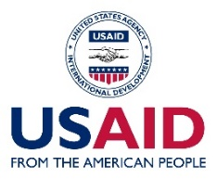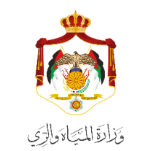

**Newsletter** *August & September, 2017*

**Water Management Initiative (WMI) Project**

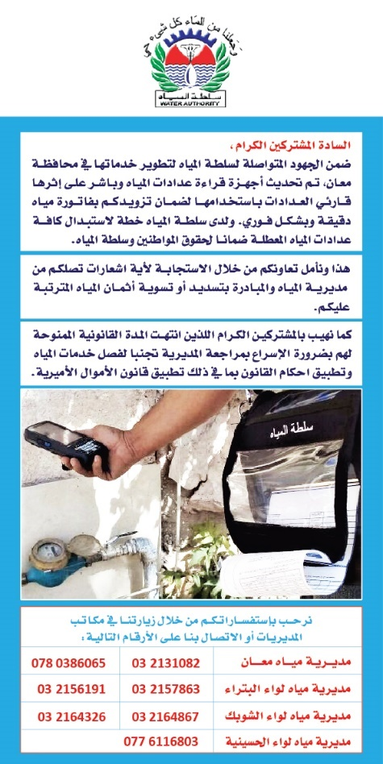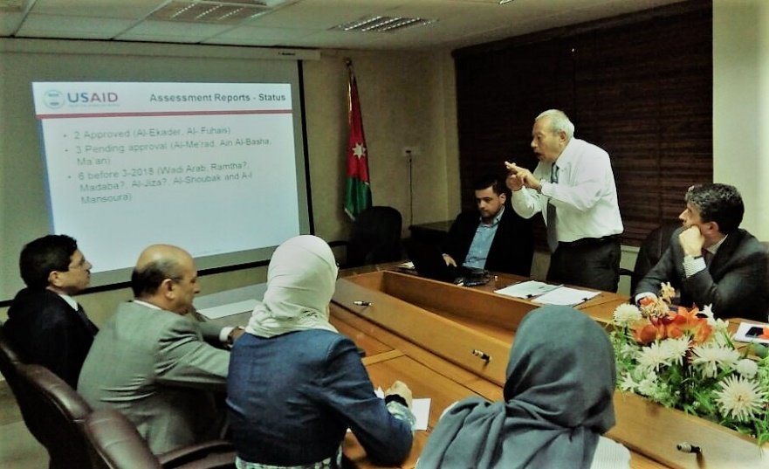

**SITUATIONAL ANALYSIS OF WASTEWATER TREATMENT PLANTS (WWTP’s)**

USAID/WMI has developed a situational analysis of five WWTP’s (Ein Al Basha, Al Me’ard, Al-Ekader, Al-Fuhais, and Ma’an).

The situation analysis, which studied the administration and human resources capacity as well as the treatment plant units, was shared with WAJ SG and relevant staff that included recommendations to enhance quality of the WWTP’s effluent and reduce treatment costs. WAJ has partially implemented some of the recommendations. Both parties have agreed to establish an executive committee to examine and implement the rest of the recommendations as per the situational analysis report.

**MA’AN DEBT COLLECTION CAMPAIGN**

USAID/WMI is collaborating with Ma’an Administrative Unit to roll out a campaign that aims at encouraging customers to settle any water bills. The campaign will include the distribution of around 24,000 flyers by the water meter readers in Alhusayneh, Alshoubk, Wadi Musa, and Qasabet Ma’an and reach out to each customer who have passed the legal period granted to avoid implementing the Amiri Law with a direct communication message about how to settle his/her duties.

The campaign will also highlight the handheld units to be used by the meter reading staff in a bid to enhance customer service and regularly issue customers’ invoices.

**HIGHLIGHTS**

- In collaboration with USAID/WMI, Yarmouk Water Company has refurbished its HR Directorate, introducing multiple renovations and equipping it with office furniture and IT equipment in a bid to empower staff *(Refer to Good Story #13).*

- To integrate it with Yarmouk Water Company, the Enterprise Resource Planning (ERP) Oracle testing session took place from Sep. 20th through Oct. 8th (11 days). The ERP will enhance the financial & managerial operations.

- Billing percentage in Zarqa increased to 98% *(Good Story #12).*



**ROLLING OUT THE X7 SYSTEM**

The department of customer service at Yarmouk Water Company is up for a technological upgrade.

The X7, the modern customer information system, will be integrated within the utility’s operation following a series of negotiations that saw WMI work closely with WAJ ICTU to facilitate agreement signing with GFI, the French owner and provider for X7 system, on September 20, 2017.

The X7 system will be replacing the outdated COBBOS billing system.

It is expected that the system will go live in January1, 2018.

**KAP SURVEY**

USAID/WMI will be implementing a Knowledge, Attitude, and Practices (KAP) survey in communities served by Yarmouk Water Company and Miyahuna to discover behavioral insights among Jordanians and Syrian refugees.

The findings of the survey will help design campaigns targeting households to improve their knowledge about water resources and water supply challenges in Jordan including the cost of water and importance of conservation, and the importance of adoptions of technologies or techniques to save water or increase reuse of water. The campaigns also aim to promote best practices to adopt in water scarcity contexts and reinforce the promotion of water use efficiency across all groups of consumers.

The Survey’s questionnaire has been finalized and will be rolling out in October 2017.



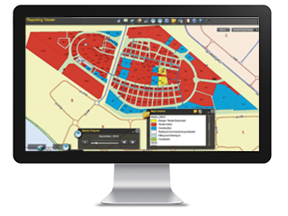

**NEW EXPERTS**

USAID/WMI has hired four short-term consultants to support Yarmouk Water Company and help uplift its business operations.

The company is now hosting experts for timed assignments in the following areas: internal auditing, HR, Strategic Planning, and ICT.



**CUSTOMER SERVICES CONTROL UNITS**

Since Yarmouk Water Company covers four northern governorates through ten Remote Operating Units (ROU’s), USAID/WMI collaborated with the utility to assess the performance and suggest means to upgrade the level of service and billing and collection in addition to establishing a Central Control Center.

The assessment report was approved by the company’s Board. Work now is underway to establish the center.

**GIS FIELD ASSESSMENT**

To explore the status of utilization of the Geographic Information System (GIS) technology that is being deployed among water utilities, a GIS inventory field survey was initiated by USAID/WMI to help define the need to develop the institutional GIS concept for the entire water sector.

The deployment of a holistic and integrated GIS will immensely support the technical and institutional capacity of the sector. The assessment report of the field survey will be presented to the ICT managers in the sector in the next quarter.

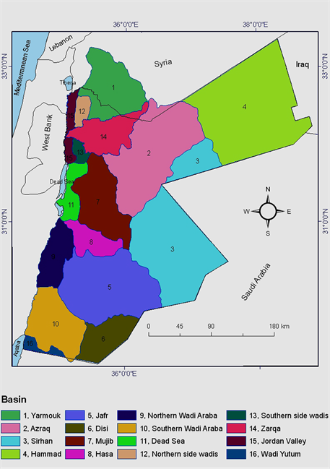

**MADABA MERGER WITH MIYAHUNA**

WAJ, PMU, Miyahuna and USAID/WMI are part of a steering committee that meets bi-weekly to follow up on the works of subcommittees tasked with producing thorough plans that will facilitate the merging of Madaba Water Administration within Miyahuna’s management.

The merger will streamline operations, standardize business, and enhance performance levels.

Following the steering committee’s meeting number 3, it was agreed that subcommittees will be submitting their plans by end of October for review.

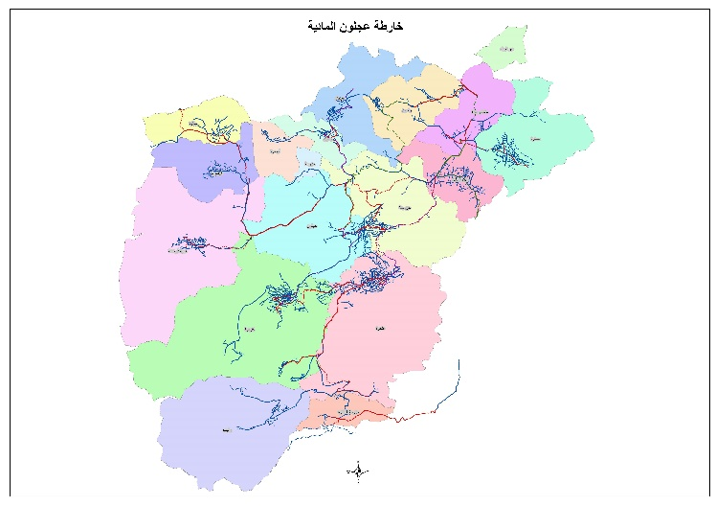

**ESTABLISHING A WATER BASINS UNIT**

WAJ Board requested USAID/WMI to support establishing a new Unit under the Water Basins Affairs. The purpose of this effort is to improve revenues and to increase efficiency of managing non-agricultural wells.

USAID/WMI is working closely with WAJ to produce proposed options and analysis of governance opportunities.

.

**YARMOUK COMPANY ASSETS REGISTRATION**

WAJ and USAID/WMI have worked jointly from July 1 until Sep 30 this year to register Yarmouk Water Company assets in Ajloun as a first phase.

The assets registration and evaluation included land, machinery, water and wastewater networks, buildings, tanks, water and wastewater plants, and other assets.

This comes as part of a comprehensive asset registration campaign that aims to reach out to the other governorates under YWC’s management to integrate all into a single system that will help the utility better operate and manage its assets.

USAID/WMI

Wadi Saqra, Mhammad Jama’an Street,

Bldg. # 4, 1st Floor

Office: +962 6 5683199 | Fax: +962 6 5683191